1. Motivate

Who are some of your favorite “sidekicks” from movies and TV shows?
- Doc Severinsen and Ed McMann with Johnny Carson
- Festus on Gunsmoke
An intro video for the lesson is available. Go to https://tinyurl.com/bdd6bkfk to view. If you have no wi-fi where you teach, it is best to download the video file to your computer from https://tinyurl.com/5n8h9jcn
- Barney Fife on Andy Griffith
- Chewbacca with Hans Solo
- Robbin with Batman
- Tonto with the Lone Ranger
- Dr. Watson with Sherlock Holmes
- Piglet with Winnie-the-Pooh
- Barney Rubble with Fred Flintstone
- Art Carney (Ed Norton) with Jackie Gleason (Ralph Cramden)
- Rhoda to Mary Tyler Moore

2. Transition

Leaders don’t lead without the help of others.
- Our examples were from fiction and TV shows
- Today we look a help given by those in Bible history

3. Bible Study

3.1 Be Ready to Help

Listen for appointments made.

Exodus 17:8-10 (NIV) The Amalekites came and attacked the Israelites at Rephidim. 9 Moses said to Joshua, "Choose some of our men and go out to fight the Amalekites. Tomorrow I will stand on top of the hill with the staff of God in my hands." 10 So Joshua fought the Amalekites as Moses had ordered, and Moses, Aaron and Hur went to the top of the hill.

Consider the challenge the people of Israel faced in this setting.
- Attacks from Amalekites
- Turns out these were descendants of Esau
- Israelites were descendants from his brother Jacob
- Amalekites were nomadic raiders – they had learned to domesticate camels for swift hit and run attacks

Who did Moses call upon to assist in resisting the Amalekites, and what do we know about them?
- Joshua – one of the 12 spies into Caanan (one of only two that gave positive report)
- Aaron – Moses’ brother
- Hur – thought to be Miriam’s husband, Moses’ brother-in-law
What challenge did Joshua have? What kind of courage did Joshua need to obey Moses?
- he’s in charge
- he would have to choose the men
- remember these were a group of people who had been former slaves
- up to now they had not exactly been warriors
- get them together as a fighting force
- he would lead them
- he would determine their strategy

What are some of the daily challenges you face?
- we feel like we don’t have enough time in the day
- finances are a worry
- kids struggling with their schooling
- worry about the times we live in with pressure of gangs, drug culture, school shootings, teen drinking
- personal struggles with temptation
- how to provide for our kids’ education
- anti-Christian attitudes of parts of our culture
- craziness of current political events

How do the challenges we deal with make it seem like we’re at war?
- they are ongoing, never ending
- sometimes they seem evil in their source
- we feel worn down
- takes courage, strategy to confront the problems
- we feel we cannot handle things on our own

Moses had the “staff of God”. What do we have in our battles?
- guidance of God’s Word
- presence and power of God’s indwelling Holy Spirit
- God’s promises
- power of prayer
- prayer of fellow believers
- the Body of Christ, the church as fellow spiritual warriors

Who are some people you would want by your side when you face challenges?
- a supportive spouse
- a prayer partner
- as a young adult, you might appreciate supportive parents
- as an aging adult, you would appreciate supportive adult children
- a boss who “has your back”
- a praying grandparent

3.2 Do What You Can

Listen for how Moses needed help.

Exodus 17:11-13 (NIV) As long as Moses held up his hands, the Israelites were winning, but whenever he lowered his hands, the Amalekites were winning.12 When Moses' hands grew tired, they took a stone and put it under him and he sat on it. Aaron and Hur held his hands up--one on one side, one on the other--so that his hands remained steady till sunset. 13 So Joshua overcame the Amalekite army with the sword.

What happened when Moses held up his hands?
- when Moses held up his hands (presumably with the staff of God), the battle went in favor of the Israelites
- when he tired and lowered his hands to rest, the Joshua and his fighting men began to lose
- a direct correlation between hands up winning and hands down losing

Aaron and Hur had wisdom to help Moses in what way?
- when he tired, they got him a place to sit
- when his arms tired, they helped hold them up
- one on either side

The “staff of God” had previously been a symbol of God’s presence and power.
- To initially reassure Moses, God turned it into a snake, then back to a walking staff
- Did the same thing before Pharaoh
- Moses used it when he held it out over the Red Sea and God parted the waters
- Moses struck a rock with the staff and water came out of the rock

When has someone “held your arms up” to help you accomplish a task?
- people who prayed for us during a crisis
- people who came and gave physical, practical assistance during the problem
- someone who gave good advice
- someone who provided financial help
- someone who loaned tools, equipment, etc.

In whose lives can you play the role of Aaron and Hur?
- aging parents
- our kids and grand kids
- fellow believers in our Bible studies, in our churches
- relatives, neighbors who are struggling with their own spiritual battles

How might we offer physical support to our leaders when they are weary?
- give practical help like yard care
- enable them to have some time away
- help with chores
- take care of the kids for a period of time
3.3 Be Dependable

Listen for more help Moses needed.

Exodus 24:13-15 (NIV) Then Moses set out with Joshua his aide, and Moses went up on the mountain of God. 14 He said to the elders, "Wait here for us until we come back to you. Aaron and Hur are with you, and anyone involved in a dispute can go to them." 15 When Moses went up on the mountain, the cloud covered it,

Moses returned to the mountain to receive the Ten Commandments etched in stone. Joshua accompanied him. What instructions did he give to the elders?
- wait here
- until we come back for you
- Aaron and Hur will adjudicate disputes while I’m gone

What other times elsewhere in Exodus do you see the growth of the relationship between Moses and Joshua?
- Joshua was one of only two men who gave a favorable report after spying out the land of Caanan
- Joshua was eventually the one who would succeed Moses in leadership
- Joshua lead the people as they conquered the Promised Land

Why might Moses have had confidence in all three of these men?
- Aaron and Hur had given wise assistance during the battle
- they had shown good judgment
- they had demonstrated faithfulness
- they had experience
- apparently respected by the people

What does it look like for someone to be dependable in their Christian walk? How will church leadership know to have confidence in church members for various ministries
- regular attendance to worship and Bible study sessions
- taking part in leadership roles
- participation in various ministries – music, committees, outreach, volunteering
- actions and attitudes align with spiritual claims and declarations

How can the church support Christian leaders?
- faithful prayer support
- faithful financial support (tithing) to the church
- the church provides sufficient salary, commensurate with responsibilities and experience
- church committees work together with leadership to do ministry
- sufficient staffing of children, youth, and adult ministries

Use the last page as a handout so your learners can take home the application points of this week’s lesson.


Application
Be present.
- Identify opportunities to encourage others.
- Offering an encouraging word to your pastor or group leader.
- Maybe help with something more tangible.
- Let others know you are there for them.

Offer thanks.
- Look around for those who have helped you get where you are.
- Write a thank you card to each one to let them know how important they’ve been in your Christian journey.

Lighten a load.
- Are there people in your life who always seem to have a burden to carry?
- How can you be supportive and hold their arms up during these difficult days?
- Look for an opportunity to lighten their load by taking on one of their tasks, even if just temporarily

Double Puzzle

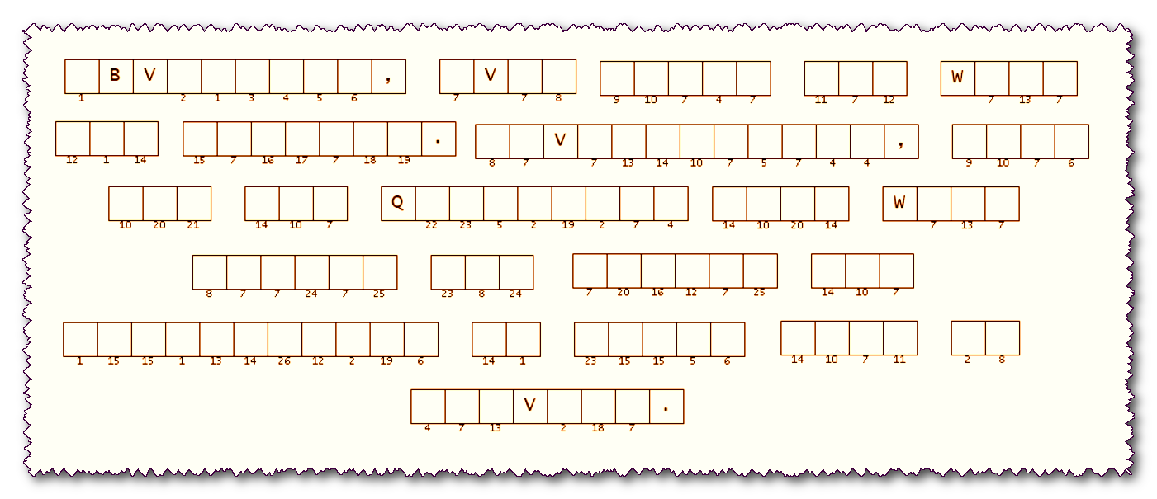
Two different operatives in Abel Toliadesh forwarded these slips of paper to the pickle ball attaché in our embassy. You must unscramble the key words, then use the numbers to complete the message. The key words are found in our Bible study passages: Exodus 17:8-13 and 24:13-15 (NIV). Go to https://tinyurl.com/5n8h9jcn for technical help.

