**1. Motivate**

What was something that you and your siblings argued about or complained about each other when you were growing up as kids?

* who got the most food – biggest piece of cake/pie/meat/ …
* he’s on my side of the car seat
* she’s laughing at me

A video introduction to the lesson is available. View it at <https://tinyurl.com/38bpszks> If you don’t have wi-fi where you teach, you will need to download the video file to your computer from <https://tinyurl.com/47vurwcx>

* he said my dress/hair/face … was ugly
* he gets to stay up later – not fair!
* quit playing with my toys
* she has less chores than I do
* he’s being mean again
* she hit me and I didn’t do *anything*!

**2. Transition**

Unfortunately squabbles (family or otherwise) can extend into our adult years as well.

* Believers have a better course of action when it comes to self-preservation and personal relationships.
* Trust God when challenged over your rights or possessions.

**3. Bible Study**

3.1 Identify the Source of Conflict

Listen for the source of conflict.

Genesis 13:5-8 (NIV) Now Lot, who was moving about with Abram, also had flocks and herds and tents. 6 But the land could not support them while they stayed together, for their possessions were so great that they were not able to stay together. 7 And quarreling arose between Abram's herdsmen and the herdsmen of Lot. The Canaanites and Perizzites were also living in the land at that time. 8 So Abram said to Lot, "Let's not have any quarreling between you and me, or between your herdsmen and mine, for we are brothers.

What were some of the details of the strife that developed?

* both men had large flocks of livestock
* if the two families stayed together there was not enough land to support both herds
* the herdsmen of both families had been quarreling over land, watering areas
* besides the two families there were some local tribes that also lived there, no doubt they had certain claims on land and water resources

How did the reference to the presence of the Canaanites and Perizzites contribute to the problem?

* these were additional people who were competing for grazing land and water
* they could add to the problem
* if there was strife between Abram and Lot, that would weaken both their positions in standing against the local herdsmen

What are some things that make conflict worse in our culture?

* social media – you post mean things you might not say face to face
* everyone can see the problem
* we are a divided culture on so many levels … politics, attitudes towards the pandemic
* news organizations that generate more opinions and not just plain reports of events
* we have an attitude of hate towards people who don’t agree with us

What are some ways that people *today* deal with conflict?

* yell and scream, other forms of verbal abuse
* give ultimatums, other forms of emotional abuse
* physical violence
* sneaky, behind the back meanness – “don’t get mad, get even!”

What are some early steps we can take to avoid or reduce conflict?

* don’t take life quite so seriously
* go with the flow
* don’t feel you have to have the last word
* walk away from conflict (even at the risk of being called a loser)
* pray for those with whom you have conflict
* allow God to live qualities of the Fruit of the Spirit through you … love, joy, peace, patience, kindness, goodness, gentleness, faithfulness, and self-control

Why is it important to be ready to handle conflict in a timely and graceful manner?

* otherwise it can undermine what God is really doing
* we could get sidetracked easily
* it affects not only us, but others also

3.2 “You before Me” Attitude

Listen for generosity.

Genesis 13:9-11 (NIV) Is not the whole land before you? Let's part company. If you go to the left, I'll go to the right; if you go to the right, I'll go to the left." 10 Lot looked up and saw that the whole plain of the Jordan was well watered, like the garden of the LORD, like the land of Egypt, toward Zoar. (This was before the LORD destroyed Sodom and Gomorrah.) 11 So Lot chose for himself the whole plain of the Jordan and set out toward the east. The two men parted company:

Why do you think Abram suggested the solution he did? Why didn’t he exert his authority as the senior family member?

* they would part friends
* it was not a “this town’s not big enough for the 2 of us” declaration
* it saved face for everyone
* there was plenty of land for both of them – a win-win situation
* he liked Lot and didn’t want to offend him

What does Abram’s example teach us?

* no need to throw your weight around when a conflict exists
* be generous when you are working towards resolution of a conflict
* be ready to be the first to suggest a reasonable solution
* kindness accomplishes more than being nasty

Suppose you are Lot and it is the end of the day … you are writing in your journal the events of the day. What would you be writing down as the explanation for your decision?

* Abram made a really great offer
* I could see what he said made sense
* I did some quick thinking, evaluating which area I wanted
* I could see the great grazing fields and streams for water
* I could also see the availability of the amenities of the cities … best of both worlds
* Abram was maybe too quick to let me choose first
* I had to choose what was best for me … I’m younger, have more kids to feed, longer time to provide for the family
* I can live apart from those reportedly wicked cities, I can handle the wickedness there – it won’t affect me

What character traits would you infer from the way Lot reacted?

* selfish
* me first attitude
* thought more highly of his spiritual fortitude than was warranted
* ungrateful (assumed from no mention of “thank you”)

How do these attitudes NOT help resolve conflict?

* not interested in conflict resolution at all
* only interested in what is best for self
* even if it means more conflict
* hoping to use or even create conflict to accomplish self-centered purposes

3.3 Trust God with the Outcome

Listen for God’s assurance.

Genesis 13:14-18 (NIV) The LORD said to Abram after Lot had parted from him, "Lift up your eyes from where you are and look north and south, east and west. 15 All the land that you see I will give to you and your offspring forever. 16 I will make your offspring like the dust of the earth, so that if anyone could count the dust, then your offspring could be counted. 17 Go, walk through the length and breadth of the land, for I am giving it to you." 18 So Abram moved his tents and went to live near the great trees of Mamre at Hebron, where he built an altar to the LORD.

What did God say in response to these events?

* Look in every direction
* all the land that you can see I will give to you and your succeeding generations
* this will be yours forever
* your offspring will be so many they cannot be numbered
* go and walk the length and breadth of the land I am giving you

Why do you think God chose this time to restate His promise to Abram?

* Abram might have feared he had “given away the farm” by being generous with Lot
* God wanted Abram to know that the promise was still in effect
* as humans we need reassurance every so often

Consider situations in our family lives where there is conflict …

* newlyweds (or “oldy-weds”) who argue about money, blaming each other for spending too much or not making enough
* couples with willful teenagers who argue in front of the kids about how to discipline
* parents who treat one of their children as the least (or most) favorite
* people who fight with their siblings over the inheritance left by parents

Many of these tensions are a normal part of life … but when tensions escalate, they can lead to alienation or abuse that goes beyond words.

How can relying on God influence on these kinds of situations?

* we learn not to rely on ourselves
* we realize how desperately we need God's help
* Christianity (religion) may be a “crutch” but the truth is we are all “limping”
* we learn that God's power is available, and it is sufficient
* when we learn to trust God for little things, we are encouraged to trust Him and see Him work in bigger things
* this becomes a powerful “habit” … a mindset that leads to a life of victory!

Use the last page as a handout so your learners can take home the application points of this week’s lesson.

Application

Go Directly to God.

* Start by asking God for wisdom and guidance in this situation.

Go Directly to the Source.

* When you are aware of a potential family conflict, take the initiative by going directly to the person seeking a peaceful solution.
* Avoid discussing the problem with others, as that can escalate the situation.

Go Diplomatically.

* When you meet be argumentative or respond with emotional expressions.
* Go with a godly goal: restoration (Matt. 18:15 and Gal. 6:1).

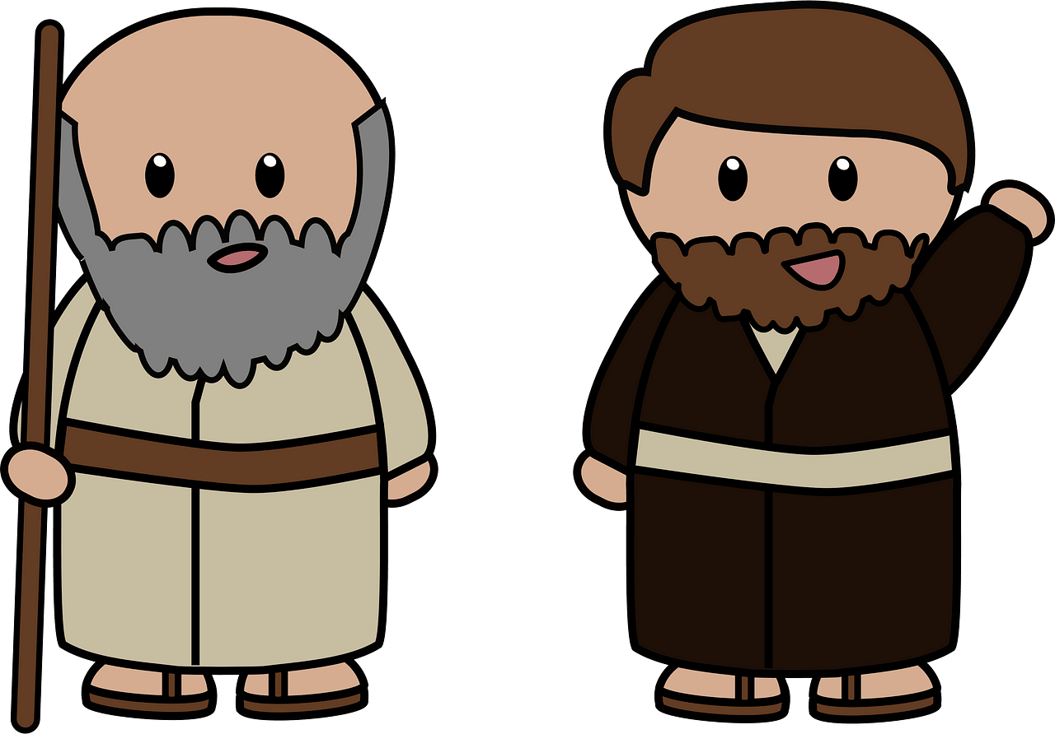Crossword Puzzle

Remember, the clues and the words come from Genesis 13:5-11, 14-18 (NIV). For help and more Family Activities go to <https://tinyurl.com/47vurwcx>