**1. Motivate**

What is an invention you cannot imagine living without?

* air conditioning
* automobile

A video introduction to the Bible study is available. View it at <https://tinyurl.com/56dxut35> If you have no wi-fi where you teach, it is best to download the video file to your computer from <https://tinyurl.com/3r9c5suh>

* washing machine
* cell phone
* television
* computer
* ice maker
* garage door opener
* graphing calculator
* power lawn mower

**2. Transition**

There are many items that are very valuable to us.

* Today we consider what God values.
* Your service to God is valuable, no matter who gets the credit.

**3. Bible Study**

3.1 Allow Yourself to Be Challenged

Listen for a challenge and a response.

Judges 4:4-8 (NIV) Deborah, a prophetess, the wife of Lappidoth, was leading Israel at that time. 5 She held court under the Palm of Deborah between Ramah and Bethel in the hill country of Ephraim, and the Israelites came to her to have their disputes decided. 6 She sent for Barak son of Abinoam from Kedesh in Naphtali and said to him, "The LORD, the God of Israel, commands you: 'Go, take with you ten thousand men of Naphtali and Zebulun and lead the way to Mount Tabor. 7 I will lure Sisera, the commander of Jabin's army, with his chariots and his troops to the Kishon River and give him into your hands.'" 8 Barak said to her, "If you go with me, I will go; but if you don't go with me, I won't go."

Whom did Deborah call and of what did she remind him? Note how specific the commands were.

* called for Barak from Kadesh
* told him to go
* take 10,000 men
* lead to Mt. Tabor
* we’ll take care of the Canaanite army – iron chariots and all
* told him where, how many, and guaranteed the outcome of victory

What assurances of victory are promised by God, communicated by Deborah?

* their commander, Sisera, will be lured into the battle
* God will lure him to the river
* you will conquer all those troops and chariots

How did Barak respond to her? What “line in the sand” did he declare?

* didn’t want to go on his own
* wanted Deborah’s leadership to accompany him
* he “drew a line in the sand”
* “I won’t go unless you go along”

What do you think was the rationale behind his “line in the sand”?

* didn’t want the responsibility
* afraid if he failed, he would take the blame
* needed someone to share the decisions
* she was the one who had the word from God,
* he might need further direction from God through her

When has God used someone to encourage you to step into a ministry opportunity?

* pastor invited to go with him door to door
* church staff asked you to teach
* music minister asked you to join the worship team
* you were asked to preach when the pastor was going to be away
* your Bible study teacher asked you to substitute for him/her
* you were asked to help plan VBS/Christmas pageant/other special event
* invited to help staff men’s/women’s ministry team

Who are some people in your circle of influence, whom you could be encouraging in matters of faith?

* your own children or grandchildren,
* niece or nephew
* promising young person in your church
* young married couple in your church
* a Christian acquaintance with whom you exercise together, do your daily neighborhood walk together
* a person in your fellowship who is new to the faith

How can you encourage those same people to take on leadership responsibilities? In what ways can we be an influence for God where we live?

* answer questions they have about the Christian walk
* pray for them/with them, have conversations of encouragement
* communicate leadership or ministry skills you see in their lives
* suggest their name to church staff when leadership openings occur

3.2 Do What You Are Called to Do

Listen for who to trust.

Judges 4:12-16 (NIV) When they told Sisera that Barak son of Abinoam had gone up to Mount Tabor, 13 Sisera gathered together his nine hundred iron chariots and all the men with him, from Harosheth Haggoyim to the Kishon River. 14 Then Deborah said to Barak, "Go! This is the day the LORD has given Sisera into your hands. Has not the LORD gone ahead of you?" So Barak went down Mount Tabor, followed by ten thousand men. 15 At Barak's advance, the LORD routed Sisera and all his chariots and army by the sword, and Sisera abandoned his chariot and fled on foot. 16 But Barak pursued the chariots and army as far as Harosheth Haggoyim. All the troops of Sisera fell by the sword; not a man was left.

According to Deborah, why could Barak move forward with confidence?

* this is the day the Lord has given you the victory
* God’s going to make it easy
* God is going ahead of you (to conquer them for you)

How effective was Barak in carrying out what he had been set aside to do?

* he advanced down the mountain
* he led his army into the battle
* as he advanced, God put the enemy (even with his iron chariots) into a rout
* their general actually abandoned his army
* Barak able to chase them and destroy the whole Canaanite army

How can we discern when God is calling us to a task?

* God’s Holy Spirit impresses His directions on our hearts
* God opens and closes doors of opportunity
* often the task God calls us to is something that He has already given us a skill or interest
* when called to a new responsibility, God will give us the skills we need
* maybe a Bible study or sermon emphasizes a verse or passage that speaks specifically to your situation

How can we encourage others to walk in obedience even under difficult circumstances?

* be aware of God’s Spirit prompting you to encourage or exhort
* be praying for those who are being considered for a given ministry
* pray *with* them as they consider an opportunity for service to the Lord
* share your own experiences of how God lead you
* point out what skills or spiritual gifts you see in their lives

3.3 Give God Honor and Praise

Listen for who gets the credit for victory.

Judges 5:1-5 (NIV) On that day Deborah and Barak son of Abinoam sang this song: 2 "When the princes in Israel take the lead, when the people willingly offer themselves-- praise the LORD! 3 "Hear this, you kings! Listen, you rulers! I will sing to the LORD, I will sing; I will make music to the LORD, the God of Israel. 4 "O LORD, when you went out from Seir, when you marched from the land of Edom, the earth shook, the heavens poured, the clouds poured down water. 5 The mountains quaked before the LORD, the One of Sinai, before the LORD, the God of Israel.

For what does Deborah praise the Lord?

* princes of Israel took the lead
* people willingly offer themselves in service
* God went out ahead of them

What imagery suggests that the Lord goes before His people? How does He demonstrate His power?

* the earth shook
* the heavens poured
* clouds poured down water
* the mountains quaked before the Lord

If you wrote a song about God’s work in your life, what would be its theme? What kinds of victories (should) cause us to praise the Lord?

* leading and guiding
* providing
* God’s intervention
* the wisdom God gives
* rescue from problems
* answers to prayer
* God changes the lives of those you’re burdened about

What could you do this week to praise the Lord for His faithfulness in your life?

* talk to God – praising Him
* tell God you are trusting Him
* make a list of all the things God has accomplished in your life
* read through 101 Reasons to Praise God at <http://average-heros.tripod.com/id17.html>
* when your kids, grandkids make the right decisions
* God's healing of our bodies

How does praising God affect our view of victory? What are the benefits of celebrating what God has done?

* we give the credit to God, not to ourselves
* we learn more and more to depend on God
* we learn that God's power is always available, always sufficient, even abundant
* it also is an encouragement to others, encouraging them to trust God in their battles
* it gives us assurance the next time we are confronted with a problem

Use the last page as a handout so your learners can take home the application points of this week’s lesson.

Application

Identify obstacles.

* Say “yes” to whatever God is asking of you, regardless of the odds against you.
* What obstacles are you facing?
* What iron wall is standing between you and what God wants you to do? God will give you what you need to be victorious.
* Be willing to step out on faith, even when you can’t “see” it.

Worship God.

* Worship Him even through the tough times, in the wins and losses of life.
* God uses us to accomplish His will but remember that all the credit belongs to Him.
* Plan a time each day this week to spend time with the Lord.

Work together.

* What project has God asked you to lead or participate in?
* Be a team player knowing that when you work as team, when the team wins, everyone wins.
* Most importantly, God is glorified.

Word Search

LEADING  
LURE  
MARCHED  
MOUNTAINS  
MUSIC  
NINE  
OFFER  
PALM  
POURED  
PRAISE  
PRINCES  
PROPHETESS  
QUAKED  
RIVER  
ROUTED  
RULERS  
SANG  
SHOOK  
SONG  
SWORD  
THOUSAND  
TOGETHER  
TROOPS  
WATER  
WILLINGLY

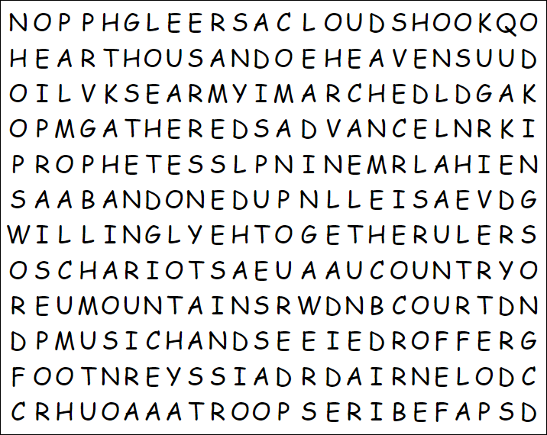

Ok, there’s no secret message from the embassy at Bopucook. It’s just ‘find the words’. Humph! I bet you can find more than that other class. Winner class gets excused from that book report. All the words go left to right, down, or diagonal. No backwards or words bottom to top. You can do this! If you wimp out, go to <https://tinyurl.com/3r9c5suh> for help (and more fun Family Activities).

ABANDONED  
ADVANCE  
ARMY  
CHARIOTS  
CLOUDS  
COMMANDER  
COUNTRY  
COURT  
DEBORAH  
DISPUTES  
EARTH  
FLED  
FOOT  
GATHERED  
HANDS  
HEAR  
HEAVENS  
HILL  
HUNDRED  
IRON  
ISRAEL  
KINGS  
LEAD  
LEADING  
LURE