1. Motivate

What is something you remember loving dearly as a child that you eventually outgrew?
- teddy bear
A video introduction is available. View at https://watch.liberty.edu/media/t/1_9o56cebk . If you have no Wi-Fi where you teach, best to download to your computer from https://tinyurl.com/86a6fn6h
- special blanket
- favorite shirt
- special toy
- your first big boy/girl bed
- a favorite book your folks read to you
- a favorite song or story on a record or tape
- a favorite TV show (Capt. Kangaroo, Sesame St., etc.)
- your own car seat
- a special wallet, coin purse, little girl’s purse
- a ball cap or little girl’s “go-to-church” hat

2. Transition

Our fondness for children’s personal items wanes with maturity.
- Our love for our Savior must not fade away over time.
- When we ground everything we do in love for Christ we will keep our relationship to Him alive.

3. Bible Study

3.1 Be Known for Your Good Works

Listen for good deeds done.

Revelation 2:1-3 (NIV) "To the angel of the church in Ephesus write: These are the words of him who holds the seven stars in his right hand and walks among the seven golden lampstands: 2 I know your deeds, your hard work and your perseverance. I know that you cannot tolerate wicked men, that you have tested those who claim to be apostles but are not, and have found them false. 3 You have persevered and have endured hardships for my name, and have not grown weary.

To whom is this message given?
- the “angel of the church” in Ephesus
- could actually mean there is an angel that watches over a church
- an angel is a “messenger” from God
- probably means the pastor or leader of the church

What two assurances come from the way in which the Lord identified Himself?
- He holds the “stars” of the churches
- He walks among the golden lampstands of the churches
- God is present and close by the churches, not just peering at them from distant heaven

For what was the church at Ephesus to be commended?
- their deeds
- hard work
- perseverance
- intolerance for wickedness
- close attention to people’s lives measuring up to their claims
- endured hardships for Christ
- had not grown weary in serving the Lord

Where is your church succeeding based on these verses? What are some of the ministries you are known for?
- great music
- active youth group
- good preaching
- interesting Bible studies
- busy small groups (Sunday school classes, connect groups)
- involved in support of local city mission
- visitation, door to door outreach
- mission trips by youth, adults
- benevolent ministries
- summer camp for youth
- VBS
- new-Christian classes
- several new baptisms per month

What things do people do that say that show or demonstrate who or what is most important in their lives?
- how you spend your money
- what you spend your time on
- who you spend your time with
- is your Bible worn out from reading it or from just carrying it around?
- is your TV remote worn out because that’s how you spend much of the day?
- does your family look forward to worshiping together?

How would you compare and contrast doing things for Jesus and spending time with Jesus?
They are similar … | They are different …
- what you do demonstrates what is important to you  - doing things for Jesus does take time  - how you spend your time is an indicator of your dedication to the Lord | - you can do some of these things without being “with” Jesus  - personal relationships are not built entirely on doing things  - a personal relationship is built on being with someone and focusing on getting to know the person, interaction, communication

3.2 Love for Christ Motivates Good Works

Listen for a criticism.

Revelation 2:4-6 (NIV) Yet I hold this against you: You have forsaken your first love. 5 Remember the height from which you have fallen! Repent and do the things you did at first. If you do not repent, I will come to you and remove your lampstand from its place. 6 But you have this in your favor: You hate the practices of the Nicolaitans, which I also hate.

What does verse 4 reveal about the Lord’s knowledge of His church?
- God sees in our lives, our churches beyond what is visible on the surface
- God knows our hearts – as individuals, as a church
- He knows where we need to change our lives
- He is constantly working to make us more like himself

What expectation of the Lord is implied by His pointing out their deficiency?
- we should be loving God more than anything else, more than anyone else
- some folks had actually declined in love for God
- there was a droop in the graph, not a constant growth
- at the very least there had been a leveling off or plateau … their love for Christ was not increasing

If a church is doing good and right, why does a drift from love need to be a concern?
- shows a spiritual health problem
- like a child who stops growing physically or mentally – we look for why … nutrition, a disease, etc.
- spiritual growth should be continuous and positive

How did the church at Ephesus need to change? What three steps were they to take to return to the fervency that had once characterized their service to the Lord?
- remember what your relationship to God used to be like
- repent – turn away from current attitudes and actions
- do the things you did at first

What does it mean to repent? What does it look like for a person who is already a Christian to repent?
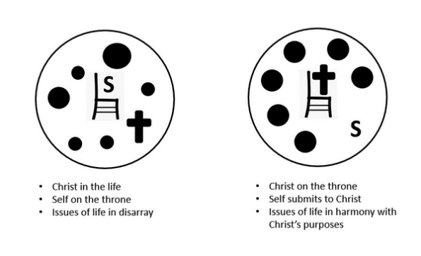
- for either the unbeliever of the Christian, to repent means to turn away from what you have been doing
- then turn to God
- turn to His forgiveness
- turn (or return) to His rule in your life
- turn (or return) to the attitudes and actions which please and glorify the Lord

3.3 One Day Dwell with Christ Forever

Listen for Jesus promise.

Revelation 2:7 (NIV) He who has an ear, let him hear what the Spirit says to the churches. To him who overcomes, I will give the right to eat from the tree of life, which is in the paradise of God.

What does Jesus promise to those who hear and heed His Word?
- given the right to eat from the “tree of life”
- experience the “paradise of God”
- an ongoing relationship with God
- closer fellowship with the Lord
- spiritual blessings

What prior Biblical event and place do the symbols in this verse bring to mind?
- the Garden of Eden
- Adam and Eve living there
- daily close fellowship with God

What practices have helped you hear and follow the Holy Spirit? How can we keep our commitment to Christ from waning over time?
- daily reading of God’s Word
- thinking about what it says and applying it to your life
- ongoing communication with God
- two-way communication – reading what He says, talking to Him in prayer
- bringing to Him Adoration, Confession, Thanksgiving, Supplication (A.C.T.S.)

How do we train ourselves to listen to what the Holy Spirit says throughout the day?
- be attentive to God’s working in the world around you
- even to note the beauty of nature and thank God for His creation
- focus on a particular concept of Scripture which you have recently read and apply it to different situations you face each day
- say a short prayer for those you encounter who need God’s help

What are some costs and benefits when it comes to listening to the Spirit’s communications to us?
Costs | Benefits
- obedience is required  - must submit to Someone  - God desires and deservers our fear/awe of Him  - means you will tithe and give of your resources | - God’s gracious rule in your life  - forgiveness  - peace, joy (and the rest of the Fruit of the Spirit)  - assurance  - God’s limitless supply of all your resources

Use the last page as a handout so your learners can take home the application points of this week’s lesson.
Application
Listen.
- Take some time each day to spend alone with God.
- Read Scripture, and as you read, ask God to help you hear what the Spirit is saying.
- Resolve to obey and act on what you read.

Love.
- Make a list of ways God has revealed His love to you.
- Pray and express your love to Him in return.
- Ask God to help you love Him in return and to keep that love in the forefront of everything you do.

Return.
- Throughout the COVID-19 pandemic, many believers got out of the habit of attending a worship service or Bible study group.
- With a mindset of “return to your first love,” graciously encourage others to come back to sharing life with the body of Christ through worship and group study.
Crossword Puzzle
Clues and words taken from Rev. 2:1 – 7 (NIV)
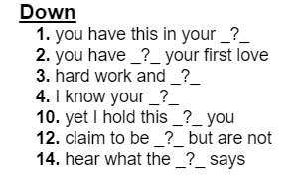
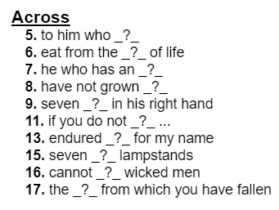
For help and for further exciting Family Activities, go to https://tinyurl.com/86a6fn6h

