1. Motivate

What’s the smallest thing you’ve seen someone fight about?
- a parking spot
- moving a grocery cart out of the way
- coffee was too hot/cold
A video introduction is available. View at https://watch.liberty.edu/media/t/1_t8opeguh
If you have no wi-fi where you teach, best to download to your computer from https://tinyurl.com/8w4me5xu
- mad about a name he was called
- which team is the best
- whose dad is tougher
- the ball landed in/out of bounds
- who had the coolest shoes/car/phone/clothes

2. Transition

Sometimes people really get out of sorts whether the issue was large or small.
- Relationships can be hurt or even broken.
- Today we study how we should trust God when conflict disrupts your relationships.

3. Bible Study

3.1 Conflict Between Friends

Listen for the issue of the conflict.

Genesis 13:5-8 (NIV) Now Lot, who was moving about with Abram, also had flocks and herds and tents. 6 But the land could not support them while they stayed together, for their possessions were so great that they were not able to stay together. 7 And quarreling arose between Abram's herdsmen and the herdsmen of Lot. The Canaanites and Perizzites were also living in the land at that time. 8 So Abram said to Lot, "Let's not have any quarreling between you and me, or between your herdsmen and mine, for we are brothers.

What were some of the details of the strife that developed?
- both men had large flocks of livestock
- if the two families stayed together there was not enough land to support both herds
- the herdsmen of both families had been quarreling over land, watering areas
- besides the two families there were some local tribes that also lived there, no doubt they had certain claims on land and water resources

What was at least one reason Abram cited for Lot and him to avoid quarrelling and strife?
- we are brothers, we’re family
- no reason for us to not be able to solve this problem without further conflict
- we should be able to reach a compromise

What are some things that make conflict worse in our culture?
- social media – you post mean things you might not say face to face
- everyone can see the problem
- we are a divided culture on so many levels … politics, attitudes towards the pandemic
- news organizations that generate more opinions and not just plain reports of events
- we have an attitude of hate towards people who don’t agree with us

What are some ways that people today deal with conflict?
- yell and scream, other forms of verbal abuse
- give ultimatums, other forms of emotional abuse
- physical violence
- sneaky, behind the back meanness – “don’t get mad, get even!”

Why is it sometimes hard to get along with family members and other people you love?
- we have a higher expectation of them because they are family or “we’ve been friends forever”
- we can be more disappointed when they do disagree
- you expect them to be nice, then when they aren’t you are especially upset
- you love them, why cannot they love you?
- our expectations are unreal, we expect them to be like us, to always agree
- we live so close together with them
- we must put up with their idiosyncrasies
- we have to listen to their old jokes
- relatives presume on each other for things they shouldn’t (like a personal loan)

When might a disagreement be a good thing?
- when we become exposed to a different point of view
- when we are wrong and the other person’s insight is correct
- if we all agreed on everything, we’d be dull and drive each other nuts
- we need variation in our lives

Consider the way musicians play different notes, but when played together, they sound beautiful … it’s called harmony. Our interactions with others who are different can also result in harmony.

Why do you think someone who “called on the name of the Lord” encountered problems such as described here?
- life happens, life has problems
- but God is good … in the midst of the problems
- we live in a sinful world
- we still live in our mortal and sinful bodies and are tempted

What are some early steps we can take to avoid or reduce conflict?
- don’t take life quite so seriously
- go with the flow
- don’t feel you have to have the last word
- walk away from conflict (even at the risk of being called a loser)
- pray for those with whom you have conflict
- allow God to live qualities of the Fruit of the Spirit through you … love, joy, peace, patience, kindness, goodness, gentleness, faithfulness, and self-control

3.2 Put Others First

Listen for Abram’s solution.

Genesis 13:9-11 (NIV) Is not the whole land before you? Let's part company. If you go to the left, I'll go to the right; if you go to the right, I'll go to the left." 10 Lot looked up and saw that the whole plain of the Jordan was well watered, like the garden of the LORD, like the land of Egypt, toward Zoar. (This was before the LORD destroyed Sodom and Gomorrah.) 11 So Lot chose for himself the whole plain of the Jordan and set out toward the east. The two men parted company:

What solution did Abram propose for settling the dispute between his and Lot’s herdsman and preventing any breach between the two of them?
- we’ll split up, there’s plenty of space here in this land
- you choose first which way you want to go
- I’ll take my people and herds in the other direction

Why do you think Abram suggested the solution he did? Why didn’t he exert his authority as the senior family member?
- he wanted to make sure the conflict was defused
- maybe Lot had an attitude, and this would help assuage his feelings
- then Lot couldn’t complain about who got the best deal
- it’s like letting two kids divide a dessert … one cuts it in half, the other gets to choose which half he wants
- Abram was being gracious
- it was not a “this town’s not big enough for the 2 of us” declaration
- there was plenty of land for both of them – a win-win situation

What choice did Lot make and what apparently influenced his decision?
- chose the valley with good water and good grazing area
- wanted what he saw as the best and most favorable
- maybe he wanted the availability of nearby city life and amusements

What lessons can be learned from the way Abram resolved his conflict with Lot?
- take care of the problem quickly
- the mature thing to do is take the lead in resolving conflict
- don’t try to throw your weight around, even if you have the authority or seniority
- God will honor your generosity, your selflessness

What would people have said about or to Abram if they’d watched this drama play out?
- you were a little too generous
- you should have told him which direction to go
- don’t know if I could have let him get the best of you that way
- well, he was a little cheeky, wasn’t he

What criticisms might we take if we seek godly solutions?
- why did you let him get off like that?
- you should have sued the rascal
- you were too easy on that person

3.3 Trust God’s Faithful Promises

Listen for God’s response to Abram.

Genesis 13:14-18 (NIV) The LORD said to Abram after Lot had parted from him, "Lift up your eyes from where you are and look north and south, east and west. 15 All the land that you see I will give to you and your offspring forever. 16 I will make your offspring like the dust of the earth, so that if anyone could count the dust, then your offspring could be counted. 17 Go, walk through the length and breadth of the land, for I am giving it to you." 18 So Abram moved his tents and went to live near the great trees of Mamre at Hebron, where he built an altar to the LORD.

What signs of Abram’s trust in the Lord are seen in these verses?
- he got up and got going
- he moved to the land God had promised him
- he built an altar, worshiped God
- obedience
- worship, praise, commitment

What did God say in response to Abram’s actions?
- Look in every direction
- all the land that you can see I will give to you and your succeeding generations
- this will be yours forever
- your offspring will be so many they cannot be numbered
- go and walk the length and breadth of the land I am giving you

Why do you think God chose this time to restate His promise to Abram?
- Abram might have feared he had “given away the farm” by being generous with Lot
- God wanted Abram to know that the promise was still in effect
- as humans we need reassurance every so often

Consider situations in our family lives where there is conflict …
- newlyweds (or oldlyweds) who argue about money, blaming each other for spending too much or not making enough
- couples with willful teenagers who argue in front of the kids about how to discipline
- parents who treat one of their children as the least (or most) favorite
- people who fight with their siblings over the inheritance left by parents

Many of these tensions are a normal part of life … but when tensions escalate, they can lead to alienation or abuse that goes beyond words.

How can relying on God influence on these kinds of situations?
- we learn not to rely on ourselves
- we realize how desperately we need God's help
- Christianity (religion) may be a “crutch” but the truth is we are all “limping”
- we learn that God's power is available, and it is sufficient
- when we learn to trust God for little things, we are encouraged to trust Him and see Him work in bigger things
- this becomes a powerful “habit” … a mindset that leads to a life of victory!
Use the last page as a handout so your learners can take home the application points of this week’s lesson.
Application
Pray.
- As an act of worship, lift up those whom you might have relational tension with right now.
- Also as you pray, a tension from your past might come to the forefront of your mind; pray for those people as well.

Check your pride.
- In comparison to Jesus, what is the level of your humility?
- Go to God and ask Him to reveal where your pride might be getting the best of you.
- Remember pride knocks you down; humility lifts you up.

Reconcile.
- What imaginary conversation have you been having with a person whom you know you need to have a real conversation with?
- Pick up the phone, set up the meeting, and have the difficult conversation.
ABRAM
ALTAR
AROSE
BREADTH
BROTHERS
COMPANY
COUNTED
DUST
EAST
EYES
FLOCKS
FOREVER
GARDEN
GIVING
HERDS
HERDSMEN
JORDAN
LAND

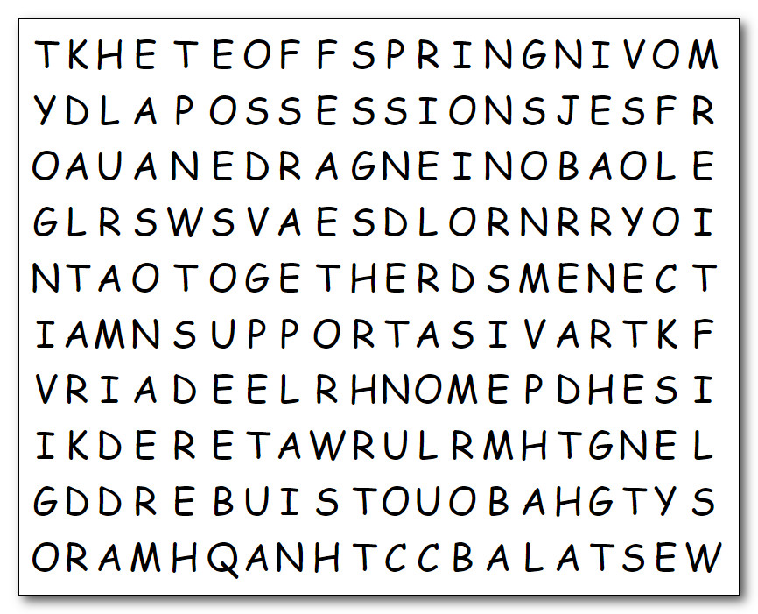Word Search Puzzle
So, you think you’re CONFIDENT ? Well, I’ll show you some CONFLICT. Humph! These words go in all directions … up, down, right, left, and diagonally. Finish this by Tuesday and you don’t owe me that book report. I suppose you’ll need help … Humph! Go to https://tinyurl.com/8w4me5xu You can find other non-conflicting activities there as well.

LENGTH
LIFT
LOT
MOVING
NORTH
OFFSPRING
PART
PLAIN
POSSESSIONS
QUARRELING
SOUTH
SUPPORT
TENTS
TOGETHER
WALK
WATERED
WEST

