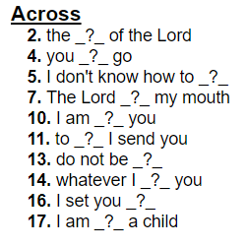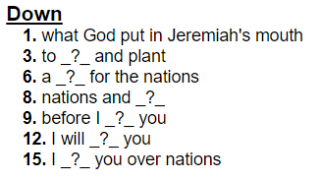

Jeremiah

How do I plan for my kid’s education? How can God help with those plans?