1. Motivate

What kinds of things do you look forward to during Thanksgiving week?
- getting to be with extended family
- a family dinner
- the traditional Thanksgiving feast … turkey, dressing, cranberry, pumpkin pie
- lots of great football games
- shopping on “black Friday”
- eating the leftovers of the big dinner
- kids like being off from school (parents maybe not so much)

2. Transition

Unfortunately, we too often give lip service to giving thanks … we’re more concerned with this other stuff
- Today we consider how giving thanks should come naturally
- It should happen every day
A video introduction to the lesson is available. View at https://watch.liberty.edu/media/t/1_hp2ifs0r If you have no wi-fi where you teach, best to download to your computer from https://tinyurl.com/2yk57hyn
3. Bible Study

3.1 Serve the Lord with Gladness

Listen for how to worship.

Psalm 100:1-2 (NIV) Shout for joy to the LORD, all the earth. 2 Worship the LORD with gladness; come before him with joyful songs.

What attitudes or traits are to be dominate in our worship?
- joy
- gladness
- singing

Why is the Lord worthy of praise and worship by all nations?
- His love for us
- Jesus loved us so much He died for us
- His power and authority
- His wisdom
- His amazing creation … the size and scope, the detail
- His presence in the lives of all believers
- His guidance, provision, encouragement

The KJV says serve the Lord with gladness. What are some ways we can serve the Lord with gladness?
- praise songs and hymns
- ministry activities within the church – do them joyfully
- be salt and light by displaying the joy God gives us – people will notice

So, what is the relationship between serving the Lord and worship?
- we tend to limit our connotation of “worship” to singing, standing, raising our arms, clapping, a preaching service
- worship means to declare worth or worthiness – “worth-ship”
- if I give of my resources … time, energy, skills, finances to God I am declaring His worth
- I say that He is worthy to receive my contributions … no matter how insignificant I may feel they are in the big picture
- I say that He is worthy … not me
- when I serve, I am acting out my declaration of God’s worth to me
- seems like it might be similar to James’ connection of faith and works

Why do you think God would ask us to do these things?
- He deserves our praise
- we need the reminder
- He wants us to realize that praising Him is meant to be a time of joy
- worship of Jehovah is not meant to be fearful nor a time of drudgery
- others should be able to see and hear our praise
- it will be a testimony of our wonderful relationship with the Lord
- we all are meant to be participants in worship, not just spectators

What are some ways in which you can worship the Lord joyfully when you are alone?
- enjoy Christian music
- sing to myself – when doing work, in the shower, driving down the road
- play worship songs, hymns on a musical instrument
- play the radio (CD, mp3, etc.) loud
- sing along with music on the radio, etc.

What are some ways you worship the Lord joyfully when you are in group worship situations?
- sing along with the choir
- enjoy vocal and instrumental worship songs
- love hearing the sounds of keyboard instruments (piano, organ, synthesizer)
- sing in the church choir
- play in the church orchestra
- pay close attention to the declaration of God’s Word – take notes to help you pay attention

3.2 Know that the Lord Is God

Listen for what we should know for sure.

Psalm 100:3 (NIV) Know that the LORD is God. It is he who made us, and we are his; we are his people, the sheep of his pasture.

What do you think the psalmist meant when he said Know that the Lord is God?
- you acknowledge that He is God
- you confess that you are not
- you let Him be your Lord (remember, you cannot respond to His command with,
“NO, Lord”)
- you let Him be in charge

The Hebrew word used for “know” suggests the kind of knowledge that comes from experience. How do your experiences help you know that the Lord is God?
- God worked things out, God provided in ways that could only be His working
- God answered prayer in ways that could not be man at work
- even the doctor admitted that the healing was beyond anything he (the doctor) had anything to do with
- help came from sources that could only have been prompted by God

How does the psalm writer describe the relationship God has with His followers?
- He is our creator, He made us
- we belong to Him … we are His people
- we are the sheep of His pasture

Why is it so important that we acknowledge that God made us?
- He is the Creator God
- He is the source of all life
- He is sovereign and the One who gives us life
- He has the right to be in charge of our lives
- when we submit to His rule in our lives, He continues to give us the full meaning and purpose for life

What was the psalmist trying to convey by referring to us as the sheep of God’s pasture?
- we are helpless and ignorant like sheep
- we need the protection and provision provided by our Heavenly Shepherd
- recall some of the ministrations of the Shepherd described in Psalm 23

How has God demonstrated that He is your Shepherd.
- protection from accidents
- healing
- strength to go through tough times in life
- providing for all our needs
- guidance in making important decisions
- enabling to serve Him

3.3 Give Thanks and Bless His Name

Listen for why to praise and thank God.

Psalm 100:4-5 (NIV) Enter his gates with thanksgiving and his courts with praise; give thanks to him and praise his name. 5 For the LORD is good and his love endures forever; his faithfulness continues through all generations.
What responses are generated from knowing the Lord as Creator and Shepherd?
- we can/should enter His presence (His gates)
- give thanks
- offer Him praise
- praise His name

How does thanking God and praising Him change our attitudes and actions?
- makes us realize who is really in charge
- always reminded of His power, His authority, His love for us
- trust Him more
- have a desire to obey
- realize His power at work in me to enable that obedience
- desire to minister in His name

Let’s enumerate the characteristics of God listed here.
- God is good
- He is love
- He is eternal … these qualities endure forever
- God is faithful
- God is consistent in these qualities … from one generation to another

Contrast these qualities … how does the world sometimes see God?
- “the Man upstairs”
- a universal policeman
- ready to clobber you if you misstep or rebel in any way
- an old Guy in white robes, with flowing beard, setting on a throne
- not always too with it or too concerned about you personally
- note the Far Side cartoons about God

God is good … His commands are for our good and for His glory!

How do God’s goodness, His love and faithfulness motivate us to obedience?
- if God has been so good to me, my response (along with worship) is submission
- I want to show my praise by doing what He says
- He loved me enough to die for me, I can certainly dedicate my life to Him
- I respond to His faithfulness in kind … I will be faithful to Him

Why is it important to regularly proclaim the goodness of God to those around us?
- He deserves our praise
- He has given the Great Commission
- so many people don’t know of His love for them
- many people are hurting and need to experience God’s blessings
- it shows our own commitment to God
Use the last page as a handout so your learners can take home the application points of this week’s lesson.

Application
Shout.
- Consider a short sentence of praise for the Lord and look for every opportunity to share it with others this week.
- “God is good.” “I’ve been more blessed than I deserve.” “Thank the Lord for __________ !” are some examples.
Serve.
- Whether it is service in the church or in the community, our service can be an act of worship.
- Find a ministry in your church or even a community organization where you can serve others and demonstrate the love of Christ.

Start.
- Begin a neighborhood Bible study for adults or a backyard Bible club for kids in your home or in a safe neutral location nearby (playground, field, clubhouse, etc.).
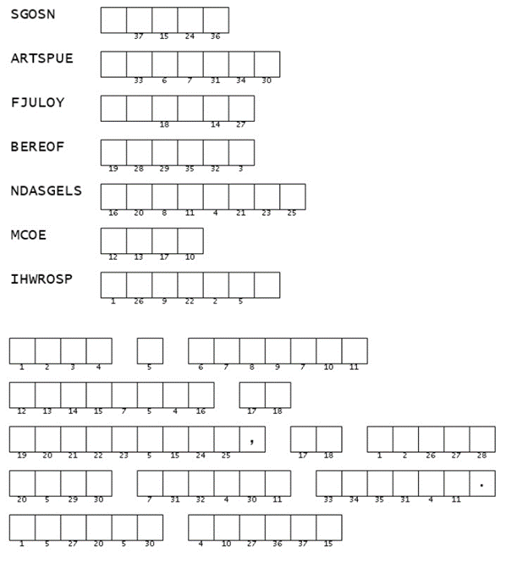
- Help others learn the joy of gathering together to worship God
Double Puzzle

Oh give me a home where the clue words are fixed, where the letters are lined up unmixed.
Then I’ll use the numbers in the statement below,
and the message is one you can know!
And if your brain gets stuck, you can go to https://tinyurl.com/2yk57hyn, where there’s other cool things you can do.

