1. Motivate

What are some good habits your parents sought to instill in you?
- personal quiet time
- dress nice
- don’t make gross noises
- study hard, do your homework
- don’t give up practicing your instrument
- honesty
- faithfulness in church attendance
- open the door for a lady
- give up your seat for a lady or someone elderly
- speak when spoken to

2. Transition

To say “Thank you” was, no doubt, one of the habits you learned.
- Today we consider that we have so much to thank God for.
A video introduction to the lesson is available. View it at https://tinyurl.com/ycx5hbpv If you have no wi-fi where you teach, best to download to your computer from https://tinyurl.com/y3r5nhmu
3. Bible Study

3.1 God’s Forgiveness

Listen for commitments to be made to God.

Psalm 65:1-4 (NIV) Praise awaits you, O God, in Zion; to you our vows will be fulfilled. 2 O you who hear prayer, to you all men will come. 3 When we were overwhelmed by sins, you forgave our transgressions. 4 Blessed are those you choose and bring near to live in your courts! We are filled with the good things of your house, of your holy temple.

What kind of commitments to God does David write about?
- commitment to praise God
- to fulfill our vows
- to pray to God
- to receive His forgiveness
- to come near to Him, to live in His courts, in His presence

Consider what God does with our sin:
- Removes our sins as far as the east is from the west
- Puts our sins “behind his back”
- Remembers them no more
- Casts our sins into the depth of the sea

If left on our own, what would our sins do to us? How would it overwhelm us?
- defeat,
- discourage
- enslave us
- give us the burden of guilt
- ultimately result in spiritual death – eternal separation from God

What kinds of iniquities do you think overwhelmed David, the author?
- different kinds of excesses
- his sin with Bathsheba
- his conspiring to commit murder on her husband
- the time he insisted on taking a census and God punish the whole nation

Why does sin (our iniquities) tend to overwhelm us?
- in the midst of the situation, it seems to control us
- afterward we feel great shame, anger at ourselves
- we feel (through Satan’s lies) that we might never be forgiven (by the victims of our sin, by God)

How does it feel when you are convinced of God’s (or someone else’s) forgiveness?
- like a load has been lifted
- feel clean
- feel renewed

How does praising God for His forgiveness change our lives?
- make us more aware of God’s love, God’s greatness, God’s authority
- cause us to look to Him more often, more regularly
- make us realize our own limitations and God’s unlimited abilities
- our faith is strengthened (more convinced of God’s power, authority)

How does the lack of praise for Him affect our lives?
- we focus on ourselves, on our problems
- we forget about God’s interest and ability in meeting our needs
- we lose our focus on God (like Peter who took His eyes off Jesus while walking on water)
- we are less at peace, more in turmoil
- our faith grows dim

What ways can we make thanks for God’s forgiveness part our holiday celebration?
- before/during/after the meal(s) read Psalms of praise
- make sure to spend time alone with God (in the midst of all the family gatherings)
- sing together as a family … have a family song time … involve everyone of every age … sing kid’s songs as well as Thanksgiving hymns as well as praise choruses

3.2 God’s Power and Authority

Listen for God’s greatness.

Psalm 65:5-8 (NIV) You answer us with awesome deeds of righteousness, O God our Savior, the hope of all the ends of the earth and of the farthest seas, 6 who formed the mountains by your power, having armed yourself with strength, 7 who stilled the roaring of the seas, the roaring of their waves, and the turmoil of the nations. 8 Those living far away fear your wonders; where morning dawns and evening fades you call forth songs of joy.

What word pictures does the writer use to describe of the greatness of God?
- ends of the earth
- distant seas
- mountains
- roar of the seas and waves
- outgoings of morning and evening

What examples of some of these things can you remember seeing?
- beautiful sunsets, sunrises
- majestic mountain scenery
- the beauty of the ocean (blues, emerald greens, crystal clear)
- the power of the waves (recall the movie/book The Perfect Storm)
- the power of hurricanes, blizzards, earthquakes
- the size of the Grand Canyon
- the marvels of Old Faithful in Yellowstone National Park
- fall foliage colors
- the renewal of each new season

How do these things cause us to praise the Lord?
- we see God’s creativity
- we enjoy the beauty of whom God is the author
- we are reminded of our own insignificance contrasted to God’s power demonstrated in nature
- too often we think our technology is so great … God regularly puts it to shame … all we can do is watch some of those weather events coming … we cannot stop them nor turn them aside
- we become more convinced of God’s authority which goes along with His power

David talks of God calming storms … Jesus did this … what kinds of “storms” in your life has God calmed?
- dealing with children (or parents)
- overcoming a debilitating habit
- going through loss of a loved one
- when you have no resources and God provides in a miraculous way
- dealing with neighborhood disputes
- dealing with a bad job situation
3.3 God’s Provision

Listen for how God provides.

Psalm 65:9-13 (NIV) You care for the land and water it; you enrich it abundantly. The streams of God are filled with water to provide the people with grain, for so you have ordained it. 10 You drench its furrows and level its ridges; you soften it with showers and bless its crops. 11 You crown the year with your bounty, and your carts overflow with abundance. 12 The grasslands of the desert overflow; the hills are clothed with gladness. 13 The meadows are covered with flocks and the valleys are mantled with grain; they shout for joy and sing.

What words and phrases in this passage describe God’s blessings?
- God provides rain for crops and fields
- provide grain/corn
- crowns the year with goodness/bounty
- causes grass to grow in the desert
- clothes the hills with gladness
- meadows covered with flocks
- valleys mantled with grain

If God brings rain to bless the earth, what does He bring to bless our lives?
- children, grandchildren, family
- shelter and food
- opportunities to serve Him
- safety in work, in travel
- health and healing
- the beauty of all that nature out there
- freedom to worship Him
- answers to prayers

Why do some people not see God’s bounty?
- looking in the wrong places
- not looking to God for their needs
- focused on material things, not spiritual issues

How does remembering God’s guidance and provision in the past encourage you for the future (or in times when you are experiencing famine, drought, or poverty)?
- when you come up against a problem, you remember what God did before
- God is just the same … only the problems are new to us
- God has handled this kind of thing before, He will do it again
- the more of these experiences of God’s provision and guidance you have, the more you are able to trust Him in the future
- God sees what is happening up ahead, He has prepared us for those events
- none of these things are surprises for God …
- His sufficiency knows no bounds
Use the last page as a handout so your learners can take home the application points of this week’s lesson.
Application
Personal reflection.
- Take some time to get specific about why you must be grateful.
- Evaluate the blessings you might often take for granted and thank God for them one by one.

Intentional encouragement.
- Some of the greatest gifts in our lives are the people with whom God has surrounded us.
- Prayerfully consider someone who could use encouragement.
- Go out of your way to tell them why you are thankful God has placed them in your life.

Family discussion.
- Amid all the holiday busyness, carve out time to list why your family should be thankful.
- Use this time as family, relatives, or friends have gathered to discuss the reasons we have to thank God.
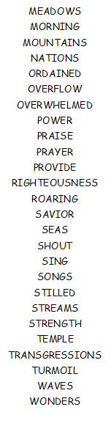
- Use this discussion to combat any endangering consumerism that tempts us during the holiday season.
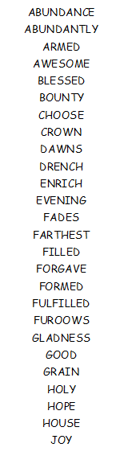
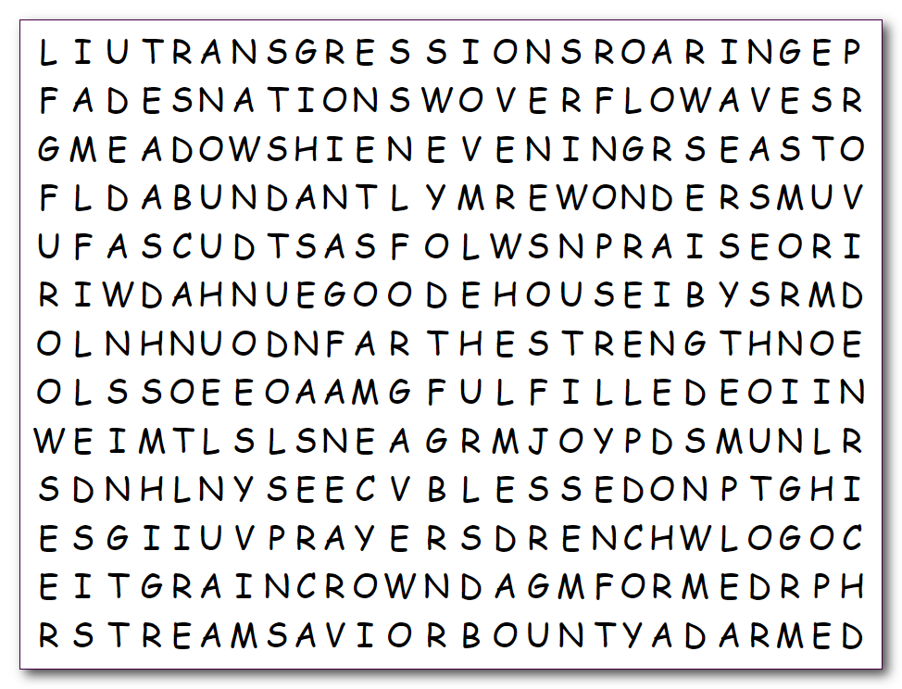
Word Search Puzzle
Humph! I hope you’re thankful for all that turkey you consumed and all that football you watched. Now find all those words from Psalms 65. That’s what thankfulness is. Just be thankful the words only go right, down, and diagonal, but not backwards! Does your Bible study leader have a prize for the person who finds the most words? If you wimp out there is help at https://tinyurl.com/y3r5nhmu The crossword and the color page are also there if you feel you must. Humph!

