1. Motivate

When have you wished you’d realized when someone was trying to get your attention or communicate with you?
- there was a phone call for me
- “XYZ” – eXamine Your Zipper
- food on my chin at a fancy dinner
- there was a good business opportunity available
- as a restaurant server, one of my tables needed attention
- I was in a queue and it had gone ahead without me
- my car was fixed and I could come and pick it up
- my kids needed me and I didn’t realize it
- I was supposed to call home and never got the message
- a close relative was near death and I was on the road
- they changed the time of my flight and I ended up missing it

2. Transition

Sometimes it is God who is trying to communicate with you.
- You want to be able to know what He is communicating.
- Today we consider the Truth of that the Holy Spirit will ensure God’s message is communicated.
A video introduction to the lesson is available. View it at https://tinyurl.com/44azuj9x . If you don’t have wi-fi where you teach, you must download the video file to your computer from https://tinyurl.com/3tpnttk5
3. Bible Study

3.1 God Works in Us What We Cannot Do

Listen for the source of God’s message.

1 Corinthians 2:6-8 (NIV) We do, however, speak a message of wisdom among the mature, but not the wisdom of this age or of the rulers of this age, who are coming to nothing. 7 No, we speak of God's secret wisdom, a wisdom that has been hidden and that God destined for our glory before time began. 8 None of the rulers of this age understood it, for if they had, they would not have crucified the Lord of glory.

How did Paul describe or define the substance of the message he and his coworkers preached in Corinth?
- a message of wisdom
- not from the world,
- not from the “rulers of this age” who are coming to nothing
- God’s secret message

What are some different kinds of “wisdom” of this age?
- academic wisdom – academic knowledge that can be applied to different areas of living
- educational wisdom – ability to teach
- financial wisdom – ability to manage money
- relational wisdom – ability to work with people
- scientific wisdom – understanding and application of scientific principles
- mechanical wisdom – good with cars and other mechanical devices
- modern tech wisdom – good with smart phones, computers, tablets, etc.

What truths or wisdom about God seem hard to believe for people in our culture? How is it mysterious?
- how much God loves them
- how simple the salvation message really is – “too simplistic”
- that submission and obedience to God is such a positive and joyful way of life, too many “don’ts”
- Jesus, the Son of God, the redemptive Person of God actually came to earth, lived as a Man
- the concept of Jesus’ dying in our place to make possible our forgiveness of sin

What did Paul mean in describing the wisdom of God as mystery?
- prophets of old didn’t really fully understand God’s plan of salvation
- unbelievers even today don’t understand what God is up to
- these were God’s plans and intentions, even before creation
- only in the redemptive work of Jesus Christ had God’s purposes become evident

So who originated the message Paul preached, and when?
- it was/is God’s message
- it originated before time began
- it was the Truth about God and His purposes and methods

God’s Spirit did not reveal this “mystery” to religious leaders of Jesus day, did not convict/convince them of this reality. Why not?
- they reject the Truth that Jesus spoke
- they did not respond in faith
- note that the disciples did respond in faith … recall the conversation
  - Jesus asks “Who do you say that I am?” and
Peter answers, “You are the Messiah …”
  - Jesus responds, “Blessed are you, Simon son of Jonah, for this was not revealed to you by flesh and blood, but by my Father in heaven.”
  - God the Father through the Spirit (who is God) had communicated to Peter

3.2 The Spirit Makes Known the Mind of God

Why are you sometimes able to almost “read the mind” of your spouse or your best friend? You can often predict what they will say, or both say the same thing together.
- You spend time with them
- you talk with them often
- you have seen them react to all kinds of situations

Listen for how you can know what God is thinking.

1 Corinthians 2:9-11 (NIV) However, as it is written: "No eye has seen, no ear has heard, no mind has conceived what God has prepared for those who love him"-- 10 but God has revealed it to us by his Spirit. The Spirit searches all things, even the deep things of God. 11 For who among men knows the thoughts of a man except the man's spirit within him? In the same way no one knows the thoughts of God except the Spirit of God

What do you think God has prepared for you that you can hardly imagine?
- what heaven is really like
- what we are going to do in heaven (or even the universe) for eternity?
- Jesus said in John 14 He was preparing “mansions” for us
- meeting believers from many peoples, from many centuries
- you read description of the heavenly city in Revelation … hard to picture it.

What is the essence of verse 9 and why is verse 10a essential to understanding Paul’s intent?
- on our own we cannot know all that God has for us
- our academic knowledge is not enough
- our skills, abilities, and modern wisdom are insufficient to realize God’s purposes in our lives
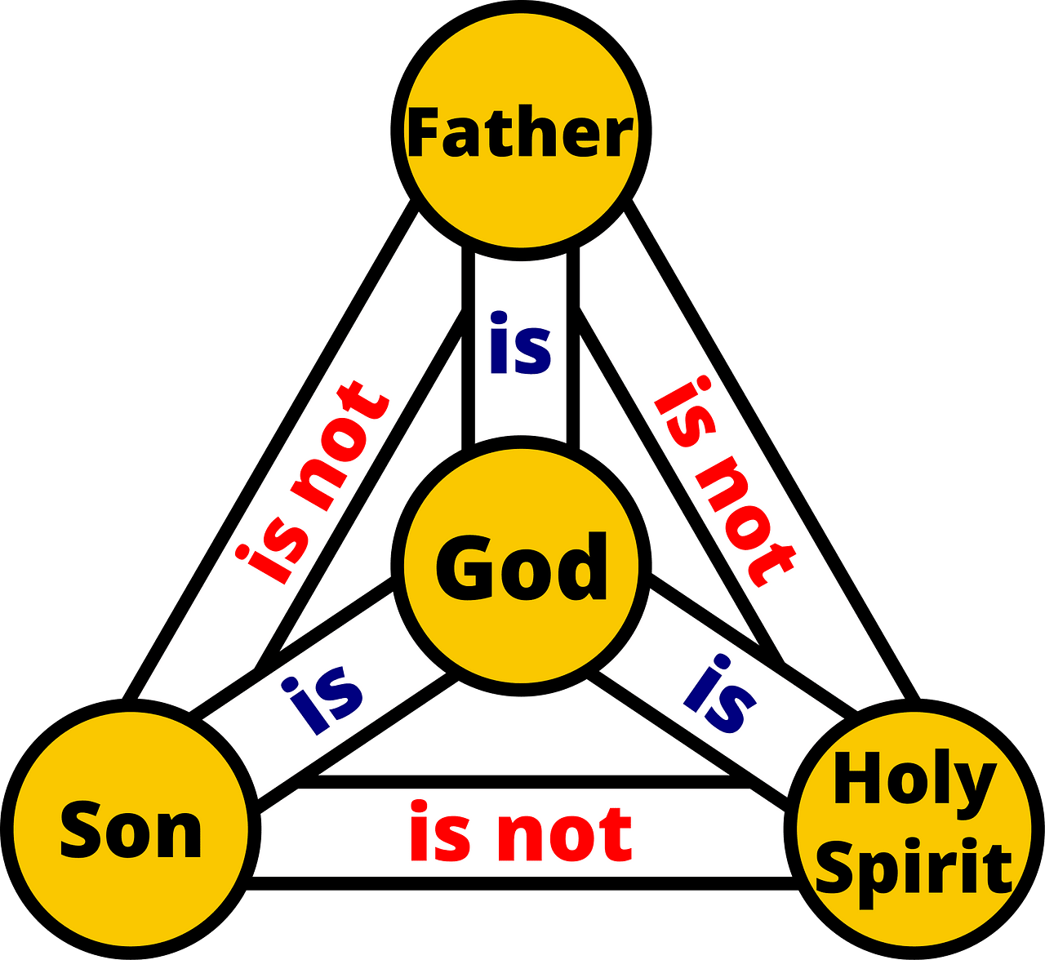
- we need the guidance of God, Himself, in the person of God’s Holy Spirit

Who enables us to know and understand what God reveals?
- the Spirit of Jesus Christ dwells within our hearts and minds
- He knows and understands all of God’s purposes and plans for our lives
- He communicates those things to us

Why is the Spirit capable of making known the things of God to us?
- The Holy Spirit is God – He loves us – He is powerful to work in our lives,
- He will impress upon our thoughts specific principles of Scripture we read or hear taught
- He plants specific thoughts and impressions in our minds and consciousness
- He guides us through the events and experiences of our lives – opening and closing doors of opportunity

How do we put ourselves in a position to receive Truth from God?
- spend time with Him, talk to Him, with Him
- read what He has to say … often
- pay attention in a Bible Study, during a sermon
3.3 The Spirit Helps Us Apply Scripture

Listen for a contrast, two kinds of people.

1 Corinthians 2:12-16 (NIV) We have not received the spirit of the world but the Spirit who is from God, that we may understand what God has freely given us. 13 This is what we speak, not in words taught us by human wisdom but in words taught by the Spirit, expressing spiritual truths in spiritual words. 14 The man without the Spirit does not accept the things that come from the Spirit of God, for they are foolishness to him, and he cannot understand them, because they are spiritually discerned. 15 The spiritual man makes judgments about all things, but he himself is not subject to any man's judgment: 16 "For who has known the mind of the Lord that he may instruct him?" But we have the mind of Christ.

How would you describe the “spirit of the world”?
- human understanding
- human pursuits
- humanistic world view – men/women are the deities of this world
- self-seeking

Note the characteristics of the wisdom that the Spirit teaches us.
- Spiritual Truth has its own vocabulary
- It is not human wisdom
- It is God’s wisdom
- It is not so much a case of the persuasion of logic or debate
- It is Truth that is revealed by God, that we accept by faith, because God said it

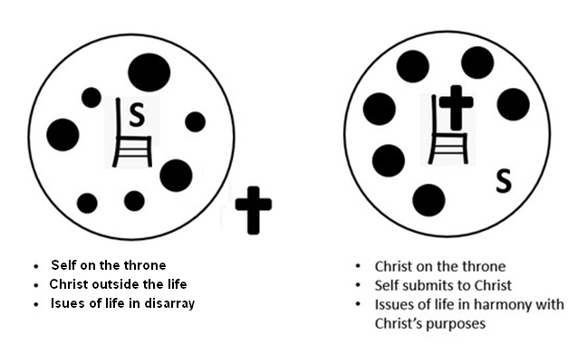
According to this passage, how are spiritual and unspiritual people different?
The “Natural” Man | The Spiritual Man
- not able to make valid judgments  - must rely on the judgments of other men (who themselves are fallible)  - do not have God’s mind or perspective | - makes judgments about all things  - not subject to man’s judgment  - we have the mind of Christ

- when you make decisions based on God’s commands, God’s Truth, God’s purposes
How can you know if you have the mind of Christ?
- when you make value judgements in line with Scripture
- when you have a sense of what God is doing in your life
- when you are able to calmly trust God in the midst of crises and turmoil of life
- your speech and your actions reflect the Fruit of the Spirit
Use the last page as a handout so your learners can take home the application points of this week’s lesson.

Application
View of God:
- Look over your checkbook and your calendar.
- Does your current sequence of choices reflect the wisdom of this world or the wisdom of God?

View of Self:
- The Holy Spirit gives you understanding through God’s Word.
- Do you allow Him to guide your application, or do you rush off on your own?
- Write down some specific things He is calling you to.

View of Others:
- What can you share with others about God’s activity in your life and what He may want to do in their lives?
- Schedule a coffee or lunch with someone God has placed on your heart this week and share what you’ve learned.



“Well hey there, Vern. You ain’t gonna believe what that fella did at the church. Climbed up on the sign to clean it—real proud of himself—then wham, knocked off half the alphabet. Letters fell straight down like hailstones, only now they’re all mixed up like a goat in a trampoline park. He’s standin’ there starin’ at ’em, tryin’ to sort out single letters, but once he hits two‑ and three‑letter words, he’s lost faster than a June bug in a jet engine. So we need you, buddy. Pastor’s gettin’ twitchy, folks are gatherin’, and that sign’s gotta make sense again. Know what I mean, Vern?” Oh … another thing … don’t tell, but there’s a cheat sheet found at https://tinyurl.com/3tpnttk5. Me, I’m gonna’ try the color page.
Fallen Phrases Puzzle

