1. Motivate

When have you really needed reliable instructions?
- getting to the airport on time
- putting together a new device
- installing a new program on my computer
- building a house
A video introduction to the lesson is available. View it at https://watch.liberty.edu/media/t/1_3ho65cmh If you don’t have wi-fi where you teach, you must download the video file to your computer from https://watch.liberty.edu/media/t/1_3ho65cmh
- filling out forms for the government
- doing IRS on April 14
- taking a test like the ACT or SAT
- cooking a certain recipe
- doing a science lab for school
- taking a new medicine
- applying for college
- finding a secret fishing hole
- finding my way to a location in a big city

2. Transition

Often in our lives we feel the need for important directions or instructions for our lives
- What college major, who to marry, what job to take, what house to buy, …
- Today we consider how God speaks to us through His Word.

3. Bible Study

3.1 God’s Word is Powerful

Listen for synonyms for the spoken/written word of God.

Psalm 19:7-9 (NIV) The law of the LORD is perfect, reviving the soul. The statutes of the LORD are trustworthy, making wise the simple. 8 The precepts of the LORD are right, giving joy to the heart. The commands of the LORD are radiant, giving light to the eyes. 9 The fear of the LORD is pure, enduring forever. The ordinances of the LORD are sure and altogether righteous.

So what synonyms do you see for God’s Word?

- law
- statutes
- commands
- ordinances

What adjectives or descriptive words did David use in talking about God’s Word?

- perfect
- trustworthy
- right
- radiant
- sure and righteous
- precious
- sweeter than honey

Why is this revelation from the Lord worthy of being studied and applied in our lives? What attitude did David have toward God’s law?
- it is perfect
- God’s statutes are trustworthy
- the ordinances of the Lord are sure, righteous
- more precious than pure Gold
- sweeter than honey

What effects can it have? What role did God’s law play in David’s life?
- revives the soul
- make us wise
- give joy to the heart
- give light to the eyes

Why do you think God has chosen to reveal His character and nature to us in His Word?
- it can be made available over centuries
- it can be published in any language
- any individual can now have their own copy of God’s messages – hard copy or digital
- (this is why Bible translation organizations work so diligently to publish the Bible in new languages)

How might God’s Word provide reliable guidance for your life? How have you experienced the benefits and blessings described in these verses?
- specific instruction on what was right or wrong
- a principle that I could apply to the situation I faced
- a promise to rely on in a time of questioning or indecision
- an example where someone in scripture faced a similar situation as mine and how they handled it right or wrong

What role can God’s Word play in your everyday life?
- builds a repository of God’s Truth in your thinking
- gives you a Biblical mindset
- gives the right insight, just when you need it, reassurance when you have problems
- is the correct substitute for the attitudes and actions of the secular world
- draws you closer to God – you are reading and thinking about His communications to you
- tell you what God requires
- tell you God’s provision
- tell you about who God is, what He is up to
- tell you what God has planned for the future
- reminder of Who is in charge
- convict/convince of things we am doing wrong
- give guidance about what choices to make

3.2 God’s Word Brings Pleasure, Warning

Listen for two metaphors.

Psalm 19:10-11 (NIV) They are more precious than gold, than much pure gold; they are sweeter than honey, than honey from the comb. 11 By them is your servant warned; in keeping them there is great reward.

The two metaphors suggest that God’s Word is like sweet honey and pure gold. How does each apply?
Honey | Pure Gold
- sweet to partake of  - readily available  - has healing properties | - has value  - good to look at  - easily worked into beautiful objects

What promises are associated with keeping the Word of God?
- it gives you warnings
- you are rewarded when you keep the Word of God

What kind of warnings does God give us in His Word?
- results of sin
- beware of false teachings … stick to God’s Word
- specific attitudes and actions to avoid

So what rewards come to you as you keep God’s Word?
- initially, salvation
- we find God keeps His promises
- we find encouragement
- we find direction
- wisdom, insight

What steps could you take to be more open to the sweetness and high value of God’s Word?
- first of all, read it daily
- stop and think about what you are reading
- take notes about what it says, what it means, what you will do as a result of its message
- ask God to help you understand, to apply
- share with someone what you have read

3.3 God’s Word Convicts and Guides

Listen for David’s confession.

Psalm 19:12-14 (NIV) Who can discern his errors? Forgive my hidden faults. 13 Keep your servant also from willful sins; may they not rule over me. Then will I be blameless, innocent of great transgression. 14 May the words of my mouth and the meditation of my heart be pleasing in your sight, O LORD, my Rock and my Redeemer.
What commitment and confession does the psalmist make in concluding the psalm?
- hidden sins
- willful sins
- may they not rule/control me

What does the psalmist (and we) need the Lord to do in relationship to his (our) sin?
- forgive
- reveal sins that we are not yet aware of (hidden sins)
- keep from willful sins
- keep sin from ruling over us
- make him/us blameless, innocent of great transgression
- cause what we say and think be pleasing to God

What results from reading and applying or keeping God’s laws?
- we are warned
- we are rewarded
- we can be forgiven
- enable us to please the Lord in thoughts and words

How is Scripture effective in keeping us from hidden faults and willful sins?
- we can know God’s desires for us
- we are convicted/convinced of our sinful attitudes and actions
- we learn what is right and wrong
- we learn of the power of God at work in our lives
- we realize that both our initial salvation and an ongoing life of righteousness are dependent on God
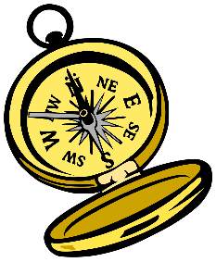
- we learn that both positional and experiential holiness and righteousness are what God has done and is doing

What facts do you know about a compass (not the device used in school for drawing circles)?
- needle points to the north
- no matter where you go, it always points to north (exception in northern polar regions, magnetic north can be off from true north)
- can help you keep a true course

How does the Bible, God’s Word act in a similar fashion?
- always gives us God’s Truth
- no matter what the culture is, it applies
- the Bible is always reliable
- it doesn’t change
- it always points you in the right direction
Use the last page as a handout so your learners can take home the application points of this week’s lesson.


Application
View of God:
- What Scripture verses has God used in your life to clearly demonstrate His will and His ways?
- Write these things down in a journal.
- What major adjustments need to happen so you can join Him in His agenda?

View of Self:
- What passage of Scripture has God used to get your attention about your heart and your lifestyle?
- Write these things down in a journal.
- How has that impacted the way you are now living?

View of Others:
- Gather with a few fellow Christians.
- What common themes emerge from your study of God’s Word?
- Is there a common application that can inform group action?

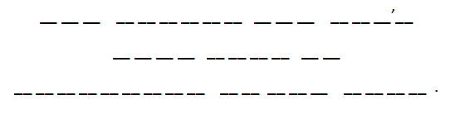

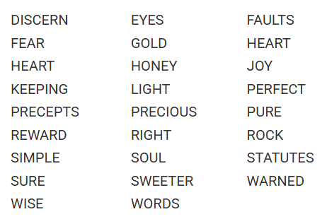
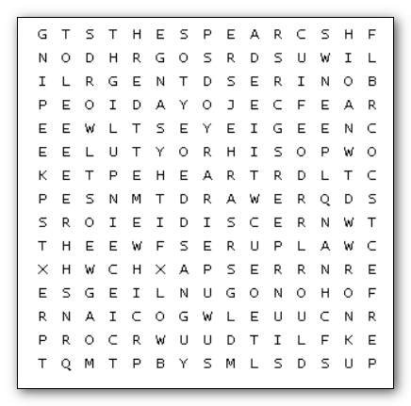
- If so, encourage one another in this journey.
Somewhere within this innocent-looking word search lies a message—one meant to edify, to encourage, perhaps even to strengthen the soul. But evil Dr. Dufus has other ideas. He has hidden that message among the letters, challenging you to find it before it disappears into the shadows. Begin by finding every word in the list. They may run in any direction. But when every word has been found, a final mystery remains. Starting in the upper-left corner and going across, copy down every letter that has been left unused. One by one, they will reveal the message. A message that was meant for you.
A message hidden by Dr. Dufus ... in The Twilight Zone. He is not aware of the assistance (and other Fun Family Activities) available at https://tinyurl.com/5fjbb5mr
Hidden Message Word Search

