1. Motivate

When someone says “God is speaking,” what do you imagine that might look or sound like?
- God would always speak in a deep voice
- if it was in English, it would probably be a British accent
- a verse in the Bible jumps out and seems to slap you in the face
- you get a feeling like a punch in the gut or a bonk on the head
- Elijah heard from God in a still small voice
- an event seems to dawn on you that this is significant in its spiritual meaning
- sometimes in a church service when God seems to be moving in many people’s lives all at once – a revival

2. Transition
A video introduction to the lesson is available. View it at https://tinyurl.com/ybabzsjp If you don’t have wi-fi where you teach, you will need to download the video file to your computer from https://tinyurl.com/mw8k5mxp

God does not ignore us …
- He loves us enough to speak to us.
- He wants to communicate.

3. Bible Study

3.1 God Takes the Initiative

Listen for a fire alarm.

Exodus 3:1-6 (NIV) Now Moses was tending the flock of Jethro his father-in-law, the priest of Midian, and he led the flock to the far side of the desert and came to Horeb, the mountain of God. 2 There the angel of the LORD appeared to him in flames of fire from within a bush. Moses saw that though the bush was on fire it did not burn up. 3 So Moses thought, "I will go over and see this strange sight--why the bush does not burn up." 4 When the LORD saw that he had gone over to look, God called to him from within the bush, "Moses! Moses!" And Moses said, "Here I am." 5 "Do not come any closer," God said. "Take off your sandals, for the place where you are standing is holy ground." 6 Then he said, "I am the God of your father, the God of Abraham, the God of Isaac and the God of Jacob." At this, Moses hid his face, because he was afraid to look at God.

Recall Moses’ history up to now:
- Raised as son of Pharaoh’s daughter
- In defending a fellow Israelite he commits 2nd degree murder against an Egyptian
- Fearing arrest, he flees to Midian, lives there 40 years, marries daughter of a priest
- Works as a shepherd

Where and how does God miraculously appear to Moses?
- far side of the desert, Horeb
- the angel of the Lord (actually this is God, a theophany)
- appeared in flames of fire from within a bush
- bush on fire, but does not burn up
Moses is told to remove his sandals … “this is holy ground”. What does holy mean in reference to God?
- God is separate from us
- He is unique … nothing, no one is his equal
- He is distinctly different
- He is omnipotent, omniscient, omnipresent, eternal … we are none of those things

What does it say about a holy God that He chose to speak to Moses while he was tending sheep in the wilderness?
- God speaks to us where we are
- He communicates with people however they are (good, bad, ugly, cute, smart, ignorant, whatever …)
- the mighty Creator God wants to communicate with us (in both directions)

The story seems to show that God came looking for Moses rather than Moses looking for God. In what ways does God reveal Himself to us to get our attention (other than burning bushes)?
- a sequence of circumstances or events
- life changing events (illness, loss of a loved one, job loss, etc.)
- through the preaching or teaching or study of God’s Word
- something someone (even a child) says that catches our attention and speaks especially to us

What are some things which distract us from hearing what God has to say?
- busy on our phones
- busy with our jobs, our hobbies
- focused on human relationships
- not “tuned in” to God … don’t want to hear from God

What can we do to make sure we are hearing God, even with all the distractions around us?
- be sure to set aside a time to read and meditate on God’s Word
- set aside some of your habits which get in the way of spending time with God
- find a quiet place to read and pray
- faithfully attend church and group Bible studies where you can hear God’s word preached and shared

3.2 Listen when God Speaks

Listen for excuses.

Exodus 3:11-15 (NIV) But Moses said to God, "Who am I, that I should go to Pharaoh and bring the Israelites out of Egypt?" 12 And God said, "I will be with you. And this will be the sign to you that it is I who have sent you: When you have brought the people out of Egypt, you will worship God on this mountain." 13 Moses said to God, "Suppose I go to the Israelites and say to them, 'The God of your fathers has sent me to you,' and they ask me, 'What is his name?' Then what shall I tell them?" 14 God said to Moses, "I AM WHO I AM. This is what you are to say to the Israelites: 'I AM has sent me to you.'" 15 God also said to Moses, "Say to the Israelites, 'The LORD, the God of your fathers--the God of Abraham, the God of Isaac and the God of Jacob--has sent me to you.' This is my name forever, the name by which I am to be remembered from generation to generation.

What was the first question Moses raised with the Lord in response to God’s call?
- who am I to confront Pharaoh?
- how can I bring the Israelites out of Egypt

How did God answer him?
- I will be with you
- here’s a sign to assure you … you will worship God right here on this mountain

What was the second question Moses asked?
- What happens when I go to the people?
- Whom do I say sent me to this task?

How does God identify Himself to Moses, what name does He tell Moses to give? How is the name God uses significant?
- I am Who I am
- the “I am” has sent me
- remind your people that I am the God of your fathers – Abraham, Isaac, Jacob
- “The God Who IS”
- (contrasted with those deities who are not – who are not God – who do not care for you)

How did God reassure Moses that he could face his challenge?
- I will be with you
- I’m telling you this is the very place where you will bring the people to worship me

How can we know that God is there communicating to us, even if we don’t sense it or “feel” his presence?
- scripture assures us off God’s presence
- God promises to be with us
- the Spirit of God dwells within the believer … empowers us for service

How does God identify Himself to Moses, what name does He tell Moses to give? How is the name God uses significant?
- I am Who I am
- the “I am” has sent me
- remind your people that I am the God of your fathers – Abraham, Isaac, Jacob
- “The God Who IS”
- (contrasted with those deities who are not – who are not real – who do not exist)

- When The God WHO IS speaks – pay attention!

3.3 Believe and Obey God

Listen for God’s message communicated.

Exodus 4:28-31 (NIV) Then Moses told Aaron everything the LORD had sent him to say, and also about all the miraculous signs he had commanded him to perform. 29 Moses and Aaron brought together all the elders of the Israelites, 30 and Aaron told them everything the LORD had said to Moses. He also performed the signs before the people, 31 and they believed. And when they heard that the LORD was concerned about them and had seen their misery, they bowed down and worshiped.

How did Aaron find out what God was doing?
- God told him to go find Moses
- Moses told him all God had said, including impending miracles

What did Aaron and Moses communicate to the Israelite leadership
- all that God had told Moses
- demonstrated miracles and signs

What was the response of the people?
- they believed what they had been told
- they bowed down before God
- they worshiped God

How did this show that God speaks to comfort and encourage His people?
- they heard God was concerned about them
- realized God was aware of their misery
- God was at work,
- He had plans in motion to rescue them

How does worship express your confidence to God of His promises?
- worship is declaring God’s worth
- you have no confidence in something or someone with no worth
- worship and praise is often the specific declaration (in song or in prose) of that very confidence

How does recalling God’s faithfulness to us inspire us to continue to listen to and obey Him?
- if God did it before, He can do it again
- God is the same yesterday, today, and forever
- we respond to His power and authority with love and dedication
- we are encouraged to believe Him for the new situation
- we keep our eyes on Jesus, and not on the problem (remember Peter’s short walk on the water)
Use the last page as a handout so your learners can take home the application points of this week’s lesson.

Application
View of God:
- Reflect on a time when you sensed God speaking.
- What did that moment reveal about His character, His purposes, or His presence?
- Write down what you learned about who God is.

View of Self:
- Trace a sequence of choices you made in response to God.
- How did your choices shape you?
- What do they reveal about how you see yourself?

View of Others:
- Meet with a friend willing to share how God worked in his or her life.
- Consider: What does their story reveal about how God works?
Double Puzzle
Clue words taken from Exodus 3:1-6, 11-15; 4:28-31 (NIV)


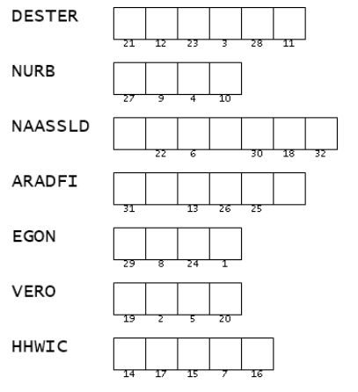
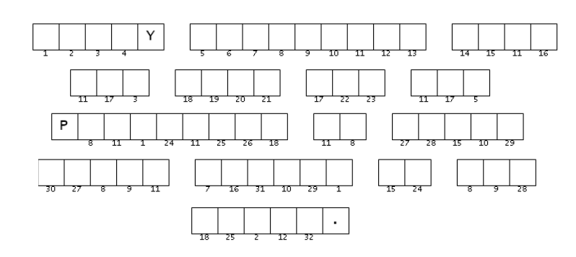
Got a real brain‑twister for ya. It starts with some clue words from your Scripture—only they ain’t clues till you unscramble ’em, and they ain’t unscrambled till you figure out what they mean. Then you take the numbers and decode the secret message with ’em. It’s kinda like gettin’ signs from the third‑base coach: you don’t know what’s goin’ on, but somehow it makes sense when you get there. Coaching and more family workout activities are found at https://tinyurl.com/mw8k5mxp
Yogi Berra

