1. Motivate
Sure, I believe in God. But actually, all religions lead to the same God

A person comes to your Bible study and says …

2. Transition

We consider tools that help you show that gods worshiped by the world religions are very different.
- Your friend should be interested in deciding which is the true God

3. Bible Study

3.1 Polytheism is the Belief in Many Gods

Some definitions:
- Polytheism – many gods
- Pantheism – like the “Force” in Star Wars. “all is in god and god is in all”
- Monotheism – one God

Contrasting Christianity and Polytheism

The Oneness of God vs. Many Gods
Christianity | Polytheism
- Monotheism – One true God  - Eternal  - Sovereign  - Unchanging | - Multiple gods,  - Often limited in power,  - Conflicting,  - Subject to change.

Deuteronomy 6:4 – “Hear, O Israel: The LORD our God, the LORD is one.”
Isaiah 45:5-6 – “I am the LORD, and there is no other; besides me, there is no God.”
1 Corinthians 8:5-6 – “For although there may be so-called gods in heaven or on earth… yet for us there is one God, the Father…”

God as Creator vs. Created Gods
Christianity | Polytheism
- Jehovah God is uncreated  - Eternal  - Creator of all things | - Part of the created world, or  - Emerged from chaos

Genesis 1:1 – “In the beginning, God created the heavens and the earth.”
Isaiah 44:24 – “I am the LORD, who made all things, who alone stretched out the heavens.”

God’s Moral Perfection vs. Immoral, Flawed Gods
Christianity | Polytheism
- Jehovah God is Perfect  - Holy – unique, distinct, totally different  - Just  - Righteous | - Deities often behave immorally  - Lying  - Stealing  - Adultery  - Jealousy

Leviticus 19:2 – “Be holy, because I, the LORD your God, am holy.”
Psalm 99:9 – “Exalt the LORD our God, and worship at his holy mountain; for the LORD our God is holy.”

One True Source of Salvation vs. Human Works to Appease Many Gods
Christianity | Polytheism
Salvation by God’s grace  Through faith in Christ’s substitutionary death | Requires endless rituals  Sacrifices  Offerings to please different deities

Ephesians 2:8-9 – “For by grace you have been saved through faith… not a result of works.”
John 14:6 – “I am the way, and the truth, and the life. No one comes to the Father except through me.”

A Personal Relationship with God vs. Distant or Impersonal Gods
Christianity | Polytheism
- Personal relationship with God  - God loves them  - God is near to them | - Deities are distant  - Arbitrary  - Require manipulation through sacrifices

Jeremiah 29:12-13 – “Then you will call upon me and come and pray to me, and I will hear you.”
Romans 8:15 – “You have received the Spirit of adoption as sons, by whom we cry, ‘Abba! Father!’”

3.2 Pantheism Believes God and Creation Are Not Separate

God is distinct from His Creation

Genesis 1:1“In the beginning, God created the heavens and the earth.”
Isaiah 42:8 – “I am the Lord; that is my name! I will not yield my glory to another or my praise to idols

How do these verses tell us about how God’s distinctiveness?
- He is the Creator
- He has always been, was not created
- He is Jehovah, the God Who IS
- He does not share His glory with any created or imagined thing

Creation Declares God’s Glory but Is Not God

Psalm 19:1 – “The heavens declare the glory of God; the skies proclaim the work of his hands.”
Romans 1:20 – “For since the creation of the world God’s invisible qualities—his eternal power and divine nature—have been clearly seen, being understood from what has been made, so that people are without excuse.”

How do these verses tell us that nature itself is not God
- they show His glory
- they describe to us His creativity
- we can see the results of His power
- they display His divine nature, but are not that divinity
- they help us understand about God
- While nature reflects God’s power and beauty, it is not divine itself.

God Is Personal, Not an Impersonal Force

Jeremiah 10:10 – “But the Lord is the true God; he is the living God, the eternal King.”
Isaiah 46:9 – “I am God, and there is no other; I am God, and there is none like me.”

How do these verses explain that God is not an impersonal divine essence within all things.
- He is living, eternal
- there is no other who is the supreme power and authority
- there is no one, nothing like Him
- He is not an impersonal divine essence within all things,
- He is a personal being who speaks, loves, and relates to His creation.

Conclusion: The One True God vs. Pantheism
- The Bible clearly teaches that Jehovah God is separate from His creation, and creation exists to glorify Him—not to be identified as Him.
- Worshiping nature or believing that everything is divine contradicts the biblical teaching that God alone is to be worshiped.
- While God is present everywhere (His omnipresence), that does not mean He is everything.

3.3 Monotheism Is the Belief In One God.

- Christianity and Islam are the only monotheistic world religions
- Here are some key differences between Christianity and Islam, along with Scripture passages that affirm the truth of Christianity:

Christianity | Islam
- Trinity – Father, Son, Holy Spirit  - Jesus is the Son of God – fully divine, fully human, lived, died, was risen from the grave  - Salvation by grace through faith in Jesus work of redemption  - Jesus death on the cross atoned for sin  - His resurrection guarantees eternal life  - God is a loving Father, desires a personal relationship with His children | - Allah is absolutely one, Trinity rejected  - Jesus is merely a prophet, did not die on the cross  - Salvation by deeds outweighing sins and Allah’s mercy  - Jesus not crucified, someone else made to look like Him, He was take up to heaven  - Allah is beyond, above, and independent of the material world and human comprehension – unknowable

Ephesians 2:8-9 – “For it is by grace you have been saved, through faith—and this is not from yourselves, it is the gift of God—not by works, so that no one can boast.”
Titus 3:5 – “He saved us, not because of righteous things we had done, but because of his mercy.”

What important truths do these verses tell us about salvation in Christianity?
- Good works do not secure salvation—
- only God’s mercy does.
- Salvation is a free gift,
- not something earned.

1 Corinthians 15:3-4 – “For what I received I passed on to you as of first importance: that Christ died for our sins according to the Scriptures, that he was buried, that he was raised on the third day according to the Scriptures.”
Romans 10:9 – “If you declare with your mouth, ‘Jesus is Lord,’ and believe in your heart that God raised him from the dead, you will be saved.”

What important truths do these verses tell us about the resurrection?
- The resurrection is essential for salvation.
- The death and resurrection of Jesus are foundational truths.
- God raised him from the dead,
- this is how you will be saved.”

Romans 8:15 – “The Spirit you received does not make you slaves, so that you live in fear again; rather, the Spirit you received brought about your adoption to sonship. And by him we cry, ‘Abba, Father.’”
John 17:3 – “Now this is eternal life: that they know you, the only true God, and Jesus Christ, whom you have sent.”

What do these verses tell us about a personal relationship with The Creator God?
- Through Jesus, believers have an intimate relationship with God as Father.
- can be compared to the child-father relationship where we address our earthly father as “Daddy” or “Poppa”
- we are adopted into His family (think about all the cultures, all the denominations, all the Bible characters, all the languages, all the believers through the ages)
- Eternal life is knowing God personally through Jesus.

Application
- List names of people you know who belong to a religion other than Christianity.
- Think about how you might respond to their questions about Christianity and study those topics to be prepared to converse with them.
- Consider what questions you might ask them and how the articulation of their beliefs could provide opportunities for further discussion.
- Pray about starting spiritual conversations with them and follow the Holy Spirit's guidance.
Word Search

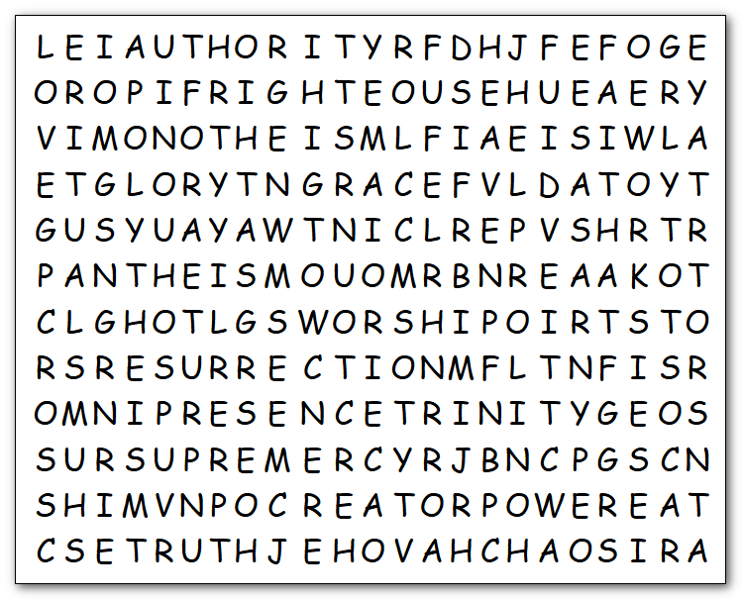
I would say, “May the Force be with you.” but we’re not pantheists. Neither am I omnipresent, but I will know if you found these words. If not … Humph! … you’ll owe me a book report. Good luck … there’s no key posted on the web site.
ARBITRARY
AUTHORITY
BELIEF
CHAOS
CHRISTIANITY
CREATOR
CROSS
DEEDS
FAITH
GLORY
GRACE
HEAVEN
HOLY
JEHOVAH
JUST
LOVE
MERCY
MONOTHEISM
OFFERINGS
OMNIPRESENCE
PANTHEISM
PERFECT
PERSONAL
POLYTHEISM
POWER
RESURRECTION
RIGHTEOUS
RITUALS
SACRIFICES
SALVATION
SUPREME
TRINITY
TRUTH
WORKS
WORSHIP

