**1. Motivate**

Your high school daughter tells you that a teacher told her he isn't a Christian because of all the errors and contradictions in the Bible. How can we believe the Bible is true when there are so many contradictions?

**2. Transition**

This lesson will help you work through this objection with her to bolster her confidence in the Bible as God's Word.

**3. Bible Study**

3.1 Different Accounts of Biblical Events Don't Contradict One Another.

Skeptics and humanists claim:

* Logically, if two statements are contradictory, at least one of them is false.
* The biblical contradictions therefore prove that the book has many false statements and is not infallible

Sample (so-called) Contradictions

Creation

|  |  |
| --- | --- |
| Genesis 1 | Genesis 2 |
| * First man and woman created at same time * Created after the animals | * Different order – first man * Then the animals * Then woman |

The Resurrection

* Mark 16:2 women arrive **at rising of the sun**
* John 20:1 women arrive when **still dark**
* Luke 24:2 tomb **open** when women arrive
* Matt 28:1,2 tomb **closed** when women arrive
* Mark 16:5 woman saw a **young man**
* Luke 24:4 women saw **two men**
* Matt 28:2 women saw **an angel**
* John 20:11,12 women saw **two angels**

Judas and the 30 pieces of silver

|  |  |
| --- | --- |
| Matt 27:5 | Acts 1:18 |
| * Judas took the money * Threw it down in temple * Went and hanged himself | * Judas used the money * Purchased a field * Fell headlong, he burst |

Explanations:

Precision

Truth

Consider that “precision” and “truth” overlap in meaning

* But are not synonymous
* Certain amount of precision required for truth
* Degree of precision varies by context

When reading scripture important to know

* Language
* Culture of the people

We will say

* Inerrant language makes good on its claims
* The Bible makes good on its claims to proclaim truth

Considering the events following Judas’ betrayal:

Matthew wrote to the Jews

* Focused on involvement of the Jewish leaders
* They didn’t want to *keep* his “tainted money”
* They let it be the money that bought the field

In Acts Luke records a summary of events

* Prefaced the record of choosing a replacement for Judas
* Funds provided by Judas used to buy the field
* Attributes the purchase to Judas

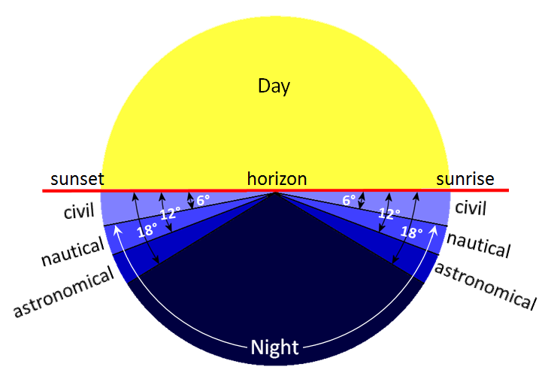

Considering the events at the empty tomb:

Different numbers and appearances of angels at the tomb:

* Where there are two, there is always one
* Some gospels focus on the single angel that spoke

Different amounts of light – “dark” versus “at sunrise”

* Sunrise can include times when it still dark
* Note National Weather Service definitions of “twilight”

Tomb open or closed?

Matthew writes about when the women started on that Sunday morning

* Describes *how* the tomb was opened
* Doesn’t specify they arrived *before* it was opened

Luke’s account

* Clarifies that the angel opened the tomb
* Before the women arrived



3.2 Imprecise Numbers, Quotes, Etc., Are Not Biblical Errors

Claimed contradiction concerning the Mount of Transfiguration

* Matthew and Mark state this occurred six days after Jesus had told the disciples some of them would see “the kingdom of God come in power”
* Luke states the time was “about 8 days” after the same conversation

Luke’s approximation includes Matthew’s and Mark’s precise number.

* Occasionally a general truth is mentioned without citing a specific text

What about pi = 3?

* 1 Kings 7:23 – Describes a circular object 10 cubits across and 30 cubits around. Skeptical claim: This implies pi = 3, which is mathematically incorrect.
* Christian response:
* The text is using rounded numbers, which was common in ancient descriptions.
* The actual inner diameter may have been 10 cubits and the outer circumference 30 cubits, accounting for thickness.
* Not intended to be a math textbook—just a descriptive approximation.
* Such examples are often cited to question the inerrancy of Scripture, but most have reasonable explanations:
* Round numbers were common and culturally accepted.
* Copyist errors can happen in transmission but are rare and identifiable.
* Different counting methods or inclusion/exclusion of groups explain many variations.

3.3 Scribal Errors and Mistranslations Were Not in the Original Documents and Do Not Affect the Truth Being Communicated.

Skeptics bring up differences in numbers found in some English translations.

* Claim these are “errors” that disprove the inerrancy of Scripture

Example

* 1 Kings 4:26 indicates Solomon had **40,000** stalls for his horses
* 2 Chronicles 9:25 reports this number as **4,000** stalls

Perhaps both were true …

* neither account specifies where the stalls were located
* 2 Chronicles could have counted the stalls in Jerusalem
* 1 Kings included stalls in the storage cities for his chariots and the cities for his horsemen

Also …

* Hebrew word for the number 40 (rbym) and the number 4 (rbh) are very close
* manuscript being copied may not have been clear
* Without definitive proof of one number being correct and the other incorrect, the scribes faithfully made their copies

Conclusion: In any event, the truth of the text is properly conveyed: Solomon was wealthy and had many horses.

Sometimes, we see differences in the text due to improper translation.

* differences were not in the original language and manuscripts
* increased understanding of the ancient languages has resulted in the enhanced translations we have now

Example in King James Version

* 2 Kings 8:26 records that Ahaziah was **22** when he began his reign in Judah
* 2 Chronicles 22:2 states that he was **42** when he assumed the throne

This is a case of mistranslation

* 2 Kings 8:16-25 states that his father Jehoram was 32 when he became king of Judah.
* Jehoram reigned for 8 years between the 5th and 12th years of the Northern Kingdom king's reign
* Thus Ahaziah had to have been 22, not 42

Subsequent translations of the Hebrew have corrected this passage

* Christian Standard Bible
* Amplified Bible
* New International Version
* New American Standard Bible … and others

Overall conclusions:

* Most of the so called “errors” are merely variant readings
  + Grammatical – spelling, punctuation
* These variant readings are spread throughout more than 5300 manuscripts
* Skeptics claim a variant spelling of one letter in 1 word in 1 verse in 2000 manuscripts is counted as 2000 errors

Bible scholars estimate only 1 in 60 variants have significance

* out of 150,000 so called errors, only 400 change the meaning of the passage
* only 50 were of real significance
* **not even one** affected basic Christian belief

Application

Formulate a plan to handle situations when you are asked about a biblical "difficulty."

What opportunity would you see?

What tone of voice would you use?

Fallen Phrase Puzzle

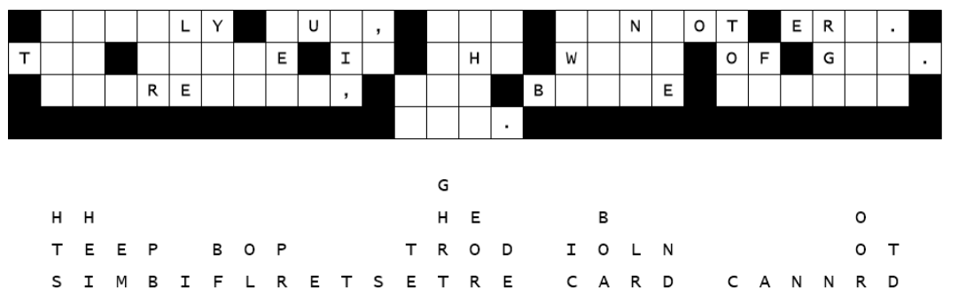

Yikes! What a storm … it blew a bunch of the letters off of our church sign. Help us put them back. They fell straight down so that should make it easier. Start with the columns where just one letter fell. Then work on the two and three letter words to find which letters make a reasonable word. When you finish, let your maintenance staff know the quote so they could use it too.