1. Motivate

What was a time when your plans failed to live up to your intent?
- rained the whole vacation
- kid’s birthday party turned into chaos
- wanted to take a college course, but it was too hard, required more time than I had
- started an exercise regimen but couldn’t keep up
- wanted to learn to play an instrument, but gave up after discouraging results
- tried to wallpaper a room … what a mess

2. Transition

Some of those failed plans we could fix, some we could not
Today we look at God’s original plan in designing men and women.
We want to discover how God fixed sin’s destruction
A video introduction to the lesson is available. Watch it at https://tinyurl.com/2rtny2kt If you have no wi-fi where you teach, it is best to download the video file to your computer from https://tinyurl.com/334vejue
3. Bible Study

3.1 Be Fruitful and Steward God’s Creation

Listen for God’s blessing.

Genesis 1:26-30 (NIV) Then God said, "Let us make man in our image, in our likeness, and let them rule over the fish of the sea and the birds of the air, over the livestock, over all the earth, and over all the creatures that move along the ground." 27 So God created man in his own image, in the image of God he created him; male and female he created them. 28 God blessed them and said to them, "Be fruitful and increase in number; fill the earth and subdue it. Rule over the fish of the sea and the birds of the air and over every living creature that moves on the ground." 29 Then God said, "I give you every seed-bearing plant on the face of the whole earth and every tree that has fruit with seed in it. They will be yours for food. 30 And to all the beasts of the earth and all the birds of the air and all the creatures that move on the ground--everything that has the breath of life in it--I give every green plant for food." And it was so.

What do the verses say about how God created man?
- let us make man in our image
- in our likeness
- let them rule over fish, birds, livestock
- let them rule over all the earth, over all creatures
- male and female

What is different about the creation of man and the creation of the other creatures?
- man has rule over the other creatures
- there is no mention of male and female animals, just of man and woman

What do you think it means when you read that you are made “in the image of God”?
- it doesn’t mean you are a God
- think snapshot or facsimile of God
- we occupy a higher place in the created order
- godliness is the path to greatest fulfillment
- you are creative because God is creative
- you are spiritual because God is Spirit
- you communicate because God communicates
- we have intelligence, emotions, a will
- since God is relational or social, so are you
- you are morally responsible because God is a moral being
- consider that when a child is conceived, we participate with God in bringing a soul into existence that did not exist before
- our sperm and egg unite and a physical being is created from that union, but the personality, the soul, comes into being at that conception

According to these verses, how does humankind fit into God’s plan and purpose for His creation?
- we rule over and manage the rest of God’s creation around us
- we work with the natural resources in order to provide for our lives
- we have created (innovated) an infrastructure to make our lives more convenient

What evidence do you see in this passage that God places high value on us?
- we are made in His likeness
- He gave us important responsibilities
- He gave us the capabilities to carry out those responsibilities
- He was willing to give of Himself to rescue us from sin’s penalty and power

We can celebrate the blessing of being made in God’s image!
- Since you are made like Him, show a “family resemblance”
- Submit to His Lordship
- Worship Him, praise Him
- Share who Jesus is with others around you … like showing family pictures

3.2 Be Obedient and Loyal

Listen for restrictions God gives.

Genesis 2:16-17 (NIV) And the LORD God commanded the man, "You are free to eat from any tree in the garden; 17 but you must not eat from the tree of the knowledge of good and evil, for when you eat of it you will surely die."

What freedoms did God give Adam and Eve?
- freedom to work and take care of the garden
- could eat from any tree in the garden … except … “tree of the knowledge of good and evil”

Consider the concept of the “knowledge of good and evil” that God would forbid partaking of it.
- This was a direct violation of God’s command, rebellion against God’s authority
- By eating the fruit, they sought to become like God, knowing good and evil independently of God
- They were rejecting their dependence on God
- They were attempting to usurp God’s unique role as the moral arbiter
- This was a breaking of the trust relationship between humans and God

Why are we attracted to do what God has forbidden?
- like a “wet paint” sign … we want to see if it truly something to be avoided
- we lack faith/trust in what God has commanded for our good that we obey Him
- Satan challenges us, just like he tempted Adam and Eve
- God has given us a free will, we can choose to obey or disobey … at times we just want to exercise that choice to disobey to show we can …
- the “you can’t tell me what to do” attitude demonstrated by a child in the “terrible two’s”

How do you understand death in the warning against disobedience?
- it may have been that God intended that physical death would not have been their (and our) experience
- it certainly meant that spiritual death happened
- sin separated Adam and Eve (and us) from God

How are God’s restrictions actually indications of His blessings?
- He sets limits to keep us from harming ourselves
- He knows what is best for us and specifies actions and attitudes that will bless us
- It’s like an owner’s manual … “use this device in this manner to get the best results “
- when God tells us to do/not do something it’s for true freedom
- it is not meant merely for constraint
- God’s commands are meant to free us
- God’s directives are always selfless, true, and loving

How can believers protect themselves from Satan’s deception and confusion?
- to know counterfeit, you must know the real thing
- read, study, apply God’s words
- James 4:7 (NIV) “Submit yourselves, then, to God. Resist the devil, and he will flee from you.”

3.3 Deal with the Consequences

Listen for consequences of sin.

Genesis 3:16-19 (NIV) To the woman he said, "I will greatly increase your pains in childbearing; with pain you will give birth to children. Your desire will be for your husband, and he will rule over you." 17 To Adam he said, "Because you listened to your wife and ate from the tree about which I commanded you, 'You must not eat of it,' "Cursed is the ground because of you; through painful toil you will eat of it all the days of your life. 18 It will produce thorns and thistles for you, and you will eat the plants of the field. 19 By the sweat of your brow you will eat your food until you return to the ground, since from it you were taken; for dust you are and to dust you will return."

What emotions do you experience when you read these verses?
- regret
- why didn’t they just do what God said? (why don’t we just do what God says?)
- it describes (maybe symbolically) what we still struggle with
- anger
- sorrow

How do the curses given to the man and woman affect twenty-first century humanity? How does this original sin affect us on a daily basis?
- we still have to work hard to make a living
- we still struggle with attitudes of domineering within a family
- childbirth is still a painful, traumatic experience
- weeds are still prolific in a garden and a yard – require constant battle
- life has other “thorns and thistles” that we struggle against

What surprises you about the way people respond to sin’s consequences?
- we refuse to take the blame
- we declare “not my fault”
- people act surprised when they must suffer consequences
- Eve blamed the serpent, Adam blamed Eve … and by implication, God
- “I didn’t really do anything wrong”
- “what I did wasn’t really so bad”
- it was a victimless crime – no one was hurt by what happened

What can mature Christians do to help people understand that sin has consequences?
- share testimony of lessons God has taught you
- gently warn them about what they are facing when you see them about to be blindsided
- pray for them lots – that their eyes will be opened to what is happening
Use the last page as a handout so your learners can take home the application points of this week’s lesson.

Application
Mediate.
- Memorize Genesis 1:27: “So God created man in his own image; he created him in the image of God.”

Pray.
- Spend time talking with God about what is preventing you from living a more purposeful life (possibly sin, fear, self-pity, selfishness, broken relationships, laziness, etc.).
- Confess and repent of those sins and commit to a life of obedient fruitfulness.

Connect with the next generation.
- Consider ways you will steward younger generations in your family and church.
- How can you invest in others so you can fulfill your purpose of providing Godly wisdom and influence to the next generations?
Double Puzzle
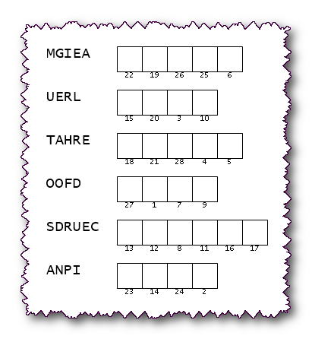

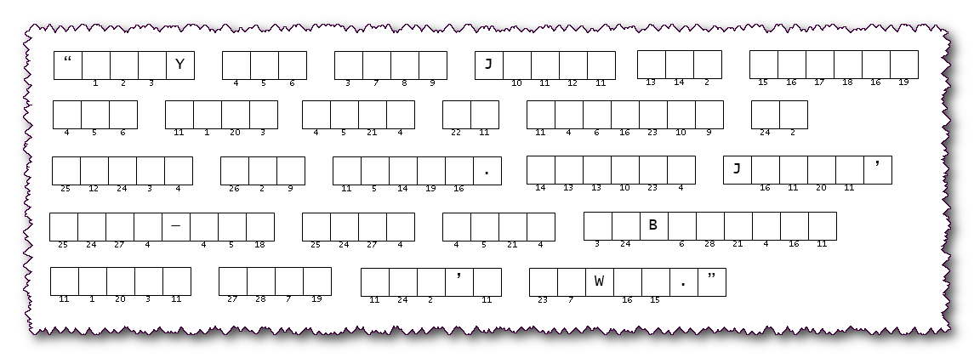
Two different local pastors in Resu Nyaraq smuggled these two portions of a secret message to our embassy there. They want the world to know they are still holding true to God’s Truth, despite persecution. You must first unscramble the letters to make words that come from our Bible study passage. Then use the numbers to match the spaces in the message below. When you decrypt the message, pass it to your evangelism committee. Help and more Family Activities are found at https://tinyurl.com/334vejue

