1. Motivate

What are some areas of life where you definitely have favorites?
- football , baseball, college, pro teams
- pizza
- cars
- music – rock and roll, southern gospel, classical, country, ….
- restaurants
- pc over Mac
A video introduction is available for this lesson. View it at https://tinyurl.com/yc23ewvv If you don’t have wi-fi where you teach, it is best to download the video file to your computer from https://tinyurl.com/3c8hnbk3
- authors
- church music
- Disney resorts
- theme/amusement parks
- weather (hot, cold, snow, sun, …)
- motel chains
- farm machinery (John Deer, Massey Ferguson, Case, …)

2. Transition

Maybe you’ve had a pet that liked one person in the family more than the others.
- It’s OK for a pet to have a favorite among family members.
- But, in general, love should be without favoritism within the family.

3. Bible Study

3.1 Differences and Favoritism

Listen for contrasts.

Genesis 25:24-28 (NIV) When the time came for her to give birth, there were twin boys in her womb. 25 The first to come out was red, and his whole body was like a hairy garment; so they named him Esau. 26 After this, his brother came out, with his hand grasping Esau's heel; so he was named Jacob. Isaac was sixty years old when Rebekah gave birth to them. 27 The boys grew up, and Esau became a skillful hunter, a man of the open country, while Jacob was a quiet man, staying among the tents. 28 Isaac, who had a taste for wild game, loved Esau, but Rebekah loved Jacob.

Describe the differences in the birth of the two boys born to Rebekah and Isaac.
Esau | Jacob
- reddish  - lots of hair – all over  - became an outdoorsman – skillful hunter | - hanging onto Esau’s heal as he came out  - quiet person  - stayed at home

What makes children even today from the same home turn out so differently?
- different skills, abilities inherited – sports, academics, music, cooking, hobbies
- different interests – hobbies, music, foods
- difference in ages
- different sets of friends each has – how they are influenced by the different groups
- sometimes it is the result of different surroundings, opportunities at a certain age
- can be good or poor influence of a given teacher at a given age (my mother in law was told by her math teacher (in the 1930’s) she’d never pass algebra, so she closed the book and never opened it again)

What do we learn about the relationship of the parents, Isaac and Rebekah, to the two sons, Esau and Jacob, as the sons became adults?
Isaac | Rebekah
- enjoyed eating wild game  - caused him to prefer Esau over Jacob | - loved Jacob more  - shared his preference for being at home and tending to home activities

How might these preferences have impacted the family dynamics?
- which parent paid more attention to which son
- what they did together
- what they did apart from the rest of the family
- how they encouraged/discouraged each child
- Rebekah may ha chided Esau for tracking in mud and dirt, but congratulated Jacob on keeping his area of the home neat and tidy
- Isaac may have praised Jacob for bringing home a trophy deer, but joked about Esau not wanting to get dirty and bloody out hunting

Why do parents today sometimes favor one child over another?
- one who is well behaved favored over the ornery willful child
- favored for going along with the parents’ wishes
- rebellious child is generally not in favor
- although if the parent has a rebellious streak, he/she may more likely bond with the rascal
- the child and parent have very similar likes and skills

What are possible consequences when parents show favoritism?
- the favorite may leverage that into preferential treatment
- the non-favorite resents the special privileges
- anger
- the less favored may give up on trying to achieve
- retaliation for perceived unfairness

3.2 Secrecy and Deception

Listen for a sneaky plot.

Genesis 27:5-10 (NIV) Now Rebekah was listening as Isaac spoke to his son Esau. When Esau left for the open country to hunt game and bring it back, 6 Rebekah said to her son Jacob, "Look, I overheard your father say to your brother Esau, 7 'Bring me some game and prepare me some tasty food to eat, so that I may give you my blessing in the presence of the LORD before I die.' 8 Now, my son, listen carefully and do what I tell you: 9 Go out to the flock and bring me two choice young goats, so I can prepare some tasty food for your father, just the way he likes it. 10 Then take it to your father to eat, so that he may give you his blessing before he dies."

What were the instructions Rebekah overheard Isaac giving to Esau?
- go out hunting, bring in some good game
- prepare it in the style I like
- bring it and we’ll eat together
- then I’ll give you your official paternal blessing

What plan did she devise in response and how did she draw Jacob into it?
- we’ll fake it – just go out to your flock and harvest a couple of goats
- we’ll fix the in the style Isaac expects
- you pretend to be Esau
- and YOU will get the official paternal blessing

What conclusions do you draw about the quality of the relationships that existed in this family between siblings, parents, and offspring?
- the whole bunch were messed up
- Isaac worried about dying, decides to give the official blessing apparently privately to Esau
- Mom willing to lie and cheat for her favorite son
- Jacob willing to go along with it

Why is honesty so vital in healthy family relationships?
- otherwise family relationships fall apart
- no one trusts the other
- end up cheating and conniving against each other

What effect might favoritism and deception have had in shaping Jacob’s character?
- probably wasn’t the first time there was deception
- parental favoritism had run amok
- seems like it may have been a lot of similar attitudes and actions

3.3 Bad Influence and Defiance

Listen for the plot to thicken

Genesis 27:11-13 (NIV) Jacob said to Rebekah his mother, "But my brother Esau is a hairy man, and I'm a man with smooth skin. 12 What if my father touches me? I would appear to be tricking him and would bring down a curse on myself rather than a blessing." 13 His mother said to him, "My son, let the curse fall on me. Just do what I say; go and get them for me."

Rebekah had an answer to Jacob’s objections. In what sense was her willingness to take the blame still not adequate?
- it would (and did) cause a deep family rift
- there would be revenge threatened
- things that happened would be unrepairable

What makes lying and deception so difficult to overcome in a family?
- destroys trust
- deep hurts that will not heal
- creates hatred
- ends up so often in family breakup – divorce, children leave and never return

How can we exemplify life without favoritism in our families?
- make efforts to treat all in the family with love and kindness
- careful not to single out one child over another for gifts, allowances
- equal punishment/discipline as needed
- speak to one another politely, with kindness
- parents model treating

How does sinful behavior among family members impact the entire family?
- when a parent expresses less favor to one of the children, others in the family can join in and harass that child
- can end up splintering the family – divorce
- can cause a long term or permanent split between a child and one or both parents
- can cause split between siblings (as happened in this situation)
- often when parental sin results in a divorce, young children blame themselves and feel they are the cause of the breakup
- messes up the thinking and self-concepts of the children

How do you maintain a spirit of honesty, integrity, and transparency, so that you will not be guilty of family mistrust?
- daily communication with God – “hearing” what He says to you, talking to Him in prayer
- be quick to confess, repent, seek forgiveness (with God and with your family member) when you fail (sin)
- be ready to forgive others who offend or sin against you
- worship God together as a family
- foster the attitude of supporting one another

Use the last page as a handout so your learners can take home the application points of this week’s lesson.
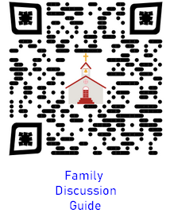
Application
Read.
- This week read 1 Corinthians 13.
- It provides a template for love and respect in families.

Reflect.
- Journal and reflect on when you have felt wounded in times when others seemed to be more valuable and appreciated than you.
- How did you overcome those feelings? How did you respond?

Practice.
- Seek to rectify the favoritism in your own life (James 2:1,3,9).
- Do you think you may have been guilty of showing favoritism in your family?
- Set aside a time to have a conversation with the family member whom you may have harmed through favoritism.
Word Search Puzzle
ISAAC
JACOB
LISTENING
OPEN
OVERHEARD
PREPARE
QUIET
REBEKAH
SIXTY
SKILLFUL
SMOOTH
STAYING
TASTE
TASTY
TENTS
TIME
TRICKING
TWIN
WILD
APPEAR
BIRTH
BLESSING
BODY
BRING
BROTHER
CAREFULLY
COUNTRY
CURSE
ESAU
FATHER
FLOCK
GAME
GARMENT
GOATS
GRASPING
HAIRY
HEEL
HUNTER

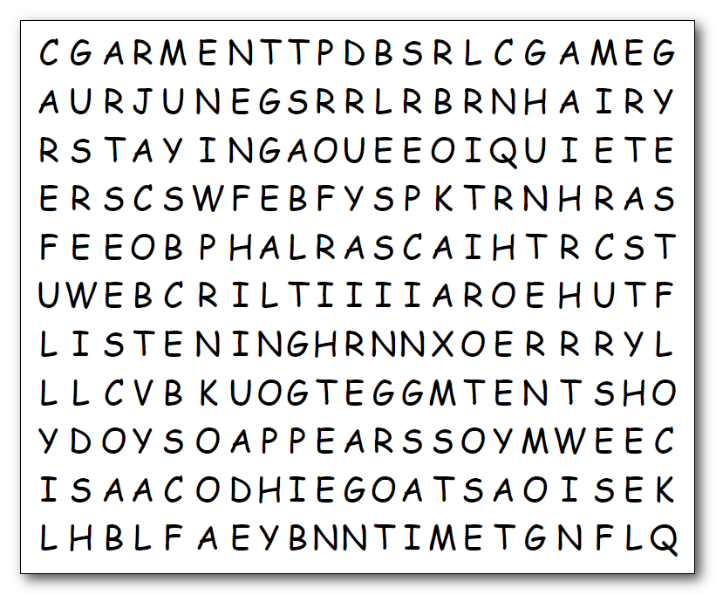
Humph! I’m tired of politics. I venture to say you are weary also. Here’s a good diversion … find the words! You know the drill: words can go left to right, top to bottom, and diagonal, but no backwards words. If you want to see the words in order, read the Bible passage. It’ll do you good. If you wimp out, help is available at https://tinyurl.com/3c8hnbk3 If you are desperate, the crossword is there too.

