ds1. Motivate

Who are some siblings from movies or TV you found entertaining?

- Waltons
- “Yours, Mine, and Ours”
- Brady Bunch
- Bonanza
- Little House on the Prairie
- Simpsons
- Family Ties
- Partridge Family
- Leave it to Beaver
- Eight is Enough
- Full House
- The Wonder Years

2. Transition

Most of the time, the families got along. By the end of the episode everyone was getting along.
Showing humility was usually part of the solution
It is critical to restoring broken relationships
A video introduction to the lesson is available. View it at https://tinyurl.com/ywfwtupy If you have no wi-fi where you teach, it is best to download the video file to your computer from https://tinyurl.com/395x2ck5
3. Bible Study

3.1 Asserting Hate

Listen for revenge planned.

Genesis 27:35-37, 41 (NIV) But he said, "Your brother came deceitfully and took your blessing." 36 Esau said, "Isn't he rightly named Jacob? He has deceived me these two times: He took my birthright, and now he's taken my blessing!" Then he asked, "Haven't you reserved any blessing for me?" 37 Isaac answered Esau, "I have made him lord over you and have made all his relatives his servants, and I have sustained him with grain and new wine. So what can I possibly do for you, my son?" … 41 Esau held a grudge against Jacob because of the blessing his father had given him. He said to himself, "The days of mourning for my father are near; then I will kill my brother Jacob."

What did Esau intend to do in retaliation for Jacob’s deception?
- wait until dad died
- then vowed to murder his brother
- wanted to get even … don’t just get mad, get even

What attitudes were at the center of both brothers’ actions?
- greed
- anger
- “me first” attitude
- look out for Number One

What is appealing about holding a grudge?
- you keep reminding yourself how you deserve better
- you plot and plan revenge

In what ways could Jacob and Esau each rationalize their actions?
Jacob | Esau
- he didn’t appreciate what he really had  - he would have squandered what he did have  - you have to take what you can get in this world  - he was so gullible | - he done me wrong (think country western song playing in the background)  - he took what was rightfully mine  - he’s always schemed against me  - and Mom helped him

What do you think that Jacob and Esau’s parents could have done differently to help the brothers get along better?
- treat them equally
- not involve them in trickery
- communicate between themselves about how to raise the children
- declare that because they were twins, they would get equal inheritance (even though technically one was minutes older)

What might the brothers each have done to make things come out better?
Jacob | Esau
- not be so sneaky  - not so greedy  - learn to be interested in each other’s activities | - take thought to what you do and say  - don’t be gullible  - take thought for the future, not just satisfying current appetites

Be thinking about your own family … do you have conflicts with a brother and sister that you need to acknowledge (whether or not you plan to wring their neck!!)

3.2 Choosing Humility

Listen for a family reunion.

Genesis 33:1-4 (NIV) Jacob looked up and there was Esau, coming with his four hundred men; so he divided the children among Leah, Rachel and the two maidservants. 2 He put the maidservants and their children in front, Leah and her children next, and Rachel and Joseph in the rear. 3 He himself went on ahead and bowed down to the ground seven times as he approached his brother. 4 But Esau ran to meet Jacob and embraced him; he threw his arms around his neck and kissed him. And they wept.

What were some thoughts and emotions that may have surfaced in Jacob’s mind when he saw Esau coming with a large group of men?
- I’m a goner now
- he vowed to kill me, now he’s going to wipe out the bunch of us
- why did I treat him that way
- I shouldn’t have listened to Mom

What precautions did Jacob take that suggest he was motivated by his old mindset of self-centeredness?
- sent servants and less favorite wife first
- put kids in line ahead of him
- then favorite wife and her child
- then himself last, if head of line got attacked, he could maybe get away

How did Jacob demonstrate humility?
- finally did go ahead to meet Esau first
- bowed to the ground seven times
- bowed in obeisance
- showed deference

How did Esau respond to Jacob?
- ran to meet him
- “hugged his neck” as we say in the South
- kissed him, they both wept

What do you imagine were some of the emotions, feelings
evident between the brothers when they were reconciled?

- joy
- relief
- peace
- excitement
Which set of feelings do you prefer?
- love
Which set of feelings do you prefer?

In contrast to these feelings at reconciliation, what feelings
do people hold when they are in conflict with one another?

- turmoil
- dread
- hate
- hurt

What significance do you see in the fact that God initiated the reconciliation through Jacob? Why might it not have been quite as meaningful had Esau taken the lead?
- much of the fault was Jacob’s, Esau was the offended party
- if Esau initiated, it might have been interpreted as a sneaky way to get even
- Jacob was the one who had been away … coming home was also symbolic of coming back into a family relationship

God wants families to be reconciled …
- He has been in the business of reconciliation from the start
- He made the supreme effort to reconcile us to Himself
- We must do the same
- We cannot hold ill will in our hearts for actual family or church family

3.3 Deciding to Restore

Listen for restoration.

Genesis 33:8-11 (NIV) Esau asked, "What do you mean by all these droves I met?" "To find favor in your eyes, my lord," he said. 9 But Esau said, "I already have plenty, my brother. Keep what you have for yourself." 10 "No, please!" said Jacob. "If I have found favor in your eyes, accept this gift from me. For to see your face is like seeing the face of God, now that you have received me favorably. 11 Please accept the present that was brought to you, for God has been gracious to me and I have all I need." And because Jacob insisted, Esau accepted it.

Esau asked two questions …
- Who are all these people with you?
- What were the flocks and herds I met?

How did Jacob’s answers help advance reconciliation between the two brothers?
- attributes blessings to God
- declares himself to be “your servant”
- states that the flocks and herds are “a gift, my lord, to ensure your friendship”
- “If I have found favor, please accept this gift”
- “What a relief to see your friendly smile, it is like seeing the face of God”

Consider that Jacob appears more dominant one in the exchange recorded in these verses? How can you tell?
- he shows proper humility – “your servant”, “God has graciously given”, “my lord”
- more bowing by family
- he insists on giving the gifts
- Esau accepts

God had been gracious to both men, and they said so. God has been good to you also. What are some ways you can humbly acknowledge that graciousness to others?
- generosity with the resources God has given you
- Jacob said “please” … humility has good manners!
- involvement in benevolent ministries of your church
- pointing others to Jesus who has demonstrated His grace and mercy to each one of us personally

Consider that we might not be accepted by the person to whom we humble ourselves.
- Even if our humble attempts of reconciliation are rejected by people, God accepts our humility and smiles on us
- Humility always wins because it pleases God
Use the last page as a handout so your learners can take home the application points of this week’s lesson.
Note that the application points may be the most important points in the lesson. Be sure to stress them.


Application
Take responsibility.
- Identify some of your learned behaviors from your family and begin humbly to address them.

Forgive.
- After humbly dealing with our sins and shortcomings, among the most significant things we can do is forgive those who have offended us or caused us harm or grief.
- Your forgiveness does not excuse their behavior; it is you letting go of the offense.

Choose to forgive.
- Do all that you can do to reconcile.
- Take the initiative to reconcile a broken relationship in your life.
- This is tough, but it pays tremendous dividends.
- Doing your due diligence to maintain a clear conscience can help prevent future conflicts. Take steps now to move toward reconciliation.
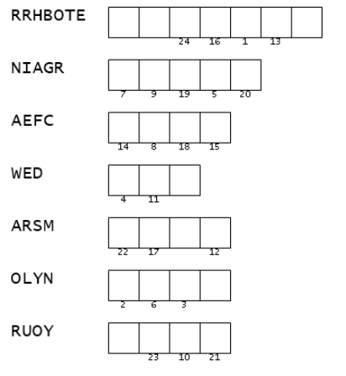
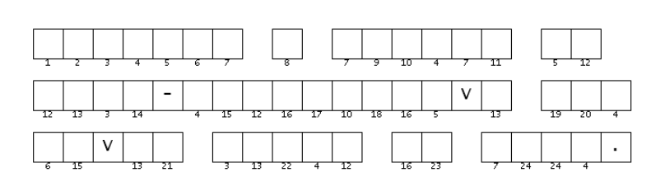

Double Puzzle
Here’s a double riddle. Unscramble the clue words on the left. They are all words from Genesis 27:35-41, 33:1-4, 8-11 (NIV). Then use the numbers to decrypt the message below. Help is available (with other Fun Family Activities) at https://tinyurl.com/395x2ck5 When you figure it out, forward the message to Spiros the Spy

