**1. Motivate**

As a child, what did you want to be when you grew up?

* cowboy
* fireman
* astronaut
* teacher
* nurse, doctor
* mother
* lawyer
* missionary, pastor
* businessman
* cook
* pilot
* pro ball/hocky/race car driver

**2. Transition**

Sometimes we just wish for something because it looked adventuresome.

* Sometimes there is also parental or cultural pressure to choose a vocation
* Today we look at how Saul’s son, Jonahtan dealt with such pressures

A video introduction to the lesson is available. View it at <https://tinyurl.com/2dd7ftf6> . If you have no wi-fi where you teach, it is best to download the video file to your computer from <https://tinyurl.com/5fj4rn3w>

**3. Bible Study**

3.1 Role Expectations

Listen for expressions of friendship.

1 Samuel 18:1-4 (NIV) After David had finished talking with Saul, Jonathan became one in spirit with David, and he loved him as himself. 2 From that day Saul kept David with him and did not let him return to his father's house. 3 And Jonathan made a covenant with David because he loved him as himself. 4 Jonathan took off the robe he was wearing and gave it to David, along with his tunic, and even his sword, his bow and his belt.

Why might we expect Jonathan to have rejected David as a friend?

* David is successful as a soldier and leader
* Saul is becoming less successful
* Jonathan could have seen David as a threat to following his father as king

What kinds of difficulties could have arisen between the oldest son of the king and a skillful and popular soldier also living in the palace?

* jealousy
* competition
* stress
* mistrust

How did he demonstrate a commitment to their friendship that may have defied the role expectations others had for him?

* they were one in spirit
* very good friends
* “loved him as himself”
* made a covenant with David
* gave him his robe, tunic, sword with belt, bow – symbols of military authority

What traits might have made Jonathan and David feel as if they were "one spirit"?

* both involved in military
* shared leadership qualities
* both wanted to help the king
* involvement in physical battles
* maybe enjoyed each other’s company there in the king’s palace
* similar age, similar interests

What kinds of things could you give to a friend to demonstrate great loyalty and trust in them?

* make them guardians of our children in case of our demise
* co-sign a loan (?? -- actually, scripture warns against this)
* give them a key to our house while we are away or in case of emergency
* allow them to borrow a vehicle
* allow children to stay overnight with them
* go into a business partnership with them

What are the benefits of having your “soul knit” to someone else in friendship?

* they “have your back”
* that person can be depended on to help you in most any situation
* you have someone who understands you
* you enjoy the same kinds of things,
* have a healthy fear of the same kinds of things
* understand the same priorities

When might God call you to give selflessly to benefit someone else?

* financial gifts to ministries
* benevolence ministries
* teaching a Bible study
* doing chores (lawn care, fix-it jobs, etc.) for a home bound person
* helping around the house without being asked
* volunteering for tutoring in a school

3.2 Unwarranted Accusations

Listen for Saul’s influence on Jonathan

1 Samuel 19:1-4 (NIV) Saul told his son Jonathan and all the attendants to kill David. But Jonathan was very fond of David 2 and warned him, "My father Saul is looking for a chance to kill you. Be on your guard tomorrow morning; go into hiding and stay there. 3 I will go out and stand with my father in the field where you are. I'll speak to him about you and will tell you what I find out." 4 Jonathan spoke well of David to Saul his father and said to him, "Let not the king do wrong to his servant David; he has not wronged you, and what he has done has benefited you greatly.

Note what Saul determined to do to David and how he proposed to execute his desire.

* Wanted to get rid of David
* Instructed his attendants to kill him

How does it feel when two people you are close to are at odds with one another?

* you feel pulled in two directions
* you want to bring peace to the situation
* you are not sure which one is right, which one is wrong
* maybe each are both a bit right and a bit wrong

What action did Jonathan take that was showing his faithfulness to his covenant with David even if it appeared he was defying the expectations of this father?

* warned David to go into hiding
* hide near where the king takes his morning walk
* I will go with him and plead your case
* I’ll tell you what I find out

How did he plead David’s case to his father, the king?

* spoke well of David
* please do not do wrong to David
* he is your servant, has not done anything wrong against you
* all his actions have benefited you greatly

What do you think … was Jonathan being loyal to David at the cost of dishonoring his father, or did he act in a way that had peaceful resolution at its objective?

|  |  |
| --- | --- |
| Loyal to David, Dishonoring to Saul | Objective Was Peaceful Resolution |
| * warned David of Saul’s intent * told him where to hide * said he would try to dissuade the king * promised to reveal the king’s plans | * emphasized David’s loyalty * pointed out David’s help to the king * pleaded for David’s life |

3.3 God’s Perspective

Listen for Jonathan’s realization of the future.

1 Samuel 23:15-18 (NIV) While David was at Horesh in the Desert of Ziph, he learned that Saul had come out to take his life. 16 And Saul's son Jonathan went to David at Horesh and helped him find strength in God. 17 "Don't be afraid," he said. "My father Saul will not lay a hand on you. You will be king over Israel, and I will be second to you. Even my father Saul knows this." 18 The two of them made a covenant before the LORD. Then Jonathan went home, but David remained at Horesh.

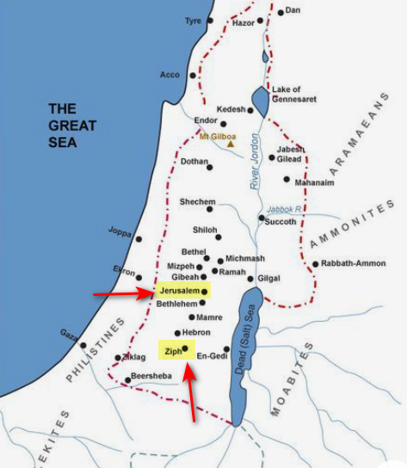

Who initiated the meeting and what was his purpose?

* Jonathan went to David, found him in Ziph
* told David Saul was on a mission to hunt him down
* helped him find strength in God

What was the encouragement Jonathan offered to David?

* don’t be afraid
* Saul will not find you
* you will be king, I will be your second in command
* even Saul now realizes this

How was this final covenant in conflict with what would normally be expected?

* Jonathan was expected to become the next king
* he had probably been educated and trained with that in mind
* now he saw much that had transpired with his father’s disobedience and obsession against David
* maybe he knew of the anointing of David to the throne by Samuel
* in any case he could see the events moving in that direction
* maybe he really didn’t want to be king and would have felt more at home to be on the royal staff

How can you learn, like Jonathan, to be content with the role God has called you to fulfill?

* be in daily communication with God – reading God’s Word and prayer
* become involved in ministries of the church as called upon and as you
* practice praise and thanksgiving to God for His faithfulness and provision
* commit your way to God
* seek God’s will, not your own

Use the last page as a handout so your learners can take home the application points of this week’s lesson.

Application

Encourage a leader.

* Leadership can be quite lonely.
* Do you have a Sunday School teacher who can use some assistance?
* Do you know a pastor who needs prayer?
* Write a note. Text a Scripture passage and be a blessing to him.

Write a life mission statement.

* Do you know God’s will for your life? Are you planning with His plan in mind?
* What is the big goal of your life? If you could write your tombstone, what would you put on it?
* Spend some time in prayer and fasting and get clarity from God regarding your role in life.
* Then write an end-vision with some attainable goals.

Stand up for someone.

* Do you have family or friends you can help with a squabble?
* Is your spouse accepted by your immediate family?
* Is there someone in your community who could use a defender?
* Be intentional to encourage them and let them know you’ve got their back.
* Don’t be afraid to publicly take a stand on their behalf.

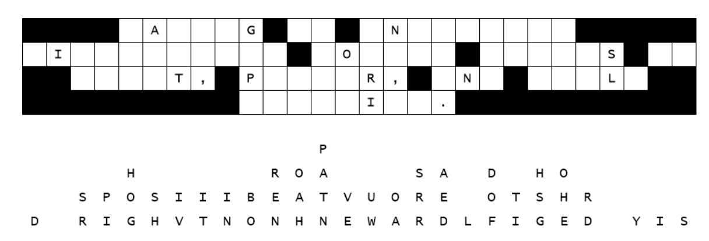

We have letters down … another attack by space aliens. The letters fell straight down, but not in order. Work on the single letter columns, then the 2 and 3 letter words. Use letters that make reasonable words. Help and more is found at <https://tinyurl.com/5fj4rn3w>

