1. Motivate

When have you heard of bad directions or instructions leading someone astray?
- how to install something – it skipped a step or that part was missing
- GPS did not have updated info
- GPS said to take the exit, but it did not exist
- GPS told me I was driving out in a field, “please return to the road”
- the fellow said “Take a left where that big tree used to be”
- A fellow asked me how to get to a certain road, I think I maybe sent him the long way around
- the map showed the road as through, but it was a dead end where it crossed the Interstate
- we had a phone number similar to a local attorney … we would get calls from dyslexic people, their “one call” when arrested
- or having a phone number similar to that of a hospital … great fun pretending to be a patient they wanted to talk to … Caller: “you sound awful!” Us: “Well, I’ve been sick”

2. Transition

Misdirection can be very serious.
- It’s important to know the right way to go.
- We will know the right way as we encounter God and His direction through His Word.
A video introduction is available. View it at https://watch.liberty.edu/media/1_02laxnxu If you have no Wi-Fi where you teach, best to download to your computer from https://tinyurl.com/yxsk4acq

3. Bible Study

3.1 Encountering God through Scripture

Listen for prayer requests.

Psalm 119:17-18 (NIV) Do good to your servant, and I will live; I will obey your word. 18 Open my eyes that I may see wonderful things in your law.

What is the request in verse 17 and why does the psalmist desire that the Lord respond to it?
- please do good to me
- I want to live
- I will obey what you tell me to do

What is the earnest request in verse 18?
- open my eyes to your direction
- I want to see all the wonderful things you have for me
- I want your direction in my life

Why did the psalmist consider that to be an important request for God to answer?
- life is a quest – what is the right thing to do, where do I go from here
- we need direction in our lives
- life is confusing, with many choices – how can we know what is best
- we are too easily led astray … we need divine guidance

What words suggest the psalmist did not see reading God’s Word as a labor but a delight?
- he asks God to “do good”
- he says God’s law (Scripture) contains “wonderful things”

What helps us hear God’s voice above all the other distracting voices in this life?
- a conscious act of the will to expose yourself to God’s Truth
- reading and applying God’s Word
- communicating with God … “listening” to what Scripture says, talking to Him in prayer
- not only prayer requests, but also declaring thanks, worshiping, confessing, repenting, declaring one’s trust

When has God opened your eyes to reveal Himself to you in a fresh way through His Word?
- confronted by sin in my life
- reading a promise that applied to me for that very day
- answering a question about a spiritual issue that had been puzzling me
- receiving direction for my life
- all of a sudden, a concept about God I had never considered, “jumps off the page” at/to me

3.2 God’s Word Helps Us Face Opposition

Listen for how to face opposition.

Psalm 119:19-22 (NIV) I am a stranger on earth; do not hide your commands from me. 20 My soul is consumed with longing for your laws at all times. 21 You rebuke the arrogant, who are cursed and who stray from your commands. 22 Remove from me scorn and contempt, for I keep your statutes.

What appeal did he make of the Lord?
- don’t hid your commands from me
- I long for your laws/truth/words
- protect me from those who do not obey your commands

How did the psalmist describe himself in relationship to his living in this world?
- he is a “stranger” in this world
- he realizes he didn’t fit in with those who did not believe and trust as he did
- he wanted to know God better, but many people around him did not
- he felt rejection from others who did not trust and obey God

On what basis did the psalmist ask God’s intervention in removing reproach and contempt.
- affirmed his separation from his culture, “I am a stranger …”
- he was “consumed with longing” for God’s laws
- this was continuous “always”
- realized God rebukes the arrogant, didn’t want that
- resolved to keep God’s statutes

Who are the proud, the arrogant?
- those who stray from God’s commands
- people who ignore what God has to say
- those who reject anything to do with God
- people who think they can live life successfully and be fulfilled without any input from God

What is God’s disposition toward the proud?
- God rebukes them, they are cursed
- they may seem to be successful, but “wide is the gate and broad is the road that leads to destruction”
- they are scornful and full of contempt

When have you felt like an outsider in this world?
- in a secular university
- seeing some of the opinions of “friends” on social media
- noting the direction of much entertainment available on the 100’s of channels available
- being in the presence of folks whose language is full of profanity and vulgarity
- not so much now, but back in the day, in certain places you were inundated with 2nd hand tobacco smoke
- hearing of “exploits” of coworkers
- seeing reports of the excessiveness of entertainment and sports idols

How might being exposed to more of the Lord’s Word help the psalmist (and you) live as a stranger in the earth?
- you don’t have the same priorities
- your values will be different
- you will act different, speak different
- you might even dress differently in some situations
- you have different motives
- you have God’s empowering, others will not

What was the psalmist’s overwhelming desire concerning the judgments of the Lord?
- he didn’t want to have God’s Truth hidden from him
- he longed for God’s laws/commands/direction
- he is consumed with that longing
- he purposed to keep God’s statutes
3.3 God’s Word Gives God’s Perspective

Listen for God’s perspective.

Psalm 119:23-24 (NIV) Though rulers sit together and slander me, your servant will meditate on your decrees. 24 Your statutes are my delight; they are my counselors.

How did he respond to those who slandered him? What did the psalmist say the Lord’s Word was for him during his challenging times?
- no mention of retaliation
- instead, he would remain God’s servant
- he would meditate on God’s decrees
- delight in God’s statutes
- consider God’s Word as good counsel

What challenges do we face in bringing God’s perspective to bear in our lives?
- God’s perspective is often counter to current culture (it was in Jesus’ day, it is likewise now)
- busy schedules
- family distractions
- emotional distractions (anger, frustration, excitement, worry)
- health … if you don’t feel good, you have a hard time concentrating
- opposition to our faith, to our values

What role should God’s Word play in our lives?
- source of God’s Truth
- reading and applying what God says
- going to God’s Word for wisdom on how to live
- encouragement
- fresh look at values we should hold
- memorization
- basis for witnessing

What strategies have helped you meditate on God’s Word?
- make sure to set aside time, don’t try to squeeze it in to the few moments you have left
- find a place of few distractions
- journal what you are reading, write down concepts that jump out at you
- make it daily
- talk to God about the concepts that day
- in your prayer requests, pray those concepts to be true those you pray for
- claim the promises you read
- ask God to enable you to live according to His commands and precepts

Use the last page as a handout so your learners can take home the application points of this week’s lesson.

Application
Read the Bible.
- If you’re not spending time in God’s Word, start here and now.
- Spend at least fifteen minutes every day reading God’s Word.

Study the Bible.
- Choose a book of the Bible and spend time studying its message.
- Your pastor or group leader can recommend a commentary or study helps to assist you in your study.

Meditate on God’s Word.
- Turn off the TV, computer, and smartphone and spend uninterrupted time meditating on God’s Word.
- Journal your thoughts and observations.

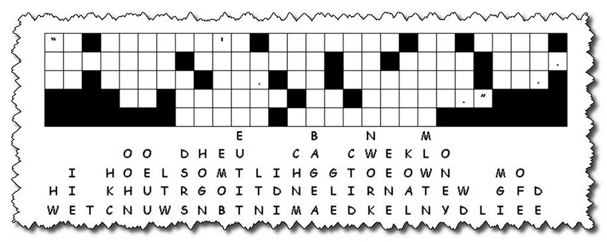Fallen Phrases Puzzle
It’s been so cold, the letters fell off this secret message from our consulate in Rkeynew. Help us out, please, all our clerks are busy watching HGTV reruns. Look for single letter columns or rows where there are only two or three letter words. Figure out what letters in those columns make sensible words. Watch for squares with punctuation … no letters there. Have your church librarian forward the message to the local office of the FBI. If you get stuck, our attaché has posted help at https://tinyurl.com/yxsk4acq. Further family intrigue is also available

