1. Motivate

Hold up a real one dollar bill and a piece of Monopoly money … what are some ways in which you can tell that the Monopoly money is not real?
- color is wrong
Note that in all cases we are comparing/contrasting the item in question to a sample of the real thing.
- size is different
- design is not right
- picture is different
- only one side has printing

2. Transition

To discover a fake you must study the real thing!

Today we apply that concept to the Christian faith … to be aware of false doctrine, study the Truth.

3. Bible Study

3.1 Jesus is Lord of All

Listen for who is conqueror.

1 John 4:1-4 (NIV) Dear friends, do not believe every spirit, but test the spirits to see whether they are from God, because many false prophets have gone out into the world. 2 This is how you can recognize the Spirit of God: Every spirit that acknowledges that Jesus Christ has come in the flesh is from God, 3 but every spirit that does not acknowledge Jesus is not from God. This is the spirit of the antichrist, which you have heard is coming and even now is already in the world. 4 You, dear children, are from God and have overcome them, because the one who is in you is greater than the one who is in the world.

Note John’s specific instructions.
- Do not believe in every spirit
- Test the spirits
- See if they are from God

John goes on to warn about false prophets in the world. Considering this warning along with previous studies on spirits, what do you think He means by the phrase “test the spirits”?
- could mean the general attitudes and spirit of thinking
- could mean evil spirits we studied about
- actually the Greek word in this passage for spirit is the same one used to describe evil spirits
- note that John proceeds directly spirits to the false prophets
- he believed that false prophets were influenced, even controlled by evil spirits

How can we distinguish truth from error in spiritual matters? How do we “test the spirits”?
- compare/contrast what they say with what scripture teaches
- if they make predictions, do they come true always … 100% accuracy
- Old Testament criteria was that if a prophet makes a prediction that does not come true, he is a false prophet (Deut. 18:22).
- test means, “to prove or to examine.”
- examine messages to see if they are from God.
- examine sources behind messages, don’t accept without questioning

While no one is perfect, it is important to examine the lifestyle of a Bible teacher before we heed the teacher’s message.
- Blatant sin shows a disregard for the clear teachings of Jesus.
- Someone who has been transformed by Jesus will begin to live more and more like Him.
- We will truly know what they stand for when we see the fruit of their lives.

According to this passage, what is the so called “litmus test” to recognize the Spirit of God?
- does the spirit acknowledge that “Jesus Christ has come in the flesh”
- if yes, the message is from God’s Holy Spirit
- if no, the message is from the spirit of the antichrist

Note some modern examples of groups who spread false teachings regarding the full humanity and full divinity of Jesus:
- Mormons, Latter Day Saints
- Jehovah’s Witnesses
- Islam
- Hinduism
- Christian Science

Common characteristics of cults – false spirits … signified by math symbols
- + They add to Scripture
- - The subtract from the deity of Christ
- × They multiply the importance of works
- ÷ They are divisive, causing divisions in families, among friends

What spirits should we be testing today? What false prophets are in the world today?
- biased news media
- statements by politicians
- people claiming to be prophets
- anyone who preaches, adheres to beliefs other than Scripture
- those who advocate policies and practices that are contrary to Scripture
- entertainment that advocates immoral, ungodly attitudes and activities

3.2 Danger of Pluralism

Listen for more warnings.

Colossians 2:6-10 (NIV) So then, just as you received Christ Jesus as Lord, continue to live in him, 7 rooted and built up in him, strengthened in the faith as you were taught, and overflowing with thankfulness. 8 See to it that no one takes you captive through hollow and deceptive philosophy, which depends on human tradition and the basic principles of this world rather than on Christ. 9 For in Christ all the fullness of the Deity lives in bodily form, 10 and you have been given fullness in Christ, who is the head over every power and authority.

Paul says, “as you received Christ Jesus as Lord” … how did we receive Christ?
- ask Jesus into your heart
- repent from, confess your sins
- receive Jesus by faith

Paul is making the point that it is by faith that we continue to live the Christian Life.

Note the two comparisons.
Not easily shaken
Based on Truth
- From agriculture “rooted in Him”
- From construction “built up in Him”

What are three characteristics given in verse 8 of hollow and deceptive philosophies?
- depend on human traditions
- based on basic worldly/humanistic principles Recall the characteristics of cults +, -, ×, ÷
- not based on Christ

Examples of philosophies have no place in the life of a believer
- Materialism, humanism
- Atheism or agnosticism
- Astrology, Spiritism

Why are these false doctrines and philosophies hollow and deceptive?
- they do not deliver what they promise
- they do not fully satisfy a person’s yearnings
- empty in that they are devoid of reality
- deceitful in that it fools its followers, it fraudulently leads them astray from Christ

What did Paul affirm about Christ?
- all fullness of the Deity lives in bodily form
- everything true about God was true about Jesus
- we are given full relationship with God through Jesus
- He is in charge of all things
- He is all powerful

3.3 Vigilance and Stability

Listen for how to defend the faith.

Jude 1:20-23 (NIV) But you, dear friends, build yourselves up in your most holy faith and pray in the Holy Spirit. 21 Keep yourselves in God's love as you wait for the mercy of our Lord Jesus Christ to bring you to eternal life. 22 Be merciful to those who doubt; 23 snatch others from the fire and save them; to others show mercy, mixed with fear--hating even the clothing stained by corrupted flesh.

What spiritual actions did Jude urge his readers to in verses 20 and 21?
- build yourself up in your most holy faith
- pray in the Holy Spirit
- keep yourself in God’s love
- wait for the mercy of the Lord Jesus Christ to bring you to eternal life

What are some ways we can build ourselves up in our most holy faith?
- communicate daily with God – read and apply Scripture … talk to God in prayer
- gather with other believers – worship, hear teaching/preaching
- involved in spiritual ministries – outreach, helping others

Note the three groups of people to whom Jude urged believers to show mercy.
- Those who doubt
- Snatch others from the fire and save them
- Those stained by “corrupted flesh

How can we balance showing mercy and contending for the faith?
- we are not to accuse and condemn
- God calls us to demonstrate grace – kindness even when undeserved
- we share the Good News, the Gospel
- we demonstrate love, joy and peace and share how others can realize the same
- when we share God’s Truth, know that God’s Holy Spirit does the convicting, the convincing

Consider the importance of showing mercy and love while defending the faith
- Mercy and love are what have been shown to us by God
- We deserve the penalty of sin, God has shown us mercy
- We don’t deserve God’s love and kindness, but He has shown grace
- We must minister God’s Truth with the same attitudes and motives

How can you show mercy and grace to believers who doubt?
- you may think they deserve condemnation, but you are not the one to condemn or reject them
- you may well have had the same doubts yourself at one time, to a lesser or greater degree
- share the joy and peace that God has given you
- live a life before them which demonstrates God’s love
Application
Pray.
- Ask the Lord for courage to stand up for what you believe.
- Ask His forgiveness for times when you have been silent and unprepared to defend the faith.

Memorize.
- As a reminder of God’s presence and power in defending the faith, memorize Jude 24-25:
- “To him who is able to keep you from stumbling and to present you before his glorious presence without fault and with great joy—to the only God our Savior be glory, majesty, power and authority, through Jesus Christ our Lord, before all ages, now and forevermore! Amen.”
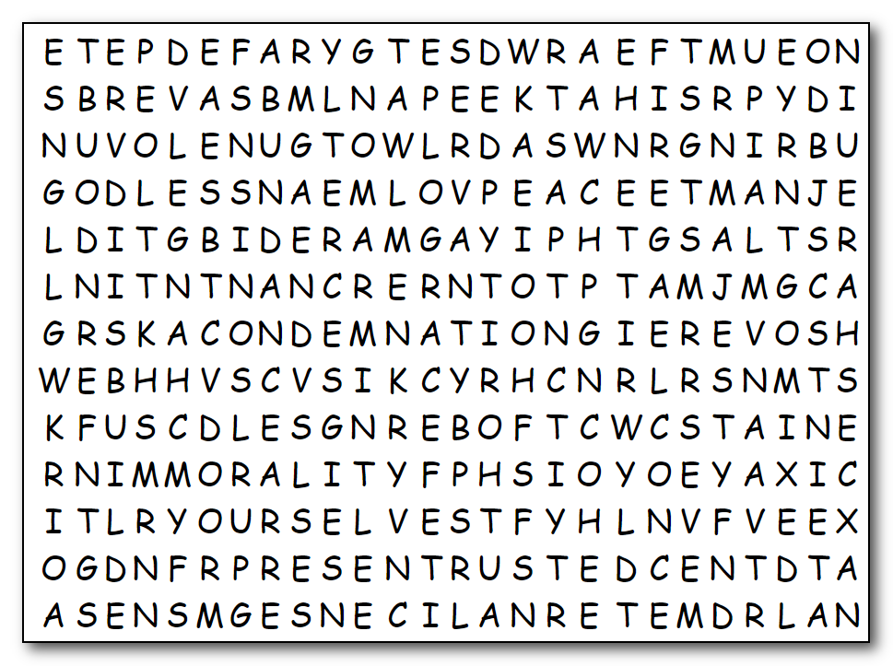

Word Search
KEEP
KEPT
LICENSE
LOVED
MAJESTY
MERCIFUL
MERCY
MIXED
ONCE
PEACE
PRESENT
SAINTS
SALVATION
SAVE
SECRETLY
SERVANT
SHARE
SLIPPED
SNATCH
SOVEREIGN
STAIN
URGE
WAIT
WRITE
WRITTEN
YOURSELVES

ABUNDANCE
AMONG
AUTHORITY
BRING
BROTHER
BUILD
CALLED
CHANGE
CLOTHING
CONDEMNATION
CONTEND
DENY
DOUBT
EAGER
ENTRUSTED
ETERNAL
FAITH
FALLING
FEAR
FIRE
FOREVERMORE
FRIENDS
GODLESS
GRACE
HATING
IMMORALITY

Ho, Ho, Ho, Humph! Someone has been naughty and scrambled all these words every which way. You’ve got to find them! I’m reporting direct to Santa, so if you want to get on his Nice list, you better get with it. Humph! That’s right, the letters can go up, down, port, starboard, and diagonal. It’s rumored that Santa’s elves can help you at https://tinyurl.com/vd7og8j Or you can go find the crossword or color page!

