1. Motivate

What does it mean to “practice what you preach”?
- your actions line up with what you say
- your beliefs and your lifestyle agree
- when you say you’re going to do something, that is, indeed, what you do
- you don’t contradict what you say with what you do
- you keep to your promises
- people can depend on what you say you will do
- your walk agrees with your talk

2. Transition

Today one of our passages is from the Epistle of James
- It looks at what James says about faith and how you live.
- What you believe is seen in what you do.

3. Bible Study

3.1 Supremacy of the New Covenant

Listen for means of communication.

Hebrews 1:1-3 (NIV) In the past God spoke to our forefathers through the prophets at many times and in various ways, 2 but in these last days he has spoken to us by his Son, whom he appointed heir of all things, and through whom he made the universe. 3 The Son is the radiance of God's glory and the exact representation of his being, sustaining all things by his powerful word. After he had provided purification for sins, he sat down at the right hand of the Majesty in heaven.

Note the words and phrases from this passage which describe how God the Father has communicated to people.
- Through prophets
- At many times
- In various ways
- Through His Son, Jesus Christ

In what ways is the picture we have of God in the Old Testament incomplete?
- prophets didn’t have the complete picture
- their prophecies were often cryptic, symbolic
- sometimes they spoke to specific situations – “forth-telling” rather than foretelling
- they didn’t realize what the Messiah would be like (a spiritual savior, not a political or military leader)

So, how does it benefit Christians today that God has spoken in many diverse ways?
- we get a variety of viewpoints
- we see different things about God and what He is doing
- God is great and diverse … we need many types of revelation
- we get to see and read all the ways God communicated in the past
- We can put them together today to get a fuller picture of His purposes
- we have hindsight to help us make more sense of all the different communications

Why do you think the author of Hebrews made such a point of Christ’s deity to these Hebrew Christians?
- some of them thought of Him only as a teacher, a rabbi
- others thought He might have been just a martyr
- some didn’t know of or believe in Jesus’ resurrection
- many of them didn’t see Him as the promised Messiah
- they didn’t see Jesus as the perfect Lamb of God, sacrificed once and for all for sins

What does Jesus’ life tell us about God that we wouldn’t know otherwise?
- God is a personal God – He can (and wants to) communicate with us as individuals
- God is willing to give of Himself to provide for our redemption
- God understands our feelings, our temptations, our problems – He lived as a human
- He told us things about Himself and about God the Father that we didn’t know
- Jesus fulfilled what the prophets had been predicting … His work of redemption
- Jesus IS God … He came personally
- God loves us
- God overcomes death

Based on what we have learned about Jesus in this passage, how should we relate to Jesus?
- worship
- awe, reverence, fear
- submission
- trust, faith
- loving obedience
- service

3.2 The Necessity of Faith

Listen for how to be justified.

Galatians 2:15-16 (NIV) "We who are Jews by birth and not 'Gentile sinners' 16 know that a man is not justified by observing the law, but by faith in Jesus Christ. So we, too, have put our faith in Christ Jesus that we may be justified by faith in Christ and not by observing the law, because by observing the law no one will be justified.

What does Paul mean by “observing the law” or “works of the law”? It would have resonated with both Jews and Gentiles of his day.
- Jewish ceremonies – sacrifices, festivals, day of atonement, circumcision
- Sabbath day observance (no work of any kind)
- for Gentiles, sacrifices to deities
- doing penance to earn favor with their deity
- some even sacrificed children to their deity

Contrast works of the law with faith in Christ.
Faith in Christ | Works of the Law
- justified, sins forgiven  - Jesus did the “work” (not us)  - freely given, cannot earn forgiveness  - Jesus accomplished it once and for all | - required effort, actions on our part  - we would be earning forgiveness by deeds  - actions/ceremonies must be repeated regularly

How do we sometimes still rely on “works” or on our own efforts to earn right relationship with God?
- feel that if we are regular church attenders God will be happy or satisfied
- feel we must somehow be involved in church ministries to keep God happy
- if we fail (sin) we feel we have to do something good to counterbalance the bad deed
- exhortations in a sermon to live a certain way can cause us to feel like we should do those things in order to please God (or at least the pastor)

What will faith in Jesus Christ look like in your daily life?
- study God’s Word to learn what He wants you to know, apply God’s Truths to your life
- “put on” or appropriate the whole armor of God … helmet of salvation, breastplate of righteousness, …
- trust God to work in and through your life so that the Fruit of the Spirt will be demonstrated

How can we live out our faith in a way that reflects reliance on Jesus, rather than legalism or performance?
- cling to the reality that we can please God with our daily lives by trusting Him … just like we trusted in His offer of salvation
- remember that your involvement in church ministries are done in God’s strength and trust Him for the intended results
- don’t seek glory or adulation as you serve the Lord … do it with an attitude of worship
3.3 Usefulness of Works

Listen for a relationship.

James 2:20-26 (NIV) You foolish man, do you want evidence that faith without deeds is useless? 21 Was not our ancestor Abraham considered righteous for what he did when he offered his son Isaac on the altar? 22 You see that his faith and his actions were working together, and his faith was made complete by what he did. 23 And the scripture was fulfilled that says, "Abraham believed God, and it was credited to him as righteousness," and he was called God's friend. 24 You see that a person is justified by what he does and not by faith alone. 25 In the same way, was not even Rahab the prostitute considered righteous for what she did when she gave lodging to the spies and sent them off in a different direction? 26 As the body without the spirit is dead, so faith without deeds is dead.

Why was Abraham an apt example for showing the relationship between faith and works?
- he claimed to believe in Jehovah
- he believed God would give him a son (even though he and Sarah were well past childbearing age)
- now, sure enough, here’s the son … probably a teenager by the time this happened
- he obeyed God
- he still believed God would give (or preserve) his only heir

Why would Rahab be an unusual, yet appropriate example of a person with active faith?
- she was a “madam”, ran a brothel
- she “feared” the God of the Israelites
- she believed in the power of Jehovah
- so much so she was willing to jeopardize her life by hiding the spies and misdirecting the local authorities
- she acted on her beliefs, her faith

Why do you suppose Abraham was called “God’s friend”?
- he and God communicated
- he listened to what God told him
- he obeyed God – got up and left his home and went to where God told him to go
- he believed God’s promise of a son to carry on his lineage which would grow to many people

What changes can we make in our lives to be seen as “God’s friend”?
- you cultivate that relationship
- you communicate with Him – listen to Him, talk to Him
- you value what He says
- you believe what He says, obey what He tells you to do
- He is pleased by how you act, what you say
- you share that friendship with others … He is good to have as a friend

Application
Read and pray.
- Read Psalm 139:23-24: “Search me, God, and know my heart; test me and know my concerns. See if there is any offensive way in me; lead me in the everlasting way.”
- Pray, asking God to expose areas in your life where you are not living what you claim to believe. After praying, develop a plan for life change to help align your actions with your faith.

Write and reflect.
- Create a “faith-in-action journal” in which you list at least five of your core beliefs.
- Over the next week, write ways your actions show (or do not show) that you are applying those beliefs in your life.

Ask and listen.
- Ask a trusted friend to speak into your life and tell you how consistent you are at living your faith.
- Listen to what they tell you.
- Avoid getting defensive.
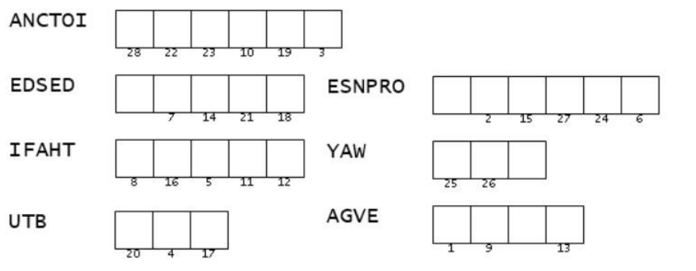


- Prepare to make some life changes based on what you hear
Double Puzzle
Aiee Cucaracha! I’m doubly confused. The message is just a bunch of empty boxes. And the clue words with the numbers to determine the letters are all scrambled. Find those words in James 2:18-20 (NIV) and un-scramble them. Tech help is available at https://tinyurl.com/3tbhymzb along with further intriguing Family Activities.

