1. Motivate

What gives you a strong sense of contentment?
- dinner with the whole extended family
- all the chores done
A video introduction to the lesson is available. View it at https://watch.liberty.edu/media/t/1_5sbuozhu If you have no wi-fi where you teach, best to download to your computer from https://tinyurl.com/bdzy65jd
- finishing a project on time
- a good uplifting tv program
- a great homemade pizza
- a newly mowed lawn
- looking at the colorful trees in the fall
- getting home after a long drive
- successfully fixing something that wasn’t working

2. Transition

When you are contented, you probably don’t want any more.
- Knowing God’s love can bring great contentment.
- Today we consider how there is no room for fear when we are filled with God’s love.

3. Bible Study

3.1 Experience the Love of Jesus

Listen for a definition or description of love.

1 John 3:13-18 (NIV) Do not be surprised, my brothers, if the world hates you. 14 We know that we have passed from death to life, because we love our brothers. Anyone who does not love remains in death. 15 Anyone who hates his brother is a murderer, and you know that no murderer has eternal life in him. 6 This is how we know what love is: Jesus Christ laid down his life for us. And we ought to lay down our lives for our brothers. 17 If anyone has material possessions and sees his brother in need but has no pity on him, how can the love of God be in him? 18 Dear children, let us not love with words or tongue but with actions and in truth.

According to this passage, we know what love is.
- Example of Jesus Christ
- Laid down His life for us
- Died in our place
- Took the punishment (death) we deserved for our sinful lives
- Gave of himself totally

How then should Christians love? If God’s loves dwells with us, what ought we to be willing to do with the resources we have at our disposal?
- not with just words
- not with only what we say
- rather demonstrated by actions
- give of our resources to minister to others
- willing to give time, skills, finances to help others

Why is it easier to love with words rather than actions?
- it’s easy to talk a good line, harder to actually do it
- talk requires no commitment
- the saying goes, “talk is cheap”

What are some not-so-apparent needs of different age groups in our church, in our community?
- teens struggling with peer pressure
- young marrieds struggling with managing their finances
- young parents struggling with handling multiple little ones in diapers
- middle aged people acting as care givers for aging adults
- single parents trying to play multiple roles and make ends meet
- senior adults with health and finance concerns

Why do we sometimes fail to help these groups meet their needs, even if we are aware?
- you are probably in one of those groups, struggling with your own problems
- you don’t want to interfere
- easy to take the attitude, they got themselves into the problem, they can get themselves out of it
- there are so many needs … how can we even begin to meet them?

Consider steps we can take to overcome the feeling of being overwhelmed by the number of needs to be met.
- Pray regularly for families around you (in church, in neighborhood, at work)
- Ask God to minister to them
- Ask God what role He would have you play in ministering to them

3.2 God’s Love in Us

Listen for why Jesus came to earth.

1 John 4:14-16 (NIV) And we have seen and testify that the Father has sent his Son to be the Savior of the world. 15 If anyone acknowledges that Jesus is the Son of God, God lives in him and he in God. 16 And so we know and rely on the love God has for us. God is love. Whoever lives in love lives in God, and God in him.

What qualified John and others to be witnesses?
- he had seen Jesus personally
- heard his teaching firsthand
- watched what Jesus did
- been in close personal contact

Note the substance of their testimony.
- Jesus was/is the Messiah
- He is God’s Son
- He is 100% God … and He is 100% man
- He came to be the Savior of the world

What is implied by the phrase “acknowledges that Jesus is the Son of God”? How is it more than mental acceptance of that fact?
- receive by faith the fact that Jesus died for our sins and arose from death
- receive by faith God’s love for us through the person of Jesus
- “live in love”, “live in God”
- allow (invite) Christ to live within us through the person of the Holy Spirit

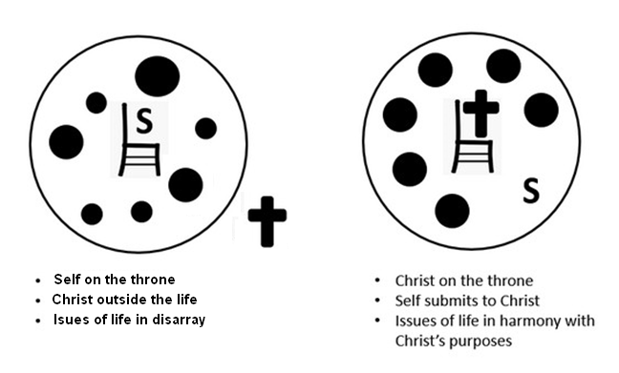

(Talk about how this diagram
expresses these concepts)

3.3 God’s Love Dispels Our Fear

Listen for loss of fear.

1 John 4:17-18 (NIV) In this way, love is made complete among us so that we will have confidence on the day of judgment, because in this world we are like him. 18 There is no fear in love. But perfect love drives out fear, because fear has to do with punishment. The one who fears is not made perfect in love.

Note the word, “herein” from the KJV at the beginning of verse 17. The NIV says “in this way” It is a transitional word or phrase.
- Refers to the previous verses, similar to “therefore” (see what it is there for)
- Answers the question of how love is made complete
What is the result of our being in God’s love, abiding in God, and knowing He dwells with us have on the character of our love?
- gives confidence on the day of judgment
- we can be assured of eternal life, eternal union with God
- we don’t fear being separated forever from God

What kind of fear or fears does this passage talk about?
- rejection by God
- can include fear of failure,
- fear of insufficient food, shelter, provisions for family
- can include fear of the evil of the world system

Negatively speaking, what does a person who fears lack in his or her life?
- knowledge God’s love, never heard the Gospel message
- not being convinced of God’s love
- lack of realization that God’s power and authority backs up that love
- knowing that God can work to accomplish His good and loving purposes for you

How does hate stimulate fear? What are some examples?
- a husband who beats his wife stimulates fear, not love
- Hitler hated the Jews, tried to kill them all – stimulated fear
- the hated person fears the expression of that hate (physically, emotional, verbally, etc.)

How does knowledge and being fully convinced of God’s love for you drive out these fears?
- we are assured that God loves us
- we know God has solved our sin problem, paid our debt
- we realize if He loved us that much to deal with our sin, He also will be at work to provide for us
- we might say He has a “vested interest” in us and won’t abandon us
- Consider Philippians 1:6 NLT: And I am certain that God, who began the good work within you, will continue his work until it is finally finished on the day when Christ Jesus returns.

We can choose actions that will convince ourselves (and others) how much God does love us, and have fears be driven away.
- Fill our minds with what God says – read and apply God’s Truth
- Avoid filling our minds with worldly messages (entertainment, news, etc.)
- Heed what God says, not news of current events
- Memorize scripture – God will bring it to our consciousness when confronted with things we fear

Use the last page as a handout so your learners can take home the application points of this week’s lesson.

Application
Write.
- Make a list of all the ways you know you are loved by Christ.
- Turn that list into a prayer, thanking God for His incredible love.

Serve.
- Look for a tangible way to show love to somebody in your life.
- Identify a need or way you can help that individual.
- This could be anything from providing a meal to leaving a note of encouragement.

Love.
- Identify someone you find hard to love.
- Do something intentionally that reflects how Christ has loved you.
- It is genuinely Christlike to love an enemy or someone who is annoying or gets on your nerves.
- Afterwards, write down what you learned and what it revealed to you about Christ.
It is I, the Word Ninja. Our Embassy in Landwe Nikiasier had two containers thrown over the fence into the compound. Once we ascertained the containers were not bombs, we found these encoded messages. Because of the numbers, we think they go together. Unscramble the clue words, then use the numbers to fill in the message. Some of the jumbled clue words form more than one real word, so read your Bible study passage to make sure the word is there. Once you have decoded the message, pass it along to your Jr. Hi youth leader. Go to https://tinyurl.com/bdzy65jd for intelligence assistance.
Check out further Fun Family Activities

Double Puzzle

