1. Motivate

What motivates one person to love another person?
- you are related to them
- you are attracted to their appearance
A video introduction is available. View at https://watch.liberty.edu/media/t/1_prnwame2
If you have no wi-fi where you teach, best to download to your computer from https://tinyurl.com/xeannudc
- you are attracted to their personality
- you see a need they have
- God places a love in your heart
- they love you back
- they play hard to get ;-)
- the other person is rich, old, and has a bad cough
- you share similar interests

2. Transition

God is at work in our lives transforming us into people who love.
- God’s love is seen when we love others as He has loved us.

3. Bible Study

3.1 God Loves Us in Jesus.

Listen for how God showed love.

1 John 4:7-10 (NIV) Dear friends, let us love one another, for love comes from God. Everyone who loves has been born of God and knows God. 8 Whoever does not love does not know God, because God is love. 9 This is how God showed his love among us: He sent his one and only Son into the world that we might live through him. 10 This is love: not that we loved God, but that he loved us and sent his Son as an atoning sacrifice for our sins.

On what truth is the appeal founded to love one another?
- love comes from God
- if you are born of God and know God as Savior, then you are motivated and have the capacity to love one another

What does love indicate about a person’s relationship to God?
- if you do not love others, then you do not know God (as Savior and Lord)
- logically speaking, if you do love one another, you might be a believer – no guarantee

What does it mean to say, God is love?
- His very essence is love
- He blesses people who do not deserve it … and that’s all of us
- what He does, He does in love

Note: we cannot say that “Love is God” … that would make an idol out of the act and attitude of love

How is love an action verb?
- if we truly love someone or something, it must show up
- it will be shown by how we treat that person, that thing
- it will be seen by what we do
- we will give top priority to that person
- we will do things for the person for their sake alone, not for hope, desire, or expectation of reciprocal favor
- we will do without something for ourselves in order to provide benefit for the object of our love

What is the difference between saying “God loves” and “God is love”?
God loves | God is love
- it is one of many things He does  - implies He might do something else sometimes | - His whole nature demonstrates love  - everything He does is loving  - he cannot do or be anything else but do good for others

How did God reveal, model, and express His love toward humankind?
- He sent his Son into the world
- His Son took upon Himself all our sins and the penalty/judgement of deah that we deserved
- He made it possible to have an eternal relationship with God, eternal life
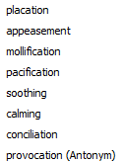
Note the terms “atoning sacrifice” and “propitiation” (depending on the version you have).
Consider the synonyms:
- God’s righteous indignation against sin had to be satisfied.
- God’s love for humanity compelled Him to pour out His wrath on His “One and Only Son … so that we might live through Him

What separates God’s love from any other kind of love?
- it is selfless love
- it does not demand or even expect reciprocity on our part
- He blesses and does good things for us even though we don’t deserve it
- that is God’s grace
- God’s mercy is when he withholds punishment that we do deserve – and that is loving
- in one sense mercy and grace are opposites
- in another sense grace is a subset of mercy

grace
Mercy

3.2 God Expects Us to Love

Listen for whom we are to love.

1 John 4:11-13 (NIV) Dear friends, since God so loved us, we also ought to love one another. 12 No one has ever seen God; but if we love one another, God lives in us and his love is made complete in us. 13 We know that we live in him and he in us, because he has given us of his Spirit.

Since God loved us through giving His Son, what should be our response?
- love one another
- act with kindness and blessing even other people don’t deserve it
- acts of kindness with no requirement or even expectation of returning the favor

What does our loving one another say about our relationship to God?
- we realize how much God loves us
- we are God’s children, we are in God’s family
- we carry the family trait
- we talk the same, have the same characteristics, we act the same way
- God is living in us through the person of His Holy Spirit
- He produces through us all the Fruit of the Spirit … including love

How is God’s love perfected in us?
- God is at work within our lives
- shaping and molding us into the person He wants us to be
- His “family characteristics” become more and more our own
- He changes us from the inside out
- He motivates us and enables us

How does God’s love help us love others?
- normally we might not have that loving attitude that God does
- consider the Fruit of the Spirit … love, joy, peace, patience, kindness, goodness, gentleness, faithfulness, and self-control
- our normal personality may have some of these qualities to some degree – but not all
- God works in our lives producing those qualities (including love) through us

When have you seen love really make a difference?
- unsolicited acts of kindness get another person’s attention – you become “salt and light” for the Gospel
- someone else is grumpy but if you give them a loving smile, they respond in like kind
- when someone is having a bad day, our loving act of kindness gets them back on track

What does it mean to live in God?
- recall Jesus’ teaching about how He is the vine and we are the branches
- we, by an act of faith, daily place our trust in His sufficiency for our needs,
- we are drawing our strength and sustenance from Him as the branches do from the vine
3.3 We Must Not Hate

Listen for what we must not do.

1 John 4:19-21 (NIV) 19 We love because he first loved us. 20 If anyone says, "I love God," yet hates his brother, he is a liar. For anyone who does not love his brother, whom he has seen, cannot love God, whom he has not seen. 21 And he has given us this command: Whoever loves God must also love his brother.

On what basis is our ability to love God established?
- we realize the Truth of the Gospel message that He loved us enough to die for our sins, to take the judgment of death in our place
- when we realize how much He loves us and the enormity of how He demonstrated it, we respond with love and submission
- we should know that He loves us and was willing to die for us, even if we do NOT respond with faith and love for Him

What is the relationship between loving God and loving others?
- if you love God, you will love one another
- if you do not love one another, you are lying if you say you love God

God revealed His love in sending His Son to atone for our sins. What other examples do you see in the life of Jesus that reveal God’s special kind of love?
- He provided food for multitudes of more than 5000 one time, 4000 another time
- He showed love for children, “let them come to me”
- He healed people, He forgave their sins
- He was kind to people, even in the face of the opposition of the religious leaders
- He faithfully taught the disciples

Think of a person you find difficult to love. What are some actions you can take that will allow God’s love to show itself through you to that person?
- unsolicited acts of kindness
- smile and greet pleasantly
- offer to help the person with some of their chores (often the hard to love person is a grumpy old man or woman with limited abilities and resources)
- express your friendship often – cards, letters, calls
- invite to church for special programs
- cake and/or presents for birthday or holiday
- invite for a meal in your home or take them out to eat

What are some specific actions through which we could demonstrate love in our church?
- look for ways to help in ongoing church activities
- volunteer for committees
- volunteer for tasks where the leadership needs help
Use the last page as a handout so your learners can take home the application points of this week’s lesson.
- affirm one another's efforts
- support the activities of children's and youth ministries
- visit those in need
- give of resources to those in need
Application
Examine your life.
- Are there people in your life whom you have a difficult time loving?
LIAR
LIVE
LIVES
LOVE
ONE
ONLY
SACRIFICE
SEEN
SENT
SHOWED
SINS
SON
SPIRIT
THROUGH
WOEVER
WORLD
- Make a list and begin to pray for them.

Align your life.
- Following up on your prayer list, look for ways to demonstrate love by serving those individuals.
- Write an activity, a time, and a place.
- Then invite someone to hold you accountable for loving action.

Make a difference in someone’s life.
- Lead out this week in helping your group do something for someone in need.
- You could put together care packages for the homeless, volunteer at a local food pantry, or find a family in need and minister to them.
- Organize a group to pack Operation Christmas Child shoe boxes.

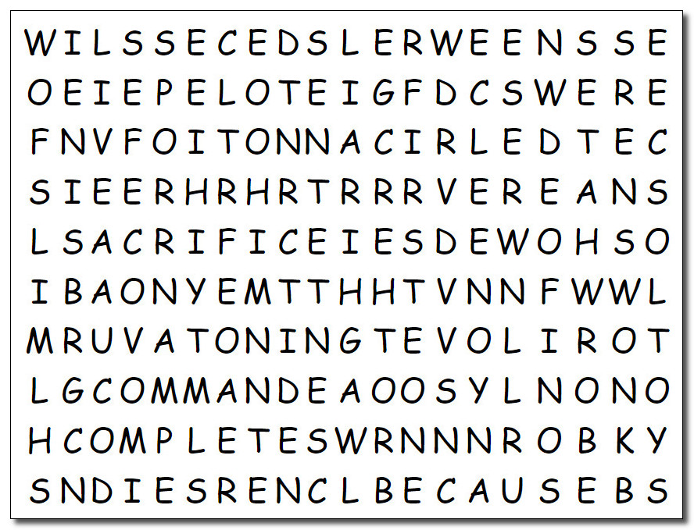Word Search Puzzle
As usual the words got put in the grid higgledy-piggledy. Humph! Those editors ought to be assigned 17 book reports each. You know the drill … the words go up, down, left, right, and diagonally. And don’t go circling words that are not in the two lists. Humph! I suppose you’ll need help … go to https://tinyurl.com/xeannudc And you’ll find other Family Friendly things to do

LIAR
LIVE
LIVES
LOVE
ONE
ONLY
SACRIFICE
SEEN
SENT
SHOWED
SINS
SON
SPIRIT
THROUGH
WOEVER
WORLD

LIAR
LIVE
LIVES
LOVE
ONE
ONLY
SACRIFICE
SEEN
SENT
SHOWED
SINS
SON
SPIRIT
THROUGH
WOEVER
WORLD
LIAR
LIVE
LIVES
LOVE
ONE
ONLY
SACRIFICE
SEEN
SENT
SHOWED
SINS
SON
SPIRIT
THROUGH
WOEVER
WORLD
LIAR
LIVE
LIVES
LOVE
ONE
ONLY
SACRIFICE
SEEN
SENT
SHOWED
SINS
SON
SPIRIT
THROUGH
WOEVER
WORLD
ANOTHER
ANYONE
ATONING
BECAUSE
BORN
BROTHER
CANNOT
COMMAND
COMPLETE
DEAR
EVERYONE
FIRST
FRIENDS
GIVEN
HATES
HIM
KNOWS

