1. Motivate

Think of a situation where you were initially upset by what was going on, but it turned out for the good?
- a bad room assignment at a hotel, they made it good with a beautiful suite
- delayed by a flat tire, but missed being in a big traffic jam and/or wreck
- stopped on a walk to tie a shoelace and missed being hit by a large falling limb (this really happened to me)
- got lost on a trip and ended up finding a wonderful tourist attraction
- the item you went to purchase was out, but you found something different that was a better buy

2. Transition

Joseph was certainly upset when his brothers sold him to a caravan of Ishmaelites.
- Today we look at how God is at work
- Even when it’s not obvious
A video introduction is available. View at https://watch.liberty.edu/media/t/1_igl79j2n If you have no wi-fi where you teach, best to download to your computer from https://tinyurl.com/4va8y62a
3. Bible Study

3.1 A Dysfunctional Family

Listen for love and hate.

Genesis 37:1-5 (NIV) Jacob lived in the land where his father had stayed, the land of Canaan. 2 This is the account of Jacob. Joseph, a young man of seventeen, was tending the flocks with his brothers, the sons of Bilhah and the sons of Zilpah, his father's wives, and he brought their father a bad report about them. 3 Now Israel loved Joseph more than any of his other sons, because he had been born to him in his old age; and he made a richly ornamented robe for him. 4 When his brothers saw that their father loved him more than any of them, they hated him and could not speak a kind word to him. 5 Joseph had a dream, and when he told it to his brothers, they hated him all the more

Why might a parent favor one child over another?
- maybe just because of their gender … the parent had always wanted a boy/girl
- their personality agreed with that parent more than the other siblings
- behavior … one kid gets in trouble, the other never causes any problems
- first child, middle child, last child (baby of the family)

What reasons do you see for conflict between Joseph and his brothers?
- favoritism from their father
- special gifts he was given
- he told about the dreams he had (not in this passage)
- he might have been “in their face” with his coat
- he tattled on them to their dad

What other kinds of things cause jealousy between siblings?
- when one excels at something (sports, academics, etc.) and the others don’t
- where the child is in the sequence of siblings
- oldest may be jealous over attention of baby of the family
- youngest jealous over the older ones having more freedoms
- middle child can feel both of those influences

How does boasting get people like Joseph into trouble?
- puts others off
- people get tired of hearing it
- “who do you think you are, anyway?”
- others feel the person has an inflated image of themselves
- the qualities boasted about may be entirely untrue
- if they are true, it can grate on your nerves

Suppose you are one of the brothers. How do you feel about Joseph? What thoughts would you have?
- what a jerk
- we’ll see who’s really in charge and who is not, when dad is gone
- I’d like to take that coat and …
- what was dad thinking?
- I’m going to have me a dream and it’s going to be a nightmare for someone
- that Joseph has some kind of ego
- he needs to be put in his place

Thinking of cause and effect, do you think hatred was the cause or the result of this conflict?
- probably a bit of both
- likely a spiral effect
- their dislike of his favored status caused them to treat him badly
- he might have responded with flaunting his status
- this resulted in more disfavor and hate
- (however, in the rest of the story of his life, he comes across as an honorable person)
- Joseph may have been immature when he received his fancy coat and bragged about it along with his dreams

How can parents avoid fueling jealousy between their children?
- try to treat them equally
- encourage each for their individual (but different) accomplishments
- give each child appropriate responsibilities that change as they grow up
- each child works as an understudy of the older sibling and takes on that job as they all move up the ladder of maturity
3.2 The Peril of Hostility and Jealousy

Listen for plans of betrayal.

Genesis 37:19-24 (NIV) "Here comes that dreamer!" they said to each other. 20 "Come now, let's kill him and throw him into one of these cisterns and say that a ferocious animal devoured him. Then we'll see what comes of his dreams." 21 When Reuben heard this, he tried to rescue him from their hands. "Let's not take his life," he said. 22 "Don't shed any blood. Throw him into this cistern here in the desert, but don't lay a hand on him." Reuben said this to rescue him from them and take him back to his father. 23 So when Joseph came to his brothers, they stripped him of his robe--the richly ornamented robe he was wearing-- 24 and they took him and threw him into the cistern. Now the cistern was empty; there was no water in it.

Initially, how did the brothers propose to get rid of Joseph?
- kill him and
- throw the body in a pit,
- blame wild animals
- be rid of the favoritism and boasting dreams

What intercessory role did Reuben play? What was his plan?
- tried to rescue him
- let’s not us actually kill him
- throw him into the pit and leave him
- (Reuben actually planned to then rescue him)

How might you respond when you’re betrayed by people close to you?
- cry, eat chocolate
- don’t get mad, get even
- get on Facebook or Twitter and let them have it
- pray justice … for them … for yourself

What makes jealousy such a powerful emotion?
- someone else has something you don’t
- you feel they don’t deserve it, you feel you deserve it
- it’s a constant indication of their favored position
- it doesn’t go away
- the other person often makes a big deal about it, flaunts their position

How can you keep anger or jealousy from taking root in your life? How should we deal with feelings of jealousy?
- practice daily thanksgiving to God
- choose an attitude of gratitude for what God has provided
- pray for those who you feel are against you
- work at being a peace maker
- don’t react in anger when you feel slighted
- don’t “fuel the fire” by trying to get back at someone
- ignore apparent slights
3.3 God Is Still at Work

Listen for what saves Joseph’s life.

Genesis 37:26-27 (NIV) Judah said to his brothers, "What will we gain if we kill our brother and cover up his blood? 27 Come, let's sell him to the Ishmaelites and not lay our hands on him; after all, he is our brother, our own flesh and blood." His brothers agreed.

Who was Judah and what alternative proposal did he present to his brothers concerning Joseph?
- sees a way to avoid actually murdering their brother
Ishmaelites were descendants of Abraham’s first child (Ishmael) by Sara’s handmaid. Now three generations later.
- sell him off to the traveling caravan
- then he’ll be gone
- won’t be us harming him if that happens

What suggests to you that the brothers were worried about bearing the guilt of Joseph’s death?
- what will we gain if we kill him and try to hide it
- we cannot kill our own flesh and blood
- we can get someone else to do him dirty – the Ishmaelites
- we’ll sell him to the caravan and let them do whatever … won’t be us doing it
- and we’ll make 20 pieces of silver besides

How would Joseph expect his life to change once he was sold?
- treated like a piece of property
- do the dirty work for a bunch of heathens
- be mistreated, beaten, live a life of misery
- work long and hard
- even death
- never see home or family again

How can God be at work during pitfalls in people’s lives?
- God rescues them from attitudes of anger and hate
- when they lost a job, God got them a better situation
- as they seek God’s intervention, He heals their hurt
- they learn to trust God and rise above the situation

How can our group help one another when someone is faced with a setback or betrayal?
- prayer support
- possible ways to meet immediate financial or logistical needs
- provide or make available personal counsel
- encouragement
- be a sounding board, a listening ear … give them the chance to verbalize their problems
Use the last page as a handout so your learners can take home the application points of this week’s lesson.

Application
Be honest with God.
- Many live in denial, refusing to admit that their heart was broken.
- Step one is to open up with God and to admit your hard feelings.

Pray for a friend.
- Most of us know someone who feels a deep sense of betrayal.
- Begin praying for them and look for signs that God is at work in helping them heal. Be ready to step in as part of the answer to that prayer.

Begin a support group.
- As you meet others dealing with betrayal, consider starting an informal Bible study, perhaps a weekly coffee.
- Be sure to invite one or two people who have overcome their struggles who can help other
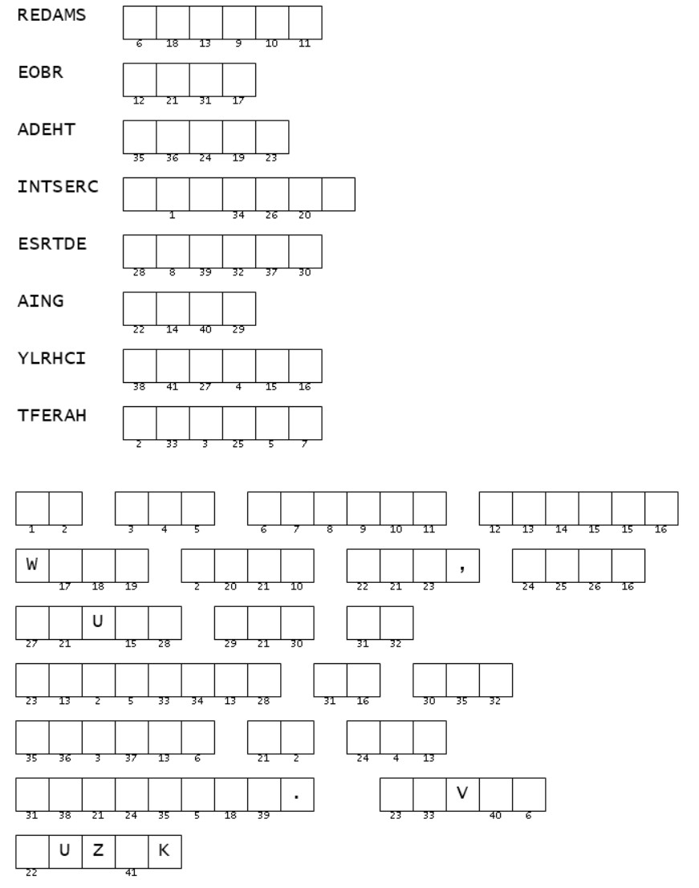
Double Puzzle

Then use the numbers to determine the letters in the blanks of the comment and the name of the author who wrote about Joseph’s situation. Get help at https://tinyurl.com/4va8y62a Find other Family Activies there also.
Rearrange the letters to determine the clue words. These words can be found in your Bible study passage.

