1. Motivate

When was a time you told a true story that other people found hard to believe?
- you got a good grade on a test
A video introduction to the Bible study is available. View it at https://tinyurl.com/mvxhxrnu If you don’t have wi-fi where you teach, it is best to download the video file to your computer from https://tinyurl.com/yph8h637
- your team won the game
- you got a new job with a raise
- you lost your job
- gossip important information that was so juicy that people wouldn’t believe it
- you got engaged
- we’re going to have a baby, again

2. Transition

Today we look at some important news shared by some women “Jesus is Alive!”
- It was totally true but was hard for many to believe when they first heard it
- It is still true today and some people still struggle with the reality!
- Jesus rose again to give us victory over death.

3. Bible Study

3.1 Look to the Empty Tomb

Listen for multiple surprises.

Luke 24:1-6a (NIV) On the first day of the week, very early in the morning, the women took the spices they had prepared and went to the tomb. 2 They found the stone rolled away from the tomb, 3 but when they entered, they did not find the body of the Lord Jesus. 4 While they were wondering about this, suddenly two men in clothes that gleamed like lightning stood beside them. 5 In their fright the women bowed down with their faces to the ground, but the men said to them, "Why do you look for the living among the dead? 6 He is not here; he has risen!

Why did the women go to Jesus’ tomb?
- took burial spices
- figured Joseph of Arimathea had maybe done only a minimal job when he received the body
- wanted to do a more complete application

What emotions would you have experienced on the way to the tomb?
- fear
- sadness, Jesus had such a good ministry going
- depression
- dread having to see the body of a dead friend
- uncertainty … how to open the tomb, will the soldiers chase us away?

So, what surprises did they experience as they got to the tomb?
- stone rolled away
- empty tomb
- men in gleaming, shining garments

Note the glorious message they heard.
- You are looking among the dead for Someone who is alive!
- Jesus is not here.
- He is risen !

Consider Paul’s comments …
1 Corinthians 15:14-15 (NIV) And if Christ has not been raised, our preaching is useless and so is your faith. 15 More than that, we are then found to be false witnesses about God … 17-19 And if Christ has not been raised, your faith is futile; you are still in your sins. 18 Then those also who have fallen asleep in Christ are lost. 19 If only for this life we have hope in Christ, we are to be pitied more than all men.

According to Paul, what would be different if Jesus had not risen from the dead?
- if Christ not raised, our preaching is useless
- so is your faith
- we are false witnesses about God
- our faith is futile
- we are still condemned in our sinful condition
- people who have died are lost
- we are to be pitied more than all men

How could / should the life of a believer reflect one’s belief that He is risen?
- weekly worship of the Risen Savior
- daily fellowship with Him by reading His Word, praying to Him
- telling others of that reality, inviting them to know Him
- involvement in various church ministries
- raising children, helping grandchildren to know the reality of the risen savior

3.2 Remember What Jesus Said

Listen for a reminder.

Luke 24:6b-8 (NIV) Remember how he told you, while he was still with you in Galilee: 7 'The Son of Man must be delivered into the hands of sinful men, be crucified and on the third day be raised again.'" 8 Then they remembered his words.

Of what words of Jesus were the women reminded?
- He told them of coming death, resurrection after 3 days
- tried to tell them why He was on the way to Jerusalem and what would happen

Why do you think they weren’t yet remembering what He said about raising again from the dead?
- that had gone right past them when He had said it
- it hadn’t made sense to them at the time
- this didn’t make sense either … the whole scene was humanly illogical on several levels

What words indicate divine necessity and divine control over what happened to Jesus?
- Jesus said that these things “must” happen
- Jesus knew what was coming
- He had tried to warn them so they wouldn’t be blindsided
- events were not out of control for God … were not an accident

What kinds of things at Easter distract people in our culture or misdirect attention from the reality of what Jesus said and the reality of His resurrection?
- Easter clothing,
- Songs about Easter bonnet, Easter parade
- Easter bunny
- Easter baskets with Easter candy and Easter eggs
- Easter egg hunts (we had one in our house and one of the real eggs stayed hidden for weeks)

What kinds of things distract believers from the reality of what Jesus said
- our daily responsibilities and problems
- focus on material elements of our lives
- if we are not reading what He says in His Word, we won’t know
- the fast pace of our lives crowds out time spent with Jesus

You are a news reporter when Jesus arose. What title or headline would you write for a news article about Jesus death and resurrection?
- Crucified Man’s Body Disappears
- “King of the Jews” Missing from Grave
All these headlines are still true today!
- Jesus’ Followers Stunned, Roman Officials Suggest Grave Robbers
- Confusion over Missing Body of Executed Criminal
- “He Said He Would Return” Claim Followers
- Self-Proclaimed Messiah Seen Alive After Death

3.3 Jesus Makes Himself Known

Listen for proof that it really happened.
Luke 24:38-43 (NIV) He said to them, "Why are you troubled, and why do doubts rise in your minds? 39 Look at my hands and my feet. It is I myself! Touch me and see; a ghost does not have flesh and bones, as you see I have." 40 When he had said this, he showed them his hands and feet. 41 And while they still did not believe it because of joy and amazement, he asked them, "Do you have anything here to eat?" 42 They gave him a piece of broiled fish, 43 and he took it and ate it in their presence.

The disciples thought they were seeing a ghost. What kinds of things contributed to this reaction?
- they had seen Him die
- the tomb was empty, but who knew how that had happened?
- the whole series of events of the past week had taken such a dramatic turnaround, their minds were still reeling
- the door was locked … how could anyone all of a sudden enter?

How did He prove that He was not a ghost, He indeed had a real (yet risen) body?
- talked to them (offering peace, “Shalom”)
- showed them His hands and feet with evidence of the wounds of the crucifixion
- allowed them to actually touch Him … He was tangible, not an ethereal being
- he ate food

How does Jesus reveal Himself to us today?
- through Scripture
- through the presence of the Holy Spirit who lives within each believer
- the Spirit convicts/convinces us of the Truth God wants us to know
- answers to prayer
- intervening in the events of our lives

The disciples needed God’s peace because of the traumatic events in which they were involved. What kinds of traumatic events do we have that cry out for God’s peace?
- troubled or dysfunctional family relationships
- financial crises, health issues
- loss of a loved one (child, spouse, parent)
- stress and pressure from a job
- aging parents to care for
- family tragedies (death, accidents, job related injuries, wayward children)
- natural disasters – hurricanes, tornadoes, blizzards, earthquakes

Consider that the reality of a risen Savior can indeed bring peace to these situations
- the same power that raised Jesus from the dead is at work in your life, your family
- God cared enough for you to allow His Son Jesus to go through this suffering and separation so that you can have a personal relationship with Him
- He also cares for you in the midst of the non-peaceful situation you find yourself in
- He is interested in you and in what is going on in your life
- He declares "Peace be with you." just like He did for the disciples
Use the last page as a handout so your learners can take home the application points of this week’s lesson.
Application
A Reminder.
- On a notecard, write the simple declaration that changes everything: “He is risen!”
- Place the notecard on your mirror so that you can be reminded every day of the reality of Jesus’s resurrection.

A Summary.
- Memorize 1 Corinthians 15:1-8
- It is a great summary of the story of Jesus.

A Reflection.
- In a journal, write the words “Because Jesus is alive . . .” at the top of several pages.
- Use each page to reflect on an area of your life
- Consider how the resurrection changes that area of life.
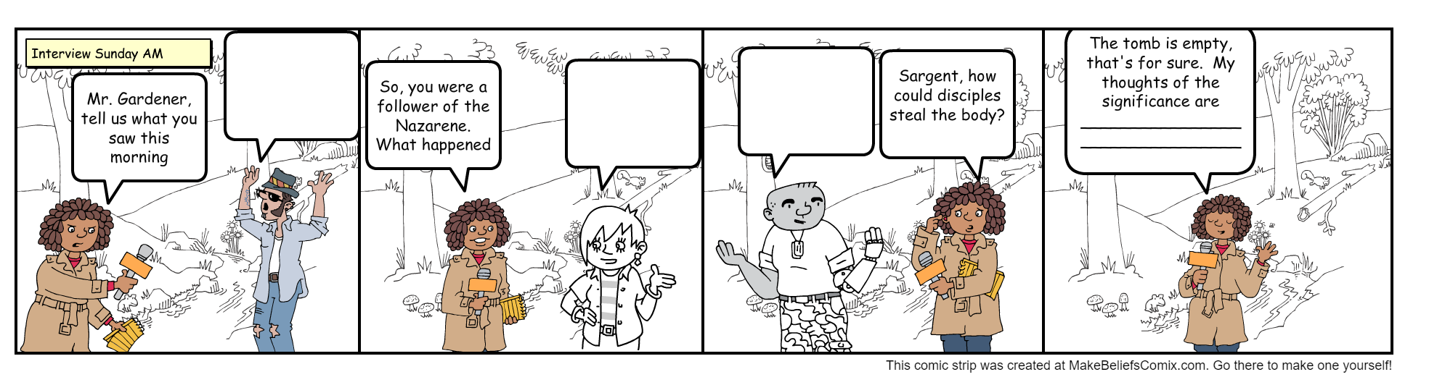
- For example, “Because Jesus is alive, my spending habits . . .”
Interview in the Garden
Crossword, Word Search also available at https://tinyurl.com/yph8h637

Work together as a family to think what some of these people might have said if interviewed? What conclusion can be reached? What message can be shared?

