1. Motivate

What food tempts you to say “yes” to just one more bite?
- pizza
A video introduction to the lesson is available. View at https://watch.liberty.edu/media/t/1_aobqjef7 If you have no wi-fi where you teach, best to download to your computer from https://tinyurl.com/2vymyvwb
- lasagna
- chocolate candy
- mac and cheese
- chocolate pie with whipped cream
- apple pie a-la-mode
- the all you can eat shrimp buffet
- brownies

2. Transition

Unfortunately you discover the results of those seemingly harmless “one more” bites when you step on the scales.
- Saying “yes” to those temptations make a difference
- We have no one to blame but ourselves when we fall into sin.

3. Bible Study

3.1 God Does Not Tempt You to Sin

Listen for what not to say.

James 1:13 (NIV) When tempted, no one should say, "God is tempting me." For God cannot be tempted by evil, nor does he tempt anyone.

What are some ways we may excuse our temptation to sin?
- it’s my “besetting sin”
- I can’t help myself
- what I do is really not so bad – it’s not like I’m hurting anyone
- the 10 commandments don’t say anything about doughnuts
- God just placed that temptation to be right in front of me
- No way I could avoid falling right into it

Why would we try to say God tempted us?
- takes the blame away from ourselves
- we think of God as being in control … easy to say He did it
- we tend to confuse temptations with trials or tests we talked about last week
- maybe God is testing us by sending a temptation
- we have the wrong understanding of God

Why is it not possible for God to be at fault for our temptation to sin?
- God is righteous, just – He always does the right thing
- Scripture declares, God does not sin, and He does not tempt us to sin

Why is it important to know that God doesn’t tempt anyone?
- we need to be aware that that cannot be our reason (excuse) to do something
- we can trust God to help us and not to lead us astray
- we need to be sure of the attributes of God – holiness, righteousness/justice, love, omnipotence, omniscience, …

So what makes a temptation appealing?
- promises pleasure
- looks like fun
- suggests personal gain
- gain of money, adventure, position, or an appeased palate
- suggests/promises you won’t get hurt

If temptations promise good but never deliver, why do we so often say yes to them?
- we fool ourselves
- we think this time is different
- we block out the other times they didn’t deliver
- this time it looks better
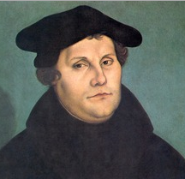
Martin Luther said, “You cannot keep the birds from flying over your head, but you can keep them from making a nest in your hair.” What does that have to do with temptations?
- temptations will happen
- they are inevitable
- the temptation itself is not a sin
- yielding to the temptation is the sin
Picture from Wikipedia

James is telling us that when we do sin, we have no one to blame but ourselves

What practices can help us avoid the enticement of sin (or the birds from nesting in your hair)?
- daily communication with God
- read and apply God’s Truth to our lives
- talk to God about the action or attitude that you struggle with
- confess the sin (agree with God that what you had done is sin)
- receive by faith His forgiveness (1 John 1:9) – acknowledge that God has already forgiven you through Christ’s death on the cross for all your sins
- tell God you are trusting in His strength to not give in to that temptation

3.2 Temptation Begins with Our Own Sin Nature

What are some things that are tempting to some people but not to others?
- gambling
- drinking alcohol
- theft
- anorexia/bulimia
- chocolate
- the desire for power, for more riches

Listen for who is to blame when we sin.

James 1:14-15 (NIV) but each one is tempted when, by his own evil desire, he is dragged away and enticed. 15 Then, after desire has conceived, it gives birth to sin; and sin, when it is full-grown, gives birth to death.

Let’s list the sequence that starts with temptation.
- temptation appears
- one’s own evil desire drags the person into the enticement of that temptation
- the evil desire is “conceived”
- it gives birth to sin
- “full-grown” sin gives birth to death

You should know that temptation follows a predictable pattern

Consider some basic needs that we have … for each, identify how it can be twisted into something sinful.
Need | Twisted into evil
Food | - tastes good, we keep eating … and eating and eating
Approval | - we overdo the pursuit of approval, even to the abandoning of our principles of right and wrong, just to be accepted by the crowd
Shelter | - my shelter has to look nicer, be larger and fancier (and cost more)
Companionship | - pursue wrong relationships, outside marriage (“my spouse just doesn’t understand me”)
Transportation | - my car/truck has to be the best, most powerful, prettiest, most expensive
Clothing | - I need new things … I deserve pretty things … got to keep up with latest styles whatever it costs
Entertainment | - it’s only rated R, I can ignore that stuff … no one will know this web site I go to … I’ll erase the cache

3.3 Everything Good Comes from God

Listen for a reminder of God’s goodness to us.
James 1:16-18, 21 (NIV) Don't be deceived, my dear brothers. 17 Every good and perfect gift is from above, coming down from the Father of the heavenly lights, who does not change like shifting shadows. 18 He chose to give us birth through the word of truth, that we might be a kind of firstfruits of all he created. 21 (NLT2) So get rid of all the filth and evil in your lives, and humbly accept the word God has planted in your hearts, for it has the power to save your souls.

What do you see here about how God does demonstrated goodness to us?
- gave us good and perfect gifts
- He is unchanging, dependable
- He gave us birth (both physical and spiritual)
- birth through the word of truth
- He made us the “firstfruits” of all he created.

What good gifts have you received from God?
- health
- freedoms
- Fruit of the Spirit
- family
- shelter, clothes to wear, food to eat, transportation

- Salvation
- God’s power and authority acting
on our behalf, God’s love

How does James’ image of light illustrate the constancy and faithfulness of God?
- light is constant - the sun just keeps shining
- His love shines on us continuously
- He does not hide that light of love
- no shadows that might signify a capricious or unpredictable anger against us

Verse 18 says, “He chose to give us birth through the word of truth” What do you think is the role of the Bible in leading a person to experience new birth?
- gives the specific steps needed
- tells of need for repentance, confession, faith
- tells in whom to place our trust
- tells what Jesus did to solve the sin problem

It is vital to know specific passages which give the sinner these truths and the sequence in which to present them.

Verse 21 says, “humbly accept the word planted in you” for the purpose of getting rid of the moral filth and evil excess … how does God’s Word help do this?
- in some areas it gives specific behaviors which must be/not be present in the life of a believer
- also gives principles of behavior
- teaches of the presence and the power of God dwelling within the life of the believer
- gives examples of people whose lives were changed or who demonstrated lives of victory over evil
- gives promises about God’s help, gives encouragement
Use the last page as a handout so your learners can take home the application points of this week’s lesson.

Application
Confess.
- If you blamed others or God for your sin or the fact you fall into sin, confess that to God.
- Admit your own responsibility and look to God to help you stand and resist the pull of sin.

List.
- Make a list of the good things God has done or placed in your life.
- Add to your list any trials or difficulties God used to strengthen your faith in Him.
- Offer a prayer of thanks for how He has worked in your life.

Instruct.
- Help someone you know who is struggling with temptation by sharing the truths you discovered in James 1:13-18.
- Don’t just focus on the principle that we alone are to blame for our sin, but lift up the goodness of God who can walk with and strengthen us.
Double Puzzle
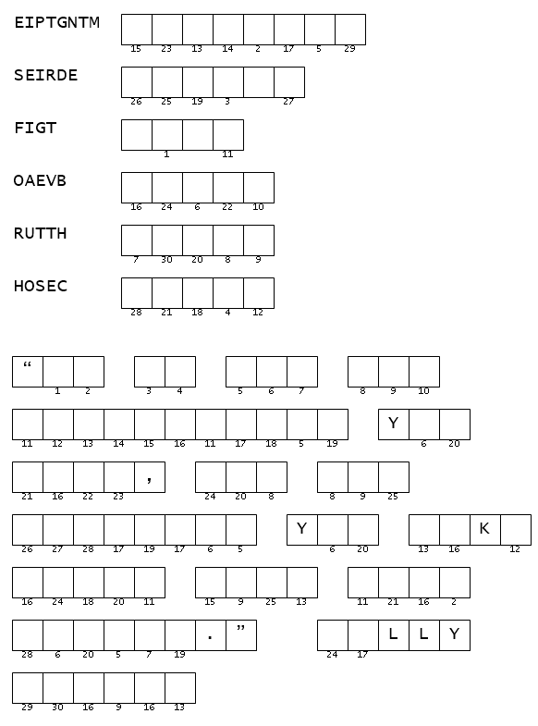
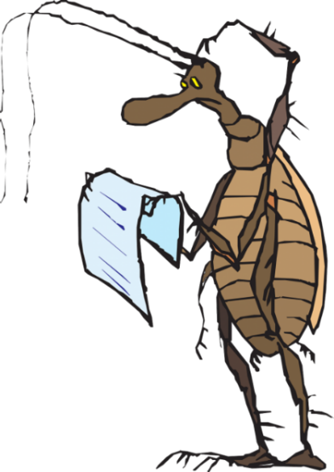
Aiee Cucaracha !! Those words … are they even words? Oh, I see, they’re scrambled and if you can get them unscrambled, they give you the numbers for the secret message. Rumor has it they all come from your Bible Study passage. Spiros the Spy forwarded this to our department. That really bugs me. Assistance is found at https://tinyurl.com/2vymyvwb along with other Fun Family Activities.

