1. Motivate

Why do different people struggle with different types of temptations?
- different personalities
- different environments, cultural backgrounds
- physical makeups
- men versus women – different temptations
- different things tempt you when you are young and when you are older
- the people you associate with
- in some cases, Christians might have different temptations than unbelievers

2. Transition

Though temptations may be different for different people …
- You need to know, whatever tempts you, God has something better.
- Today we look at how to follow Jesus’ example in defeating spiritual attacks.
A video introduction to the Bible Study is available. View at https://watch.liberty.edu/media/t/1_95n2ecn6 If you have no wi-fi where you teach, best to download to your computer from https://tinyurl.com/ktwft9kf
3. Bible Study

3.1 God-given Desires

Listen for why Jesus was vulnerable.

Matthew 4:1-4 (NIV) Then Jesus was led by the Spirit into the desert to be tempted by the devil. 2 After fasting forty days and forty nights, he was hungry. 3 The tempter came to him and said, "If you are the Son of God, tell these stones to become bread." 4 Jesus answered, "It is written: 'Man does not live on bread alone, but on every word that comes from the mouth of God.'"

Jesus had been without food. Why would someone be more susceptible to temptation when physically tired and hungry?
- physical weakness affects your thoughts and actions
- you don’t think straight
- your body’s reactions are slower
- your thinking is not sharp

Why did Satan preface his temptation with “If you are the Son of God …”?
- cast doubt in Jesus’ mind while He is weak with hunger
- appeal to Jesus’ self-concept of deity
- make fun of Jesus
- remind Jesus He had the power to do these things, even if it might not have been the right thing to do

This temptation was in the physical realm. What are some ways we face temptation through our physical appetites?
- alcohol
- tobacco
- chocolate chip cookies – substance abuse of any kind
- overindulging in food
- sex
- overuse of painkillers

How do we justify decisions to satisfy God-given desires in the wrong way?
- “I couldn’t help it”
- I was hungry – couldn’t stop eating those doughnuts/that pizza
- she was so pretty / he was so good looking
- I needed that money to pay the rent
- I was so tired of feeling depressed, I needed the pill to get going
- I’ve got so much work and responsibility, I needed to get along with out the sleep
- I’m so tired on the weekend, need the sleep more than getting up for church
- I’ve got no clothes nice enough to be presentable at church

When have you been tempted to doubt God’s provision?
- when the money ends before the month ends
- when there’s not enough time to meet all my responsibilities
- when the doctor cannot figure out what is wrong with me/with my child/with my spouse
- when I’m trying to find a new job and I’m too old to get hired
- when I can’t get a job because of no experience, but without a job you can’t get experience
- the car has 250,000 on it and keeps breaking down and there’s no money for a replacement
- I’ve prayed and prayed, and my son/daughter is still rebelling against God

How did Jesus respond to this temptation?
- quoted scripture
- “it is written, man does not live on bread alone”
- rather we live on “every word that comes from the mouth of God”

How can memorizing Scripture help us combat temptation? What role does the Word of God play in resisting temptation?
- knowing and claiming God’s promises
- knowing God’s principles and being able to recognize what in Satan’s temptations are really wrong
- being convinced of God’s power and authority and love for me
- knowing and meditating on the attributes of God – omnipresence, omnipotence, omniscience, love, sovereignty, healer, mercy, grace, …

3.2 God’s Provision

Listen for how God provided.

Deuteronomy 8:2-5 (NIV) Remember how the LORD your God led you all the way in the desert these forty years, to humble you and to test you in order to know what was in your heart, whether or not you would keep his commands. 3 He humbled you, causing you to hunger and then feeding you with manna, which neither you nor your fathers had known, to teach you that man does not live on bread alone but on every word that comes from the mouth of the LORD. 4 Your clothes did not wear out and your feet did not swell during these forty years. 5 Know then in your heart that as a man disciplines his son, so the LORD your God disciplines you.

What purpose did these forty years in the wilderness serve?
- humble them – get them to realize and remember their limitations
- remind them of God’s power and authority at work for them
- get them to realize their need for God
- remind them of His sufficiency
- they learn that obedience and trust/dependency on God is the way to live

What lesson did the manna, the Lord’s total care of clothing, and strengthening of feet teach?
- miraculous provision for food, miraculous preservation of their resources
- God will provide your needs
- He will make your resources go farther than they normally would
- God will act and supply in His timing and will never be late

How can remembering God’s past actions help us resist the temptation to doubt His provision for today?
- you realize God’s “track record”
- maybe the current situation is different, but you realize God is just as powerful and creative to deal with what is going on now

Why do we tend to question God when we experience severe need?
- why did God let this happen?
- we think, “this is too big / too small for God to handle” … “He’s too busy for little old me”
- how could this ever be resolved – what a mess
- “I can’t think of any solution to this problem”

We are spiritual people … what we need most is spiritual food. In what ways does God’s word “feed” us?
- tells us what God wants us to know
- tells us of His power
- tells us about salvation through Christ, tells us principles by which to live
- reassures us of God’s love, God’s care
- gives us many promises
- it is the “owner’s manual” – go by what it says to get better “mileage” out of life
3.3 Trust and Obey

Listen for amazing promises.

Deuteronomy 8:6-10 (NIV) Observe the commands of the LORD your God, walking in his ways and revering him. 7 For the LORD your God is bringing you into a good land--a land with streams and pools of water, with springs flowing in the valleys and hills; 8 a land with wheat and barley, vines and fig trees, pomegranates, olive oil and honey; 9 a land where bread will not be scarce and you will lack nothing; a land where the rocks are iron and you can dig copper out of the hills. 10 When you have eaten and are satisfied, praise the LORD your God for the good land he has given you.

What promises did Moses make to faithful Israelites?
- God is bringing you into a good land
- the land will have streams, pools, springs
- the land will have wheat and barley, vines and fig trees, pomegranates, olive oil, honey
- the bread will not be scarce
- you will lack nothing
- there will be minerals in the earth to be mined and used

What phrases describe the requirements of faithfulness that would make these promises happen?
- observe God’s commands
- walk in God’s ways
- revere God – be in awe of His power, authority, love for you

Upon enjoying all that the Lord had given, how were the people to respond?
- be sure to praise God for His provisions
- remember it is God who has accomplished all of these good things
- don’t be tempted to think, “how lucky, how fortunate”
- don’t be tempted to think, “I really deserve this”
- don’t be tempted to think, “look at what I have achieved”
- give God the glory

God has been good to us … praise Him … give God the glory … be in awe of His love

So how does knowledge of what God will do for you in the future affect how you act in the present?
- the promised results are good motivation
- the cause and effect is laid out before us
- what God offers is far better than what we can do on our own
- it only makes sense to take His offer and believe what He says
Use the last page as a handout so your learners can take home the application points of this week’s lesson.
Application
A grateful heart.
- One of the ways we can battle when Satan tempts us to doubt God’s provision is to give thanks for all God has provided for us.
- Take a moment to count your blessings and give thanks for His provision.

A trusting heart.
- God will provide as we trust Him. Between now and the time He provides, wait and trust.
- God will provide what you need in His perfect timing. Trust Him to strengthen your faith as you wait.

A generous heart.
- When we doubt God’s provision, we wish we had what others have.
- We can also be drawn to materialism. Generosity is the key to battling covetousness and materialism.
- As you trust God to provide what you need, be willing to give and be a conduit of His provision to others.
Fallen Phrases Puzzle
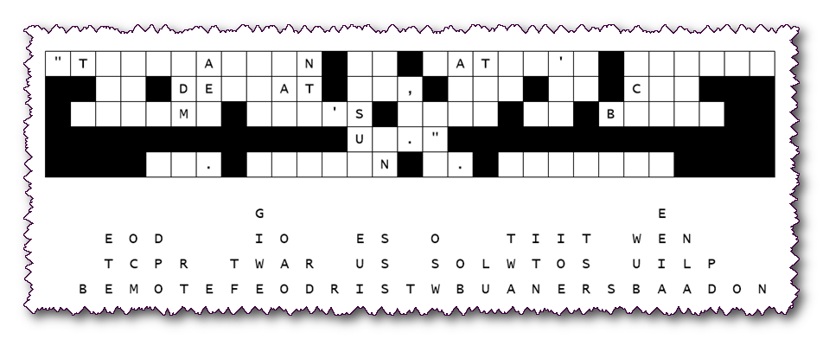
This discarded message form was retrieved from the trash of the Walirianew Secret Police. Apparently, they were unable to reconstruct the secret code. We believe your Bible Study class has the knowledge to recreate the original text. The letters are straight down from their original location. Begin with single letter columns, then two and three letter words. Use letters that make reasonable words. Watch out for punctuation marks, there’s no letters there. Additional help and other Family Activities are available at https://tinyurl.com/ktwft9kf

