1. Motivate
A video introduction is available to view at https://watch.liberty.edu/media/1_ufxc3cuf
If no Wi-Fi available where you teach, download to your computer from https://tinyurl.com/y2vy4js3

When has a friend or family member helped you through a difficult experience?
- dad helped me with throwing a baseball, my friends were making fun of me
- brother helped me learn how to slide into a base, otherwise I’d been hurting my knee
- sister helped learn how to finish a sewing assignment I was flunking in home ec.
- mom gave pointers on baking a cake after a disastrous first try
- uncle was a whiz at math and helped me not flunk algebra
- grandpa was a woodcarver, got me past the fear of cutting off my finger
- grandma was a prayer warrior, faithfully prayed for me during my rebellious teens
- neighbor rescued me when my car broke down 15 miles from home
- friendly policeman stopped and helped me change a flat tire (I was a new driver)

2. Transition

It’s great to have folks we know we can depend on in a tough situation.
- It’s especially true when we are confronted with a tragic loss.
- How wonderful to know the assurance from God, who responds to our troubles and sorrows with grace and compassion.

3. Bible Study

3.1 Call to God

Listen for a cry for help.

Psalm 116:1-4 (NIV) I love the LORD, for he heard my voice; he heard my cry for mercy. 2 Because he turned his ear to me, I will call on him as long as I live. 3 The cords of death entangled me, the anguish of the grave came upon me; I was overcome by trouble and sorrow. 4 Then I called on the name of the LORD: "O LORD, save me!"

The psalmist declared his love for God. What reason did he cite for his declaration of love?
- He heard my voice
- He heard my cry
- He turned his ear to me

What promise did the psalmist make?
- I will call on Him as long as I live
- I know I can always depend on Him to hear me and help

What specific examples, what words and phrases did the psalmist relate to substantiate his claim about his problems?
- the cords of death entangle me
- the anguish of the grave came upon me
- I was overcome by trouble and sorrow

What are some of our typical first responses to sad news?
- cry
- eat chocolate
- be mad at God, blame Him
- ask “why did this have to happen?”
- some version of “when you worry, when you doubt, run in circles, scream and shout”
- fall apart
- pull the covers over your head and withdraw

What kinds of things might keep us from taking our sorrows to God?
- think “this is too small for God to attend to, He’s got bigger issues to deal with”
- think “this is too much of a mess for even God to fix”
(both of these are lies from Satan)
- lack of faith
- we’re not in the habit of going to God first
- we think that we take problems to God, but our sorrows are just feelings we need to deal with on our own
- we need to develop a closer walk with God to realize His love and concern, His mercy and grace
- we think He is omniscient, knows everything, so He must know about this obvious problem

Why should prayer be such an important part of the grieving process?
- we need to talk to God about all the issues in our lives
- tell Him how you feel (He knows, but talking to Him is a declaration of faith)
- when we go to God with our feelings (both good and bad) we are showing that we realize how much he loves us and wants to be involved in our lives
- God is someone who will listen, someone who is always there, someone who can do something about the problem

3.2 Rest in God

Listen for God’s benevolence.

Psalm 116:5-9 (NIV) The LORD is gracious and righteous; our God is full of compassion. 6 The LORD protects the simplehearted; when I was in great need, he saved me. 7 Be at rest once more, O my soul, for the LORD has been good to you. 8 For you, O LORD, have delivered my soul from death, my eyes from tears, my feet from stumbling, 9 that I may walk before the LORD in the land of the living.

Identify three traits of the character of the Lord the psalmist highlighted in verse 5. What is the meaning and significance of each?
Character Trait | Meaning & Significance
Gracious | demonstrates love and bless us, even though we don’t deserve it
Righteous | is just, does the right thing, makes the right decision
Full of compassion | concerned, kind, considerate

What are some specific examples the psalmist gives of God’s love and compassion? Why could he feel at rest?
- protects the simple hearted
- when he was in need, God saved him
- God has been good in the past, will be good to us in the future
- delivered my soul from death, my eyes from tears
- kept him from stumbling

What does it mean to you to find rest in the sense used by the psalmist?
- often in times of trouble and grief, we cannot sleep
- our mind seems to go a million miles an hour in circles trying to deal with the situation
- we have no solutions, none in sight
- until God gives assurance
- He takes the load, declares He will deal with it
- it is no longer our problem

What hope is expressed in verse 9?
- he will continue to walk with the Lord
- as long as he lives, he will continue to put his trust in God
- problems come and go, but God is always with him

What attributes, characteristics about God can help you during times of sorrow?
- God’s love for us
- God’s omnipotence, power
- God’s sovereignty – He is in charge and does as He pleases to do (he pleases to show His love for us)
- God’s presence – omnipresence … we are never out of His care and watchfulness
- God sees us where we are, is watching over us, knows what we are going through

What kinds of feelings and thoughts does a person have when physically or emotionally exhausted?
- ready to give up
- despair
- don’t know where to turn, what to do
- might feel like God has forsaken, forgotten us
- we don’t think straight – shouldn’t make decisions in that context

In light of these kinds of emotions, why was the writer able to rest in God? How does “resting in God” express thanks to Him?
- turn over the problems to God
- let Him deal with it because we certainly cannot
- we are declaring our trust in His love, power, and authority – that declaration of trust is a form of thanks

3.3 Trust in God

Listen for God’s perspective on death.

Psalm 116:15-17 (NIV) Precious in the sight of the LORD is the death of his saints. 16 O LORD, truly I am your servant; I am your servant, the son of your maidservant; you have freed me from my chains. 17 I will sacrifice a thank offering to you and call on the name of the LORD.

What different perspective on death did the poet come to understand?
- death (separation of body and spirit) is a precious event to God
- it is not altogether a tragedy
- we believe he understood it as precious because God welcomes the believer (His saints) into His presence
- the person’s spirit leaves the body and joins the presence of God in heaven
- believers will now be rescued not only from the penalty and power of sin, but we are also then delivered from the actual presence of sin

Why is worship important even while we are experiencing grief?
- worship is declaring God’s worth¸ His worthiness to be praised
- it is an act of faith when we in crisis to declare God is worthy of our praise
- we are declaring His power, authority, and love for us
- we are declaring that He will continue to be in charge and will bring us through victoriously
- Note: easy to say this in a Bible Study class … often more challenging to put it into practice when we are in the midst of a crisis

What are some benefits of trusting God during difficult circumstances?
- we are assured God is at work in every circumstance in our lives
- He’s “got your back”
- He can accomplish good things in our lives even from the difficult situation
- we learn to trust him more and more
- we discover His powers of deliverance
- we experience God’s victory over the bad things Satan tries to use to defeat us

What helps you trust God during difficult circumstances?
- meditating on God’s attributes … love, sovereignty, omnipotence, omnipresence, omniscience, wisdom, …
- remembering how God met the need in previous situations
- talking with God … hearing Him speak through Scripture, talking to Him in prayer
- confessing my doubts, my fears

When facing a struggle, how do you come to a place of rest that enables you to press on because you know God loves you?
- meditate on who God is, His attributes
- remind yourself of God’s promises
- declare your trust in His love for you and His greatness
- claim specific verses – their Truth, their promise, the reality of God who is in charge
Use the last page as a handout so your learners can take home the application points of this week’s lesson.
Application
Pray.
- If you’re in a season of grief or sorrow, pray.
- Talk to God about what you’re experiencing and feeling.
- Read Psalm 116 as a prayer of trust.

List.
- Make a list of all the ways God has shown you grace and compassion.
- When difficulties arise, pull out that list and reflect on the ways God has worked in your life.
- Trust God to continue working in your life.

Listen.
- If you have a friend or relative going through grief, invest time to sit with him or her.
- You don’t have to offer advice or try to talk them out of their grief.
- Just sit, listen, and be the presence of Christ.
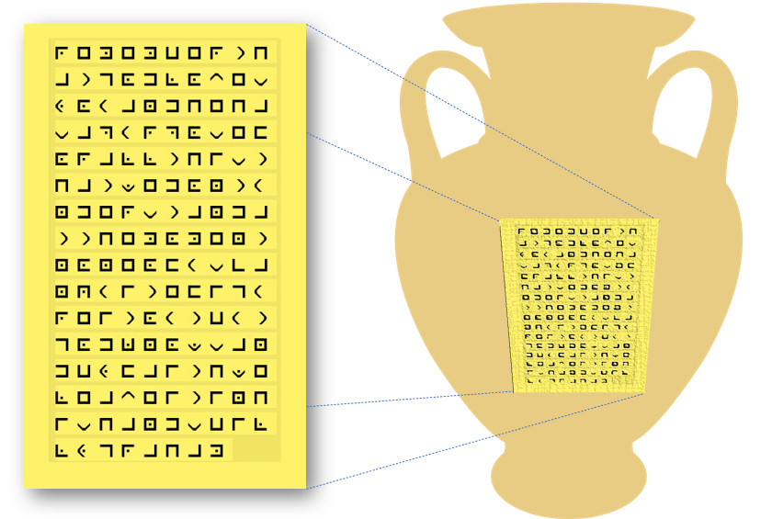

Our Fine Arts Secretary at the Roonstanbaz embassy has forwarded us a photo of a recently discovered urn with what is meant to look like decorative engraving on the side. This appears to be an ancient commonly used code for which we have the key (shown above). Give us a hand and decode it. Have your visitation committee forward it to NSA immediately. Technical assistance and further engaging activities are available at https://tinyurl.com/y2vy4js3

