1. Motivate

When has someone shown you that they really “had your back”?
- helped the family when I was in the hospital
- warned me of a dangerous potential problem
- someone who pulled me out of a burning car
- helped me study for a test in school
- the person who was concerned enough to share the Gospel with me
- all those little old ladies who prayed for me while I was deployed overseas in the army
- the pastor who counseled me when I was a teenager
- my parents who wisely disciplined me and set reasonable limits
- the teacher who went the extra mile to make sure I understood the topics
A video introduction is available. View at https://watch.liberty.edu/media/1_2qc965c8
If no Wi-Fi where you teach, best to download to your computer from https://tinyurl.com/y6rmg8dk
2. Transition

As we studied earlier, “no man is an island.”
- We need one another
- We strengthen one another to live a life honoring to God.

3. Bible Study

3.1 Help to Stand Against Worldly Sin

Listen for a contrast.

Ephesians 5:8-14 (NIV) For you were once darkness, but now you are light in the Lord. Live as children of light 9 (for the fruit of the light consists in all goodness, righteousness and truth) 10 and find out what pleases the Lord. 11 Have nothing to do with the fruitless deeds of darkness, but rather expose them. 12 For it is shameful even to mention what the disobedient do in secret. 13 But everything exposed by the light becomes visible, 14 for it is light that makes everything visible. This is why it is said: "Wake up, O sleeper, rise from the dead, and Christ will shine on you."

What contrasting imagery did Paul use to describe the change that had taken place in the lives of his readers?
- You were once darkness
- now you are light
- live as children of light

What are effects of light on darkness?
- darkness is the absence of light
- light exposes what is there
- enables us to find what we want, avoid what we don’t want
- light makes things visible

These are physical qualities of light. What point is Paul trying to make spiritually? What does he mean is spiritual “light”?
- God’s Truth, God’s Word
- the Gospel message
What do you think it means to be ‘children of light’?
- grow spiritually in an environment of spiritual light
- the light of the Gospel changes the believer
- the Truth of God’s Word begins to have more and more of an effect on how we live
- it exposes elements of our lives that God wants to change
- it shows us not only what to change but shows us how to change … by allowing God’s Spirit to change us
- our lives will demonstrate God’s Truth and light to those around us

How does the apostle describe light or its fruit in Ephesians 5:9? Define each term in your own words.
- goodness doing, saying good things
- righteousness doing the right thing, living right
- truth truth is that which aligns with reality …
we live demonstrating God’s reality

What are some examples of “fruitless works of darkness” that exist in our culture?
- human trafficking
- opioid epidemic (legal drugs)
- illegal drugs
- gang violence
- racial unrest
- hatred between political parties
- constant pursuit of pleasure, power, material gain

What is to be the relationship of the believer to works of darkness?
- have nothing to do with them
- realize they are fruitless – they don’t accomplish anything good
- they are not among the Fruit of the Spirit (in fact the opposite)

How can we avoid becoming desensitized to this darkness?
- it is all around us … news, commercials, entertainment
- it fills our sight, our minds
- we must purposefully fill our minds with the Light of God’s Truth, God’s attitudes of goodness and righteousness
- pray against the spirits of darkness
- minister to people who have become trapped in this darkness

How can we expose fruitless works of darkness without saying a word?
- quietly walking away when dirty stories/jokes are being told
- when our reading material is obviously in the open for others to see and is in contrast to other people’s
- politely declining invitations to entertainment you know is unacceptable for a believer, “Sorry, it’s not my style.”
- counter such invitations with something you know is more acceptable, maybe even uplifting
3.2 Help to Make Wise Use of Time

Listen for a contrast between wise and unwise.

Ephesians 5:15-17 (NIV) Be very careful, then, how you live--not as unwise but as wise, 16 making the most of every opportunity, because the days are evil. 17 Therefore do not be foolish, but understand what the Lord's will is

What is the admonition in these verses?
- be careful how you live
- don’t live foolishly, unwisely … live wisely
- make the most of every opportunity

What would be some characteristics of a believer who lives wisely in the midst of our sensual culture?
- careful about entertainment choices
- fill your mind with good things
- read from and meditate on God’s Word
- pray for God’s wisdom, guidance in decisions made
- claim the Spiritual armor (especially the helmet of salvation, breastplate of righteousness to protect our minds and our hearts/emotions)

How is it that even a believer can lose focus on living wisely?
- we neglect to guard our hearts – consider Proverbs 4:23 (NIV) Above all else, guard your heart, for it is the wellspring of life.
- we are bombarded with commercials, advertisements that stress pleasure (for even housing, cars, and food)
- lack of time spent with God

Why is seeking pleasure an unwise way to spend life?
- such an attitude seeks to fulfill self
- it is inward focused – no thought or effort to meet needs of others
- God gives believers Spiritual Gifts to minister to one another, to build one another up, not to receive personal satisfaction

You may know or admit to being a “workaholic.” How might this be an unwise use of one’s time and even result in impurity?
- again, this is focusing on a self-need
- it offers the excuse that he/she is doing it for the benefit of family
- in reality the family suffers from that person’s absence
- he/she should be making contribution of time and attention to other family members

In addition to time alone with God and quality time with family, what are some other wise uses of our time where you support others?
- church ministry opportunities
- volunteering for community activities (civic groups, hospital volunteer groups)
- learning new skills, taking classes to improve one’s knowledge
- go on a mission trip
3.3 Help to Living in Mutual Submission

Listen for yet another contrast.

Ephesians 5:18-21 (NIV) Do not get drunk on wine, which leads to debauchery. Instead, be filled with the Spirit. 19 Speak to one another with psalms, hymns and spiritual songs. Sing and make music in your heart to the Lord, 20 always giving thanks to God the Father for everything, in the name of our Lord Jesus Christ. 21 Submit to one another out of reverence for Christ.

What two contrasting options are identified for determining our conduct
- being drunk with wine – coming under the influence or control of some substance
- being filled with the Spirit
- allowing other things to control you vs. allowing God to control your life
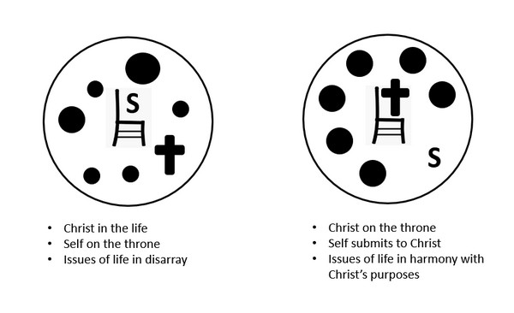
What does it mean to be filled with the Spirit?
- sensitive to God’s control in your life
- allowing God to guide your choices, your actions
- depending on God for the Spirit’s strength
- allowing God to demonstrate the Fruit of the Spirit through your life … love, joy, peace, patience, kindness, goodness, gentleness, faithfulness, and self-control

What are some of the results of being filled with the Spirit?
- Fruit of the Sprit demonstrated in our lives
- each believer receives and lives out a Spiritual Gift for the benefit of the Body of Christ … fellow believers
- Spiritual armor and weapons – helmet of salvation, breastplate of righteousness, belt of Truth, shoes of the Gospel, sword of the Spirit (the Word of God), shield of Faith

How does the biblical concept of being submissive differ from the popular cultural view?
Biblical Submission | Cultural View of Submission
- defer to one another  - not always demanding your own way  - willing to go along with other reasonable opinions | - you will do what I say  - you will submit to ME  - I’m in charge, you are not  - more an attitude of domination

What motive does Paul give for being submissive to one another?
- out of reverence to Christ
- we submit to God, to His control in our lives
- then we will be considerate of others
- we act in love … acts of kindness with no demand or expectation of reciprocity
- God loves us in that way, we love others in the same way

Use the last page as a handout so your learners can take home the application points of this week’s lesson.

Application
Identify.
- Through prayer and introspection, identify recurring sins and temptations that weigh you down.
- Confess those things to God and ask Him to bring others into your life to strengthen your walk.

Influence.
- As you experience strength and victory in your own life, look for opportunities to influence others.
- Be a self-less and submissive member of your church.

Invite.
- Invite another Christian or group of Christians to be a part of your fight against temptation.
- Confess your temptations to them and allow them to confess theirs to you. Stand together against those struggles.
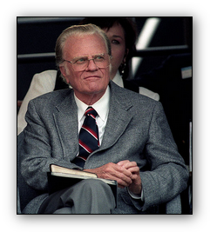
All over this great auditorium people are wondering what has happened. Well, the letters fell straight down. You can put my quote back together, right where you are. Work on the two and three letter words first to see what letter combinations make sense. Then figure out the longer words. Check Eph. 5:18b for clues. You will be strengthened by the Truth in that verse. You can find personal help and further Family Activities at https://tinyurl.com/y6rmg8dk

