1. Motivate

What are some different ways you access information for home, work, church, areas of curiosity?
- Internet, Google
- library
- access library books online
- watch the news, weather
- various apps on your computer or cellphone
- Artificial intelligence such as chat.gpt.com
- read the paper
- Facebook, Instagram, etc.
A video introduction to the lesson is available. View it at https://tinyurl.com/4unt5xkj If you don’t have wi-fi where you teach, you must download the video file to your computer from https://tinyurl.com/r83e4r2p
- check with local gossips!!
- ask your kids/parents

2. Transition

Today we look at WISDOM
- God grants wisdom as we learn from Him and apply what we learn
- Believers have the Wisdom of God because we have the Spirit of God

3. Bible Study

3.1 Worldly Wisdom – Foolishness

Listen for leading questions.

1 Corinthians 1:20-25 (NIV) Where is the wise man? Where is the scholar? Where is the philosopher of this age? Has not God made foolish the wisdom of the world? 21 For since in the wisdom of God the world through its wisdom did not know him, God was pleased through the foolishness of what was preached to save those who believe. 22 Jews demand miraculous signs and Greeks look for wisdom, 23 but we preach Christ crucified: a stumbling block to Jews and foolishness to Gentiles, 24 but to those whom God has called, both Jews and Greeks, Christ the power of God and the wisdom of God. 25 For the foolishness of God is wiser than man's wisdom, and the weakness of God is stronger than man's strength.

What kinds of things do the Jews seek? What are the Greeks looking for?
Jews | Greeks
- demand signs  - looking for a political or military Messiah | - look for wisdom  - want to debate, discover, use reasoning

Why do you think each group would struggle with the message of the cross?
Jews | Greeks
- didn’t want someone who opposed religious leadership  - how could the victorious Messiah get Himself martyred?  - if people followed this Messiah, the religious leaders would be out of a job | - this guy was just a martyr  - he’s dead  - can’t be alive now  - they crucified him  - the so called “resurrection” must have been a robbing of the grave

In what ways are we tempted to trust human wisdom more than God's wisdom?
- the life choices we make
  - marriage partner (or in today’s world, just “partner”)
  - what college to go to
  - where to invest and get rich
  - choice of vocations
- who to vote for
- how to raise children
- how to deal with problems at work, with neighbors, within families

Why do you think people often admire intelligence, education, wealth, or influence more readily than humility, faith, or obedience?
- our culture is humanistic … humans are the smartest beings on the planet
- we hear a lot of “you can be/do whatever you want”
- we are a lot like the Greeks Paul speaks of … reasoning and wisdom can be pursued and will succeed
- faith is just wishful thinking
- intelligence, education, wealth and influence are what succeeds
- “humility and faith (whatever that is) are for losers”

If God's wisdom often runs contrary to worldly wisdom, how can we become better at recognizing which voice we're listening to?
- fill our minds with Gods Truth
- daily reading and thinking on Scripture
- daily (even multiple times a day) talking to God
- follow Deuteronomy 6:6-7 (NIV) These commandments that I give you today are to be upon your hearts. Impress them on your children. Talk about them when you sit at home and when you walk along the road, when you lie down and when you get up.
- these actions build all the right attitudes, mindsets, and worldview into not only your children who hear it, but you who communicate it

3.2 The Spirit Reveals the Mind of God

Listen for how God’s “mystery” is discovered.

1 Corinthians 2:9-11 (NIV) However, as it is written: "No eye has seen, no ear has heard, no mind has conceived what God has prepared for those who love him"-- 10 but God has revealed it to us by his Spirit. The Spirit searches all things, even the deep things of God. 11 For who among men knows the thoughts of a man except the man's spirit within him? In the same way no one knows the thoughts of God except the Spirit of God.

What is the essence of verse 9 and why is verse 10a essential to understanding Paul’s intent?
- on our own we cannot know all that God has for us
- our academic knowledge is not enough
- our skills, abilities, and modern wisdom are insufficient to realize God’s purposes in our lives
- we need the guidance of God, Himself, in the person of God’s Holy Spirit

Who enables us to know and understand the things of God?
- the Spirit of Jesus Christ dwells within our hearts and minds
- He knows and understands all of God’s purposes and plans for our lives
- He communicates those things to us as we read and think on His Word

Why is the Spirit capable of making known the things of God to us?
- The Holy Spirit is God – He loves us – He is powerful to work in our lives,
- He has authority to accomplish wonderful things in and through us
- He will impress upon our thoughts specific principles of Scripture we read or hear taught
- He plants specific thoughts and impressions in our minds and consciousness
- He guides us through the events and experiences of our lives – opening and closing doors of opportunity

Why do people often fail to see God’s purpose for them?
- not looking for, not listing to what God has to say
- if you don’t read God’s Word, God’s message to you, you miss that input
- you can be so caught up in worldly pursuits that you ignore what God is wanting to communicate to you
- you might be in rebellion (active or passive) against God

How can we discern whether it’s the Holy Spirit who is speaking to and leading us?
- God’s communications to us will always be in line with scriptural principles
- an open door of opportunity seems to match the message of a verse or passage you read and study
- a closed door is followed by a new and different and better opportunity
- an activity of ministry you become involved in has positive results of God’s blessing and is a confirmation that this may well be God’s Spiritual Gift for you at this time
- a mature believer offers a word of advice or encouragement that fits with what God is impressing upon your mind at this time
3.3 Depend on the Holy Spirit

Listen for more foolishness.

1 Corinthians 2:12-16 (NIV) We have not received the spirit of the world but the Spirit who is from God, that we may understand what God has freely given us. 13 This is what we speak, not in words taught us by human wisdom but in words taught by the Spirit, expressing spiritual truths in spiritual words. 14 The man without the Spirit does not accept the things that come from the Spirit of God, for they are foolishness to him, and he cannot understand them, because they are spiritually discerned. 15 The spiritual man makes judgments about all things, but he himself is not subject to any man's judgment: 16 "For who has known the mind of the Lord that he may instruct him?" But we have the mind of Christ.

Note the characteristics of the wisdom that the Spirit teaches us.
- Spiritual Truth has its own vocabulary
- It is not human wisdom
- It is God’s wisdom
- It is not so much a case of the persuasion of logic or debate
- It is Truth that is revealed by God, that we accept by faith, because God said it

According to this passage, how are spiritual and unspiritual people different?
Spiritual People | Unspiritual People
- makes judgments about all things  - not subject to man’s judgment  - we have the mind of Christ | - not able to make valid judgments  - must rely on the judgments of other men (who themselves are fallible)  - do not have God’s mind or perspective

What does it mean to have the mind of Christ?
- be in harmony with God’s purposes for our life
- have God’s Truth as the basis for how you live your life
- sensitive to God’s Spirit convicting and convincing you of God’s purposes and desire for you
- God's Spirit brings thoughts into our mind that Christ wants us to know
- We are given the same mind set or attitude towards people and issues that Christ has (compassion for the lost, hatred of sin, etc.)
- God's Spirit helps us understand the Truths in God's Word

How can you know if you have the mind of Christ?
- when you make decisions based on God’s commands, God’s Truth, God’s purposes
- when you make value judgements in line with Scripture
- when you have a sense of what God is doing in your life
- when you are able to calmly trust God in the midst of crises and turmoil of life
- your speech and your actions reflect the Fruit of the Spirit


Application
Use the last page as a handout so your learners can take home the application points of this week’s lesson.
Submit.
- Evaluate your life and consider if you are living in dependence on the Holy Spirit.
- Ask God to fill you with His Holy Spirit (Eph. 5:18) and guide your thoughts and actions.

Examine.
- If you are facing a decision and need counsel, look to Scripture and examine passages that address that issue.
- Contrast what Scripture says with the counsel the world might offer.
- Determine to follow the wisdom God has given through His Word.

Share.
- Tell others in your group the insights God has given you.
- As God’s Spirit gives you discernment, He may desire for you to be a conduit of His wisdom to others.

Crossword Puzzle
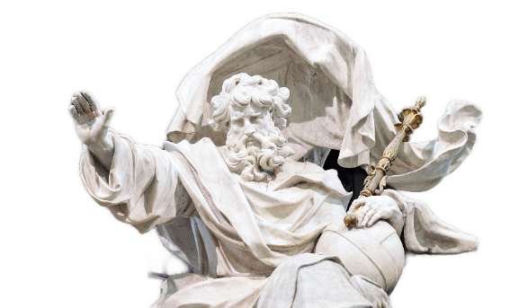
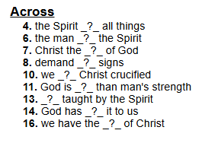
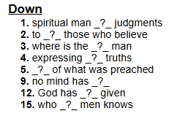
Crossword wisdom and other
fun Family Activities found at
https://tinyurl.com/r83e4r2p

